DEVELOPING PROOFREADING SKILLS
By Arlene Zimmerly

Proofreading Compositions 1
Proofreading Compared Text 2
Proofreading Document Processing Jobs 2
Using GDP’s Scoring Results 3

Language Arts exercises are systematically included throughout your textbook to help build your proofreading skills. They include “Language Arts—Composing Sentences” and “Language Arts—Proofreading,” in which you compare one set of lines with another in the text and edit the lines to correct any errors. When you proofread, take your time, minimize distractions, and concentrate.

Proofreading Compositions
In this “Language Arts—Composing Sentences” example from Lesson 24-D, page 83, you will compose a complete sentence to answer each question.
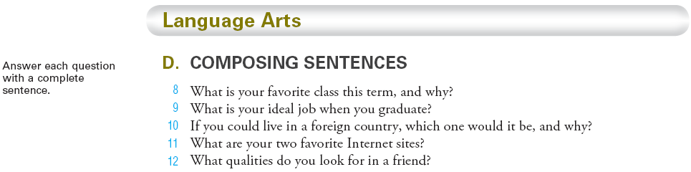
When you proofread your own writing, you use different proofreading techniques than when you compare text.
To proofread your own compositions:
- Read your composed copy aloud to see if it makes sense. Listen for things like missing, added, or transposed words. If possible, use Internet text-to-speech freeware to read typed copy aloud. You will often “hear” errors you would otherwise miss.
- Use Word’s speller feature to check for correct spelling. Word’s speller doesn’t always correctly identify misspellings and sometimes identifies correct words as incorrect. (Refer to the Word Manual, Lesson 24, “Spelling and Grammar Check.”)
- Check for grammar and punctuation errors.
- Use Word’s Zoom feature to enlarge the screen text.
- Turn off Show/Hide ¶ to hide formatting marks and make text easier to read. (Refer to the Word Manual, Lesson 24, “Show/Hide Formatting.”)

Proofreading Compared Text
In this “Language Arts—Proofreading” example from page 80, Lesson 23-H, you will compare the lines typed on one page with the lines typed on another and edit to correct any errors.
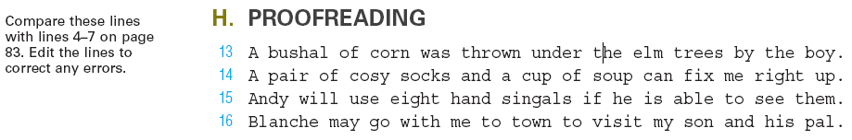
To proofread compared text:
- Point at each word as you compare the lines in the first source with those in the second.
- Place a sticky note, ruler, or paper under the line you’re comparing so you see one line at a time.
- If possible, have someone read aloud from one source while you follow along in the other.

Proofreading Document Processing Jobs
In Correspondence 25-1, you will compare text on page 85 with your own document and edit as needed.
To proofread document processing jobs:
- Read the copy aloud to see if it makes sense. Listen for things like missing, added, or transposed words you may have left out or changed when you typed the job.
- Proofread more than once with a different focus each time.
- On the first pass, pay special attention to frequently missed elements like punctuation marks, dates, names, titles, and numbers.
- On the next pass, focus on formatting. Refer to the model documents in the GDP Reference Manual and in the unit. Use Word’s Show/Hide ¶ feature to show formatting marks, and pay special attention to things like this:
  - Extra or missing blank lines (blank lines above the date and below the closing in a letter).
  - Font changes in jobs such as titles in tables and reports (size, bold, and italic).
  - Page numbers in multipage documents.
  - Trailing spaces at the ends of lines and ending punctuation and extra spaces between words. Use Word’s Find and Replace feature to help find extra spaces and trailing spaces:
- Ctrl + F; Find and Replace dialog box, Find tab; Find what box; press the Space Bar 2 times; Find Next.  - Ctrl + F; Find and Replace dialog box, Find tab; Find what box; More>>, then Special; from drop-down list, click White Space; then Special, Paragraph Mark; Find Next. | Note: These codes appear in the drop-down list for reuse.

Using GDP’s Scoring Results
GDP’s error-marking system and Proofreading Check jobs work together to systematically improve your proofreading skills. Developing proofreading skills is a four-step process:
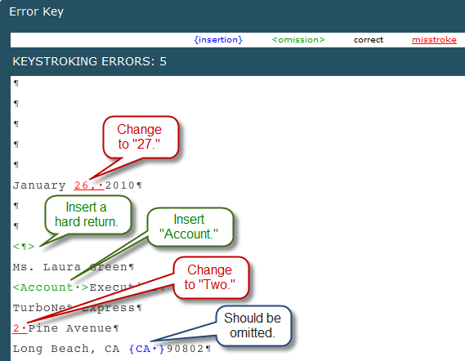
- Step 1: Recognition
GDP’s scoring and error-marking system helps you learn to recognize errors in documents.
Typically, we miss about 1/3 of all proofreading errors.
Would you have noticed that “Executive” should be “Account Executive” or that “2” should be “Two”?

- Step 2: Practice
Use Edit and the Scoring Results window to revisit and correct scoring errors until a document is mailable. If you have errors on a document, return to the document and click Edit Work to reopen the document. Use Alt + Tab to move between the Word file and the Scoring Results window, or use the Windows Taskbar and alternately click the buttons for GDP11e and the Word file.
- Step 3: Reinforcement
Proofreading Checks provide the opportunity to demonstrate that you can find all errors without assistance on the first Started attempt. Click Start Work to test your proofreading skills. In any "Start Work" attempt, you begin with a blank screen. Since the Scored Results window does not appear until you use Browse and Submit Work, attempts designated as “Started” in the Portfolio signal a job that was proofread initially without GDP assistance.
- Step 4: Assessment
Proofreading Check assessment holds you accountable—you must have no errors on the first Started attempt. In your Student Portfolio, GDP reports Attempt, Keystroking Errors, Attempt Origin (whether the attempt was Started or Edited), Time Spent and Last Modified date. If Keystroking Errors are 0 and the Attempt Origin is Started, you proofread successfully without any help from GDP.

