
COMMENTS LIBRARY
Comment Types 2
Create a Comments Library in Advance 2
Edit the Comments Library 4
Insert a Comment in Student Portfolio 4
Create, Insert, Delete, or Edit a General Comment on the fly 4
To create and insert a new General Comment and add it to the Library: 4
To delete a General Comment: 5
To insert a General comment from the Library: 5
To use the “contains” filter in the Library filter list box: 6
Create, Insert, Delete, or Edit an Annotation on the fly 6
To create and insert a new Annotation and add it to the Library: 6
To insert an Annotation comment from the Library: 7
To delete one Annotation: 7
To delete all Annotations: 8
To edit an Annotation: 8
View and Print Portfolio Comments 9
COMMENTS LIBRARY 10
Conventions: 10


Note! Preferences settings for Messaging, Resources, Gradebook, Formatting Assistant, Score Keystroking, and Proofreading Viewer affect GDP screen content and functionality. Your GDP screens may vary from those shown in this document.

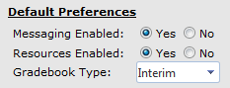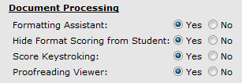

Note! Any Comments Library you create is associated with your Full Instructor account, not your Class or Section. So copied Classes and Sections do not necessarily inherit the Comments Library you create. If you are assigned to a copied Class and/or Section or new ones, your Comments Library will be available to you.

Comment Types
There are two types of Comments you can add in the Portfolio for a given item:

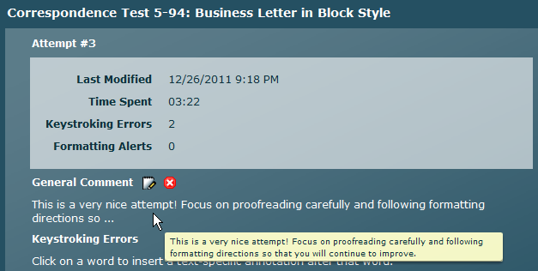
General Comments apply to the entire document and appear at the top of the dialog box.

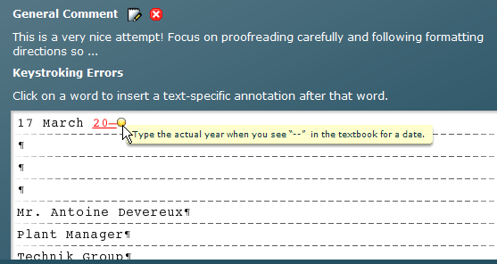
Annotations appear at a particular point in the document or exercise.

A comprehensive Comments Library appears at the end of this handout and includes General Comments and Annotations related to the exercises and documents taught in Lessons 1-120. Specific references to lessons and the Reference Manual are included to encourage students to use their textbooks and GDP as tools to find their own answers.

Use this detailed database of titles and comments to copy and paste desired information into your own Comments Library. Edit to suit your needs. All steps assume you are logged into Course Manager as a Full Instructor.

Create a Comments Library in Advance
- Click GPS, Comments tab.
- Click the Add Comment hyperlink link just below the Type box.

Note: To filter your Comments Library and display either Annotations or General Comments, from the Type box, click the list arrow and click the desired choice. Click the Title column heading to sort in ascending or descending order by title. Click the Text column heading to sort in ascending or descending order by typed text.

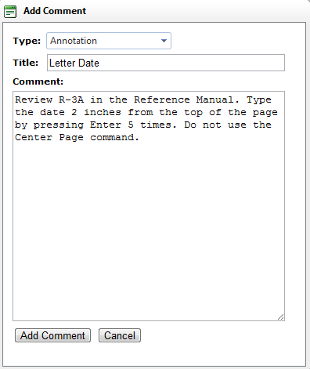
- From the Add Comment dialog box, click the list arrow next to the Type box; click either Annotation or General.
- Type a title in the Title box, or copy/paste a title from the Comments Library and edit as desired.
- In the Comment box, type the comment, or copy/paste a comment from the Comments Library and edit it as desired; click Add Comment.
- Repeat steps 2 through 5 until all desired entries have been added.

Here’s an example of a partially populated Comments Library:
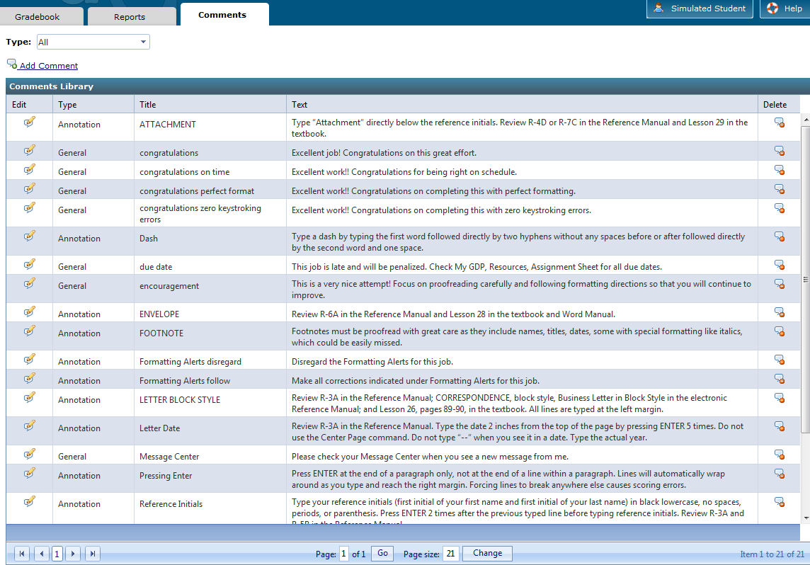

Edit the Comments Library
- Click GPS, Comments tab; click the Edit icon for the desired comment (General or Annotation).
- In the Edit Comment dialog box, make any desired changes; click Save Comment.
- To delete the comment, click Delete in the last column; click OK to confirm the deletion.

Insert a Comment in Student Portfolio
- Under USERS, click Students.
- From the Students tab, first column, click the Portfolio icon to the left of the desired student.
- From the Reports tab, click anywhere over the desired item to expand it.
- Click Details for the desired attempt.

Note! In any skillbuilding drills in which error-alert is in use (for example, New Key drills or MAP+ prescriptive drills in which you must type the correct key to continue), a Details button is not available. In any unscored document processing job (for example, Report 55-29 or Form 103-8) a Details button is not available. Therefore, you cannot add comments to these items.

- Click View in Word for any desired document processing attempt.

To switch to One Page view: From the View tab, Zoom group, click One Page.
To add One Page view to the Quick Access toolbar: From the Quick Access toolbar, click the list arrow, and click More Commands; from the Word Options window, Choose commands from box, click the list arrow and click View Tab; from the left pane, click One Page; click the Add button between the panes; click OK. Now, whenever you open a document in Word, click the One Page button to view the open document as a single page.

Create, Insert, Delete, or Edit a General Comment on the fly

To create and insert a new General Comment and add it to the Library:
- In the dialog box for that activity, click the General Comment button. |  | 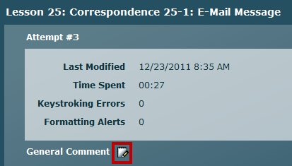
- Click in the title box and type the desired title—in this example, due date.  - Click in the text box below, and type the comment text.  - Click Insert and Add to Library.  Tip: Copy and paste a comment title and comment text from the Comments Library at the end of this handout rather than typing individual entries.  - Note that you are returned to the document window and the General Comment appears.  - Point to the General Comment icon to read the complete text for a long comment.  To delete a General Comment:  - Click the red X icon to remove the General Comment. |  | 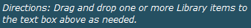  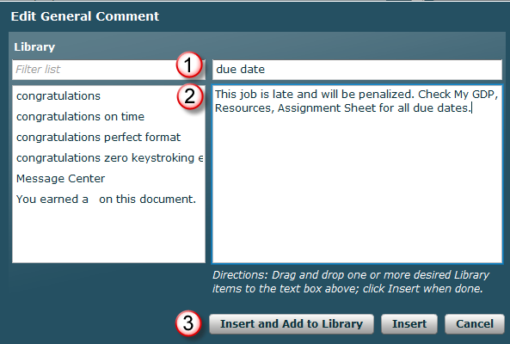  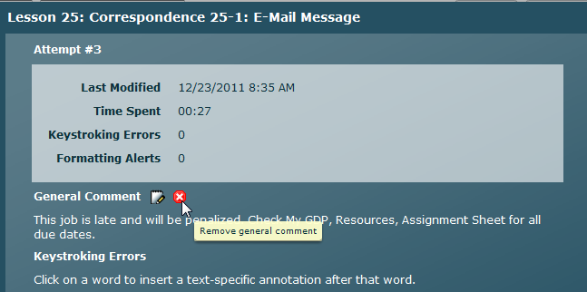

To insert a General comment from the Library:
- In the dialog box for that activity, click the General Comment button.  - In the Edit General Comment window, note that under Library, only General Comment entries (no Annotations) appear on the list.  - Point to a desired comment and drag and drop it into the text box to the right.  - Repeat if you wish to add more than one comment.  - Edit any entries in the text box itself as desired.  - Click Insert when you’re finished.  - Point to a long General Comment to see complete text via a rollover tip. |  | 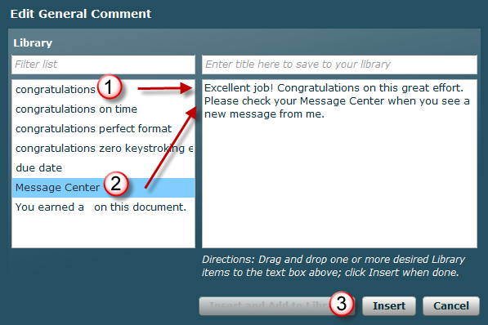  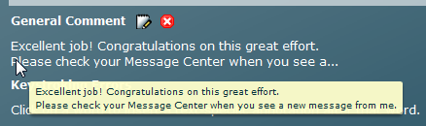

To use the “contains” filter in the Library filter list box:
As your Library grows, you should use the “contains” filter in the Library filter list box to move to a desired annotation more efficiently. These examples are for annotations, but the same principles apply to General Comments. Here’s how it works:
- Note the order of entries in the unfiltered list.  - For this example, you want to drag and drop the last entry, “year.” | 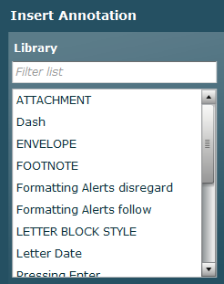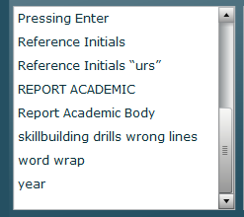
- Type a “y” in the Filter list box.  - Note that the Library filters to any entry that has the letter “y.”  - Type an “e” after the “y” in the Filter list box.  - Note that the Library filters to any entry that has “ye.” | 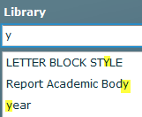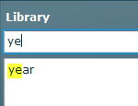

Create, Insert, Delete, or Edit an Annotation on the fly

To create and insert a new Annotation and add it to the Library:
- In the dialog box for that activity, click the desired spot in the text box under Keystroking Errors. |  | 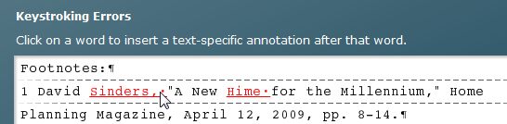
- Click in the title box, and type the desired title—in this example, FOOTNOTE.  - Click in the text box below, and type the comment text.  - Click Insert and Add to Library.  Tip: Copy and paste a comment title and comment text from the Comments Library at the end of this handout rather than typing individual entries. |  | 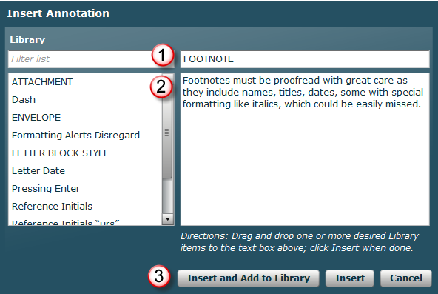
- Note that you are returned to the document window and the Annotation displays when you point to the yellow dot. |  | 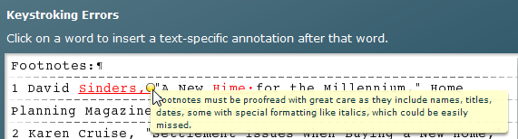

To insert an Annotation comment from the Library:
- In the dialog box for that activity, click the desired spot in the text box under Keystroking Errors.  - In the Insert Annotation window, note that under Library, only Annotation entries (no General Comments) appear on the list.  - Use the “contains” filter as needed to display the desired comment.  - Point to a desired comment and drag and drop it into the text box to the right.  - Repeat if you wish to add more than one comment.  - Edit any entries in the text box itself as desired.  - Click Insert when you’re finished. | 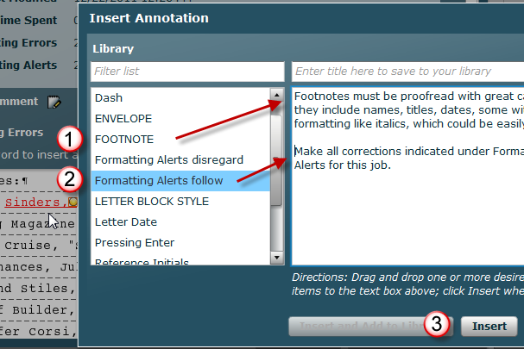
- Point to the yellow dot for the new comment to see the complete comment text display via a rollover tip. | 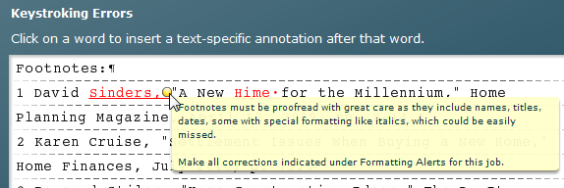

To delete one Annotation:
- Click any yellow dot to open the Edit Annotation window.  - Click Delete.  - Note that the Edit Annotation window closes, you are returned to the Details window, and the Annotation is gone. |  | 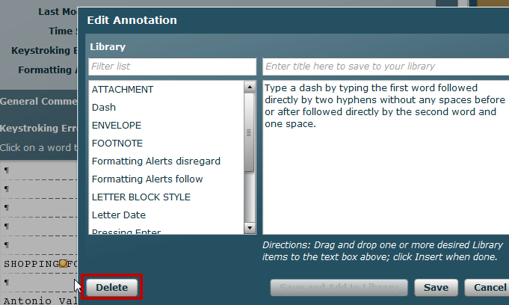

To delete all Annotations:
- Expand the desired item.  - Click Details for the desired attempt.  - Scroll to the bottom of the Details window, and click Delete Annotations.  - Note that all the Annotations are gone. |  | 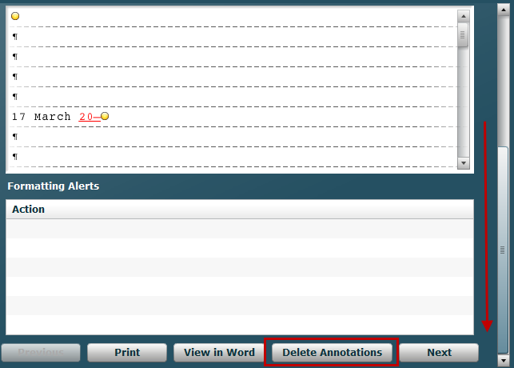

To edit an Annotation:
- Click the yellow dot over the desired annotation to open the Edit Annotation window.  - Make any desired edits. (In this example, the highlighted words were added.)  - Click Save when you’re finished. |  | 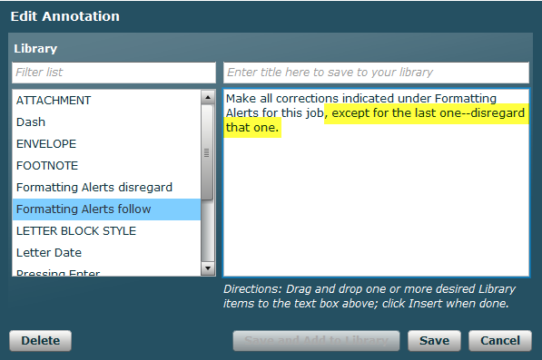

View and Print Portfolio Comments
See Course Manager Tips, “Using Filters on the Students Tab,” “Opening the Student Portfolio,” “Using the Student Portfolio—Sort and Reverse Sort by Column Heading; Date, Lesson, and Title; Expanding, Collapsing, and Sorting Items; and Annotations” for steps to view and print existing comments.

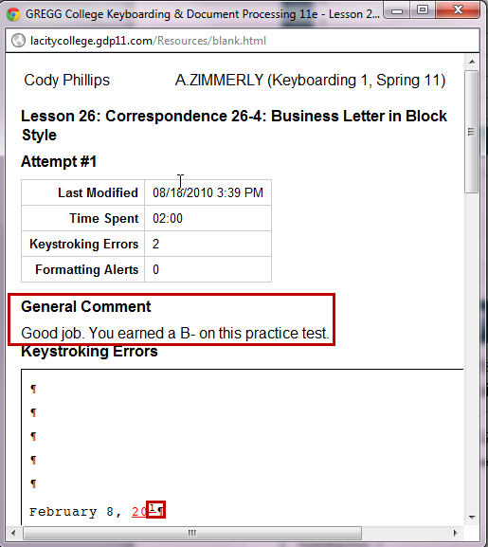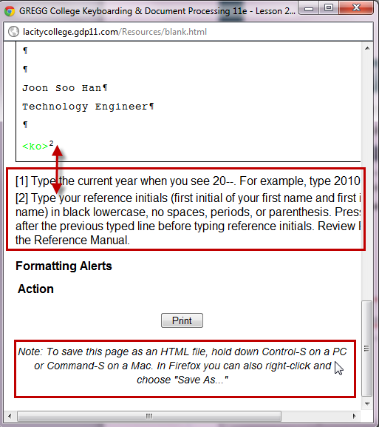
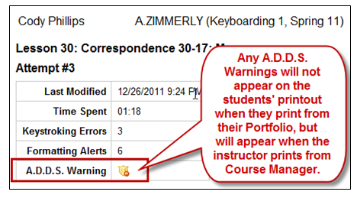

COMMENTS LIBRARY

Conventions:

- Titles in all lowercase (for example, congratulations, on time) are generic comments that may be used as General Comments.
- Titles in all caps (for example, LETTER, BLOCK STYLE) are generic comments for a specific type of document and can be used as a general Annotation on the first line of a job.
- Titles in principal caps (for example, Letter Date or Reference Initials, “urs”, or Reference Manual, Electronic) are specific annotations inserted at a pertinent point in a document.
- Titles in blue (for example, PROOFREADING CHECK) are specific comments used in Arlene Zimmerly’s Keyboarding 1 course and will not necessarily apply to your course.

Title | Comment
AGENDA | Review R-11A in the Reference Manual; or REPORTS, agenda, meeting, Meeting Agenda in the electronic Reference Manual; and Lesson 72 in the textbook.
Attachment | Type “Attachment” directly below the reference initials. Review R-4D or R-7C in the Reference Manual and Lesson 29 in the textbook.
B key Lesson 5 | Did you remember to type the “b” with the “f” finger? The “b” is one of the most troublesome keys in the technique check coming up after Lesson 10.
C key Lesson 5 | Did you remember to type the “c” with the “d” finger? The “c” is one of the most troublesome keys in the technique check coming up after Lesson 10.
congratulations, on time  | Excellent work!! Congratulations for being right on schedule.
congratulations, timed writing | Excellent work!! Congratulations for meeting the goal for speed and accuracy.
congratulations, zero keystroking errors | Excellent work!! Congratulations on completing this with zero keystroking errors.
congratulations, perfect format | Excellent work!! Congratulations on completing this with perfect formatting.
dash | Type a dash by typing the first word, two hyphens (no spaces before or after), the second word, and one space.
documents, extra | Please do NOT do any unassigned documents yet! Instead, spend your time correcting all errors on the required documents and doing your best to proofread them with zero errors on the first scored attempt to build proofreading skill.
documents, repeat | You may repeat any job one time to raise your grade, so don’t be discouraged by any low grades. Click Edit Work for a regular job or Start Work for a Proofreading Check. If you had formatting errors, check the Reference Manual, text, and any instructor annotations for formatting tips.
drills, wrong lines | You're typing the wrong line. The directions on the GDP screen at the bottom will always list the page and line number. Try again.
E-MAIL | Review R-5C—D in the Reference Manual; CORRESPONDENCE, e-mail, E-mail Message in the electronic Reference Manual; and Lesson 25 in the textbook and Word Manual.
encouragement | This is a very nice attempt! Focus on proofreading carefully and following formatting directions so that you will continue to improve.
ENVELOPE | Review R-6A in the Reference Manual and Lesson 28 in the textbook and Word Manual.
Enter key | Press Enter at the end of a paragraph only, not at the end of a line within a paragraph. Lines will automatically wrap around as you type and reach the right margin. Forcing lines to break anywhere else causes scoring errors.
error, limit | You have exceeded the allowed error limit for this attempt. Repeat the timing; if you are not successful, complete any Enrichment pages if applicable to this lesson; repeat the timing; if you are not successful, use MAP+ or any applicable drills under the Skillbuilding button to practice until you feel ready to try the timed writing again.
Enter twice | Press Enter 2 times between paragraphs.
error, marking | insertion in blue indicates a word or hard return to be deleted.  omission in green indicates a word or hard return to be inserted.  misstroke in red indicates an incorrect word or spacing error after that word.
error, correction | Correct all typos in all documents.
error, spelling grammar | Proofread your document carefully. Review Lesson 24 in the Word Manual to for information on Word’s spelling and grammar tool.
extra documents | Do NOT type any documents not specifically assigned on the assignment sheet.
Footnote | Footnotes must be proofread with great care as they include names, titles, dates, some with special formatting like italics, which could be easily missed.
Formatting Alerts, disregard | Disregard the Formatting Alerts for this job.
Formatting Alerts, follow | Make all corrections indicated under Formatting Alerts for this job.
GDP Movie Channel | In My GDP, Click Resources, GDP Movie Channel, and view this/these movie(s):  "Orientation to Technique Checks"  "Orientation to Skillbuilding & Map+"  "Sustained Practice"  "12-Second Speed Sprints"
grade | You earned a on this document.
italicize | Italicize titles of major works like books.
ITINERARY | Review R-11C in the Reference Manual; REPORTS, itinerary, Itinerary, in the electronic Reference Manual; and Lesson 71 in the textbook.
LABEL | Review Lesson 28 in the textbook and Word Manual and R-6A in the Reference Manual.
Language Arts | Repeat the Language Arts tutorial in GDP for this lesson and try the Language Arts exercise again.
late work | This job is late and will be penalized. Check My GDP, Resources, Assignment Sheet for all due dates.
line spacing, double | Change your line spacing throughout the entire document to double. Press Ctrl + A to select the entire document then Ctrl + 2 to change to double spacing. Adjust any extra blank lines or add blank lines as needed.
LETTER, BLOCK STYLE  | Review R-3A in the Reference Manual; CORRESPONDENCE, block style, Business Letter in Block Style in the electronic Reference Manual; and Lesson 26, pages 89-90, in the textbook. All lines are typed at the left margin.
Letter, Body | Review R-3A in the Reference Manual. Press Enter 2 times above and below each paragraph in the body of a letter. Do not indent paragraphs.
Letter, Complimentary Close | Press Enter 2 times after typing the last paragraph in the body, type the complimentary closing, then press Enter 4 times just before typing the writer’s identification.
Letter, Date  | Review R-3A in the Reference Manual. Type the date 2 inches from the top of the page by pressing Enter 5 times. Do not use the Center Page command. Do not type “--” when you see it in a date. Type the actual year.
Letter, Display | Review R-3A in the Reference Manual; CORRESPONDENCE, block style, Business Letter in Block Style, in the electronic Reference Manual; and Lesson 44 the textbook and Word Manual for double indent. Type a displayed paragraph single-spaced and indented 0.5 inch from both the left and the right margins.
Letter, Enclosure Notation | Review R-3B and R-5B in the Reference Manual and Lesson 27 in the textbook. Type “Enclosure” directly below the reference initials by pressing Enter 1 time after typing the reference initials.
Letter, Inside Address | Review R-3A in the Reference Manual. Type the date, then press Enter 4 times and type the inside address. Press Enter 2 times after the inside address then type the salutation.
LETTER, MODIFIED-BLOCK | Review R-3B and R-3D in the Reference Manual; CORRESPONDENCE, modified-block style, Business Letter in Modified-Block Style, in the electronic Reference Manual; and Lesson 45 in the textbook and Word Manual. Type the date and closing 3.25 inches in from the left margin.
LETTER, MULTIPAGE | Review R-5A-B in the Reference Manual; CORRESPONDENCE, multipage, Multipage Business Letter in the electronic Reference Manual; Lesson 66 in the textbook; and Lesson 32 in the Word Manual.
LETTER, PERSONAL-BUSINESS | Review R-3D and R-12D in the Reference Manual; CORRESPONDENCE, personal-business, Personal-Business Letter in Modified-Block Style and Application Letter in Block Style in the electronic Reference Manual; and Lesson 54 in the textbook. No reference initials are used.
Letter, Salutation | Review R-3A in the Reference Manual and Lesson 26 in the textbook. Type the inside address, press Enter 2 times, and type the salutation. Press Enter 2 times after the salutation to begin the body.
Letter, Writer’s ID | Review R-3A in the Reference Manual and Lesson 26 in the textbook. Type the complimentary closing, press Enter 4 times, type the writer’s identification, press Enter 2 times, and then type the reference initials.
LISTS | Review R-3B—C, R-5B, and R-12C—D in the Reference Manual. Study the examples carefully. See Lesson 33 in the textbook and Word Manual.
MAP+ | Click the Map+ button in GDP, and click the View MAP Slideshow button to review how to use MAP.
MEMO | Review R-4D and R-9C in the Reference Manual; CORRESPONDENCE, memo, in the electronic Reference Manual; and Lesson 29 in the textbook. Begin the memo 2 inches from the top of the page by pressing Enter 5 times. Press Enter 5 times to type the memo headings including the colons in all-caps and bold 2 inches from the top of the page. Press Tab after typing the colon to align the heading entry. Press Enter 2 times after each heading entry.
Memo Body | Review R-4D and R-9C in the Reference Manual; CORRESPONDENCE, memo, in the electronic Reference Manual; and Lesson 29 in the textbook. Type the last memo heading, press Enter 2 times, and type the first paragraph of the body. Press Enter 2 times between paragraphs and just before the reference initials. Do not indent paragraphs.
Message Center | Check your Message Center when you see a number by My GDP and Message Center.
MINUTES | Review R-11B in the Reference Manual; REPORTS, minutes of a meeting, Minutes of a Meeting in the electronic Reference Manual; and Lesson 72 in the textbook.
paragraph indent | Don’t indent paragraphs in a block-style letter or a memo or any single-spaced document. Review R-14C in the Reference Manual and open your text to page 120 and look at the proofreaders’ mark for a new paragraph and the draft and final copy examples.
proofreaders’ marks | Review R-14C in the Reference Manual, Proofreaders’ Marks in the electronic Reference Manual, and Lesson 33 and 35 in the textbook.
proofreading tips | Take extra care when proofreading items like names, titles, dates, and amounts. Review Lesson 33G for proofreading tips.
PROOFREADING CHECK  | Your goal on a Proofreading Checks is to have zero keystroking errors on a Start Work attempt. If you have keystroking errors, click Start Work to start from a blank screen and try again.
PROOFREADING CHECK Edit Work | You have successfully completed this Proofreading Check with zero keystroking errors on a Started Attempt. Therefore, you do not need to retype the document. However, to improve your formatting grade, click Edit Work and correct formatting errors.
PROOFREADING CHECK Start Work | Retype this Proofreading Check using Start Work until you have zero keystroking errors. You’re not allowed to use Edit Work for a Proofreading Check.
Reference Initials | Type your reference initials (initials of your first and last Student Name used to log in to GDP) in lowercase without spaces in black in place of the red “urs.” Press Enter 2 times after the previous typed line before typing reference initials. Review R-3A and R-5B in the Reference Manual.
Reference Initials, red | Type your reference initials in black, not red.
Reference Initials, “urs”  | When you see “urs” in red the textbook, type the initials of your first and last Student Name used to log-in to GDP in lowercase without spaces in black, in place of the red “urs.”
Reference Manual, Electronic  | Remember to use the electronic reference Manual in GDP. Access it by clicking the Reference Manual button. You can also find it in the introductory pages of your textbook and Word Manual.
repeat document | You may resubmit this document one time to raise your grade. Use the Scoring Results window to verify accuracy. Correct all typos and check the Reference Manual and instructor annotations for formatting tips. After you edit, use Browse and Submit Work again. I will then replace a lower grade with the improved grade.
REPORT ACADEMIC | Review R-8C—D and R-9D in the Reference Manual; REPORTS, academic style, Multipage Academic Report in the electronic Reference Manual; and Lesson 34 in the textbook. Press Enter 5 times to type the title 2 inches from the top of page; then change to double spacing to type the remainder of the report.
Report Academic, Body | Review R-8C in the Reference Manual, and Lesson 34 in the textbook. Press Enter 1 time above and below all paragraphs in the body. Press Enter only at the end of a paragraph. Press Tab 1 time to indent paragraphs.
Report Academic, Byline | Review R-8C in the Reference Manual and Lesson 34 in the textbook. Type the byline centered in bold. Press Enter 1 time before and after typing the byline.
Report Academic, Date | Review R-8C in the Reference Manual, and Lesson 34 in the textbook. Type the date centered in bold. Press Enter 1 time before and after typing the byline.
Report Academic, Footnotes | Review Lesson 46 and 53 in the textbook and Lesson 46 in the Word Manual.
Report Academic, Indent Paragraph | Review Lesson 34 in the textbook. Indent all paragraphs in an academic report.
Report Academic, Line Spacing | Review Lesson 34 in the textbook. Set double spacing for the entire academic report. If you have mixed single and double spacing inside the report, press Ctrl + A to select the entire document and then Ctrl + 2 to set double spacing.
Report Academic, List | Review Lesson 34 in the textbook; R-8C and R-12C—D in the Reference Manual; and REPORTS, academic style, Multipage Academic Report in the electronic Reference Manual. Double-space the entire list.
Report Academic, Page Number | Review R-8C—D in the Reference Manual; REPORTS, academic style, Multipage Academic Report; Lesson 34 and 63 in the textbook, and Lesson 32 in the Word Manual. Do not number the first page of a report. Insert a page number in the top right corner of the second and subsequent report pages.
Report Academic, Paragraph Heading | Review R-8C in the Reference Manual, and Lesson 34 in the textbook. Press Tab 1 time to indent all paragraph headings. Type paragraph headings in upper- and lowercase letters in bold followed by a bolded period. Press Enter 1 time above and below paragraph headings.
Report Academic, Side Heading | Review R-8C in the Reference Manual, and Lesson 34 in the textbook. Type all side headings at the left margin in all-caps and bold. Press Enter 1 time above and below side headings.
Report Academic, Subtitle | Review R-8C in the Reference Manual. After typing the title of an academic report, press Enter 1 time and type the subtitle in bold, with upper- and lowercase letters with a 12-point font size. Press Enter 1 time after typing the subtitle to begin the body.
Report Academic, Title | Review R-8C in the Reference Manual. Type the title of an academic report 2 inches from the top of the page by first setting double spacing and then pressing Enter 3 times. Type the title in bold and all caps with a 14-point font size. Do not change to 14-point font until after you press Enter 3 times to begin the report. Press Enter 1 time after typing the title. Press Enter 1 time between each line of a 2-line title.
Report Academic, Title Block | Review R-8C and R-8D in the Reference Manual. Change to double spacing (Ctrl + 2), press Enter 3 times in double spacing, type the title in 14-pt. bold, press Enter 1 time and type the subtitle (or date) in bold, with upper- and lowercase letters with a 12-point font size. Press Enter 1 time after typing the subtitle (or date) to begin the body.
REPORT APA | Review R-10A—B in the Reference Manual; REPORTS, APA style, Report in APA Style in the electronic Reference Manual; and Lesson 47 in the textbook.
Report APA, Header | Review Lesson 47 in the textbook and Word Manual. Insert a right-aligned header for all pages with a shortened title and automatic page number.
Report APA, Headings | Review Lesson 47 in the textbook and R-10A in the Reference Manual. Type main headings centered in upper- and lowercase letters. Press Enter 1 time before and after the main heading.
Report APA, Line Spacing | Review Lesson 47 in the textbook and R-10A in the Reference Manual. Set double spacing for the entire business report. If you have mixed single and double spacing inside the report, press Ctrl + A to select the entire document and then Ctrl + 2 to set double spacing.
Report APA, Margins | Review Lesson 47 in the textbook and R-10A in the Reference Manual. Review Lesson 42 in the textbook and Word Manual. Use default 1-inch top and bottom margins and change the left and right margins to 1 inch.
Report APA, Reference List | Review R-10B in the Reference Manual, Lesson 47 and 49 in the textbook, and Lesson 49 in the Word Manual. Use the same margins, spacing, and header as other APA pages. Type References centered and press Enter 1 time. Set a hanging indent and type the first line. Press Enter 1 time between each entry. Italicize publication titles.
Report APA, Title | Review Lesson 47 in the textbook and R-10A in the Reference Manual. Center and type the title and byline in upper- and lowercase.
REPORT BUSINESS | Review R-8A—B, R-9A, and R-9D in the Reference Manual; REPORTS, business (all examples), in the electronic Reference Manual, and Lesson 31-33 in the textbook. Type the title 2 inches from the top of the page by pressing Enter 5 times.
REPORT BUSINESS, BIBLIOGRAPHY | Review R-9B in the Reference Manual, and Lesson 49 in the textbook and Word Manual. Press Enter 5 times to begin. Type BIBLIOGRAPHY centered in all caps, 14-point font, and bold and press Enter 2 times. Set a hanging indent and type the first line. Single-space each entry and press Enter 2 times between each entry. Italicize publication titles.
Report Business, Body | Type the body 1 blank line below the previous line, single-spaced positioned at the left margin—do not indent paragraphs. Press Enter 2 times between paragraphs. Press Enter only at the end of a paragraph.
Report Business, Byline Date | Type the byline centered in bold. Press Enter 2 times before and after typing the byline and/or date.
Report Business, Display | Review R-8B and R-8D in the Reference Manual; REPORTS, academic style, Multipage Academic Report (second one) in the electronic Reference Manual; and Lesson 46 and 87in the textbook and Lesson 44 in the Word Manual for double indent. Type a displayed paragraph single-spaced and indented 0.5 inch from both the left and the right margins.
Report Business, Footnotes | Review R-8A —B and R-9A; REPORTS, footnotes (all entries) in the electronic Reference Manual; and Lesson 46 in the textbook and Word Manual.
Report Business, Line Spacing | Set single spacing for the entire business report. If you have mixed single and double spacing inside the report, press Ctrl + A to select the entire document and then Ctrl + 1 to set single spacing.
Report Business, List | Review R-8A, R-9A, and R-12C—D in the Reference Manual; Lesson 31 and 33 in the textbook. Press Enter 2 times before and after list. Single-space 1-line lists. For a multiline list, press Enter 2 times between each item.
Report Business, Page Number | Review R-8B in the Reference Manual; Lesson 32 in the textbook and Word Manual; and REPORTS, business, Multipage Business Report in the electronic Reference Manual. Insert a page number in the top right corner of the second and subsequent report pages only. Do not number the first page of a report.
Report Business, Paragraph Heading | Review R-8A in the Reference Manual and Lesson 31 in the textbook. Type all paragraph headings at the left margin in upper- and lowercase letters in bold followed by a bolded period. Press Enter 2 times above and below paragraph headings.
Report Business, Side Heading | Review R-8A in the Reference Manual and Lesson 31 in the textbook. Type all side headings at the left margin in all-caps and bold. Press Enter 2 times above and below side headings.
Report Business, Subtitle | Review R-8A in the Reference Manual and Lesson 31 in the textbook. After typing the title of a business report, press Enter 2 times and type the subtitle in bold, with upper- and lowercase letters with a 12-point font size. Press Enter 2 times after typing the subtitle to begin the body.
Report Business, Title | Review R-8A in the Reference Manual and Lesson 31 in the textbook. Type the title of a business report 2 inches from the top of the page by pressing Enter 5 times in single spacing. Type the title in bold and all caps with a 14-point font size. Do not change to 14-point font until after you press Enter 5 times to begin the report. Press Enter 2 times after typing the title. Type 2-line titles single spaced.
Report Business, Title Block | Review R-8A in the Reference Manual and Lesson 31 in the textbook. Set single spacing for the entire business report. If you have mixed single and double spacing inside the report, press Ctrl + A to select the entire document and then Ctrl + 1 to set single spacing.
REPORT MLA | Review R-10C—D in the Reference Manual; REPORTS, MLA Style (all entries) in the electronic Reference Manual; and Lesson 48 in the textbook.
Report MLA, Body | Review Lesson 48 in the textbook. Indent all paragraphs 0.5 inch. Press Enter 1 time between paragraphs. Press Enter only at the end of a paragraph.
Report MLA, Header | Review Lesson 48 in the textbook, and R-10C—D in the Reference Manual. Insert a right-aligned header for all pages with the author’s last name and an automatic page number.
Report MLA, Heading | Review Lesson 48 in the textbook, and R-10C—D in the Reference Manual. Type each element of the heading (your name, your instructor’s name, class name, and date) on a separate line at the left margin. Type the date day-month-year style.
Report MLA, Line Spacing | Review Lesson 48 in the textbook. Set double spacing for the entire business report. If you have mixed single and double spacing inside the report, press Ctrl + A to select the entire document and then Ctrl + 2 to set double spacing.
Report MLA, Margins | Review Lesson 48 in the textbook, and R-10C—D in the Reference Manual. Use default 1-inch top and bottom margins.
Report MLA, Title | Review R-10C—D in the Reference Manual. Center and type the title in upper- and lowercase letters.
REPORT MLA, WORKS-CITED | Review R-10D in the Reference Manual, Lesson 48 in the textbook, and Lesson 49 in the Word Manual. Use the same margins, spacing, and header as other MLA pages. Type Works Cited centered, and press Enter 1 time. Set a hanging indent and type the first line. Press Enter 2 times between each entry. Italicize publication titles.
REPORT, TABLE OF CONTENTS | Review R-7D in the Reference Manual, Table of Contents in the electronic Reference Manual, and Lesson 50 in the textbook and Word Manual. Press Enter 5 times, and type the title centered in all caps and bold with a 14-point font. Press Enter 2 times after the title. Set a left tab at 0.5 inch and a right tab at 6.5 inches with dot leaders. Type the main headings in all caps with 1 blank line above and below them. Press Tab 1 time to indent subheadings and single-space subheadings. Press Tab again to insert dot leaders and type the page number.
REPORT, TITLE PAGE | Review R-7B in the Reference Manual; REPORTS, Title Page, in the electronic Reference Manual. Review Lesson 50 in the textbook and Lesson 38 in the Word Manual. Center the page vertically. Center the title in all caps and bold with a 14-point font. Press Enter 2 times after the title. Center the subtitle in upper- and lowercase and bold in a 12-point font. Press Enter 12 times after the subtitle. Press Enter 12 times above “Prepared by.”
RESUME | Review R-12A in the Reference Manual; REPORTS, resume, in the electronic Reference Manual; and Lesson 51 in the textbook and Word Manual.
Right Shift key, Lesson 6 | Did you remember to use the RIGHT shift key to capitalize letters typed with the opposite LEFT hand?
Left Shift key, Lesson 4 | Did you remember to use the LEFT shift key to capitalize letters typed with the opposite RIGHT hand?
spacing | Space 1 time between words.
spacing, single | Change your line spacing to single. Press Ctrl + A to select the entire document then Ctrl + 1 to change to single spacing.
symbol, end line | The red | symbol indicates the end of a line. Press Enter to start a new line when you see it.
symbol, paragraph | The ¶ symbol indicates the start of a new paragraph. In a single-spaced document, paragraphs are blocked (not indented). In a double-spaced document, paragraphs are indented (not blocked).
tab | Press the Tab key at the start of paragraphs in academic report to indent them. When you see the green <[T]> in scored copy, it means you need to press Tab at that point.
TABLE | Review R-13A—D in the Reference Manual; TABLES, boxed, open, and ruled in the electronic Reference Manual; and Lesson 36-39 in the textbook and Word Manual.
Table $ | Review R-13A-D in the Reference Manual, Lesson 39 in the Word Manual, and Lesson 39H in the textbook for an explanation of spacing with column entries that include a $ (dollar sign) and spaces. If the column entry includes a dollar sign, add space after the dollar sign to align the dollar sign just to the left of the widest column entry below it. Add 2 spaces for each digit and 1 space for each comma.
Table, AutoFit | Review Lesson 36 in the textbook and Word Manual. Cell widths should be adjusted automatically to fit the contents of the.
Table, Borders | Review Lesson 36 in the textbook and Word Manual. Boxed tables have borders and open tables do not. Ruled tables have a mix of the two.
Table, Boxed | Review R-13A in the Reference Manual; TABLES, boxed in the electronic Reference Manual; and Lesson 36 in the textbook and Word Manual. Boxed tables have borders.
Table, Center | Review Lesson 38 in the textbook and Word Manual. Tables alone on a page are centered both horizontally and vertically.
Table, Column Headings | Review 13A—D in the Reference Manual, and Lesson 36 and 38 in the textbook and Word Manual. Type column headings in bold upper- and lowercase letters. Center all column headings and left-align text columns (or a mix of text and numbers) and right-align column entries that could be used in mathematical calculations.
Table, Heading Block | Review 13A—D in the Reference Manual and Lesson 36 and 37 in the textbook and Word Manual. Merge cells in Row 1 to hold the heading block. Type the title centered in all-caps and bold, with a 14-point font in row 1. Press Enter 1 time after typing the title. If the table has a subtitle, press Enter 1 time to the subtitle. Type the subtitle centered in bold, with a 12-point font. Press Enter 1 time after typing the subtitle.
Table, Number Columns | Review R-13A—D in the Reference Manual and Lesson 39 in the textbook and Word Manual. Center all column headings and left-align text columns (or a mix of text and numbers) and right-align column entries that could be used in mathematical calculations.
Table, Open | Review R-13B in the Reference Manual and Lesson 37 in the textbook and Word Manual. Remove borders in an open table.
Table, Ruled | Review R-13C in the Reference Manual and Lesson 39 in the textbook and Word Manual. Ruled tables have all borders removed first. Then a top and bottom border are applied to Row 2. Then a bottom border is applied to the last row of the table.
Table, Within Document | Review R-4D, R-5A, and R-8B in the Reference Manual, and Lesson 68 in the textbook.
tests | Never take a test on campus until you have successfully completed the practice test even if it means taking the test late and getting a 10% penalty. You have a much better chance of passing the campus test when you have passed the practice test.
timed writings 3’ | Beginning with Lesson 52, you have a choice to select either a 5-minute or 3-minute timed writing length. Select the 3-minute timing in 52-D and for all timings thereafter.
timed writings 5’ | Beginning with Lesson 52, you have a choice to select either a 5-minute or 3-minute timed writing length. Select the 5-minute timing in 52-D and for all timings thereafter.
timed writings, error limit | Since your errors are quite low, try repeating the timed writing again pushing slightly for speed. As long as you do not exceed the maximum error limit, you should try to increase your speed.
trailing hard returns | The added hard return (extra blank line created by pressing Enter) of the line is causing a scoring error. This type of scoring error does not affect the printed document in any way, so it does not affect your grade. Don’t add trailing Enters at the end of a document. Type the last printing keystroke at the end of the document and nothing else.
trailing spaces | Delete the trailing spaces at the end of a line. This type of scoring error does not affect the printed document in any way, so it does not affect your grade. In the future, type the last printing keystroke at the end of the line and nothing else and stop or press Enter to begin the next line.
underscore and ending punctuation | Do not underscore the ending punctuation in an underscored sentence.
Word, Show/Hide | On Word’s Standard toolbar, click the Show/Hide button—it’s the one that looks like the paragraph symbol. This feature allows you to show formatting symbols like spaces, tabs, and paragraph symbols representing hard returns so that you can check your document in detail for typos and formatting errors. Review Lesson 24 in the Word Manual.
word wrap | Press Enter only at the end of a paragraph. In Word, lines wrap automatically as you approach the right margin. Your line endings in Word will not match those in the book.
X key Lesson 7 | Did you remember to type the “x” with the “s” finger? The “x” is one of the most troublesome keys in the technique check coming up after Lesson 10.
year | Type the current year in black when you see 20--.
yellow highlight | Highlighted words are spelling words from the language arts activities. Do not highlight these words in yellow when you type a document.

