
COMPLETE LIST OF WORD SETTINGS FOR GDP

- GDP will automatically open Word documents with the Word 2003 Style Set in place.
- Items shown with a red checkmark will likely need to be set.
- For more detail on these settings, click here or see Appendix A in the Word Manual.

From any Word screen: | Description
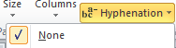 | Page Layout tab, Page Setup group, Hyphenation, check None; (except for magazine articles and newsletters).
 | Home tab, Paragraph group, Borders button, click View Gridlines to activate it.
Right-click Status bar; Customize Status Bar; click Vertical Page Position.
Note: If you do not change this setting, you will not be able to verify your vertical page position for documents, such as letters, that begin a specific number of inches from the top of the page.
From Word Options: | Description
- To get to Word Options in Word 2007, click the Microsoft Office button; click Word Options (lower right-hand corner)
- To get to Options in Word 2010, from the File tab, click Options at the bottom of the drop-down menu.
 | Word Options, Proofing group, AutoCorrect Options button, AutoCorrect tab:
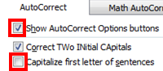 | - Check: Show AutoCorrect Options buttons
- Uncheck: Capitalize first letter of sentences
Note: If you do not uncheck this setting, when you press Enter after typing references initials, which begin in Lesson 26, those reference initials will be capitalized. On the keyboard, press Ctrl + Z or click Undo on the Quick Access toolbar to undo this capitalization immediately after it happens.
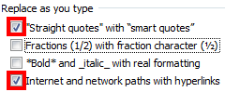  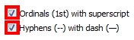 | Word Options, Proofing group, AutoCorrect Options button, AutoFormat As You Type tab:  Under Replace as you type leave all options unchecked except for:
 | - Check: “Straight quotes” with “smart quotes”
 | - Check: Internet and network paths with hyperlinks
 | - Check: Ordinals (1st) with superscript
 | - Check: Hyphens (--) with dash (—)
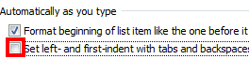 | Under Automatically as you type:  - Uncheck: Set left- and first-indent with tabs and backspaces  Note: If you do not uncheck this setting, when you press Tab to indent a paragraph, such as in an academic report in Lesson 37, an automatic indent might be set for subsequent paragraphs
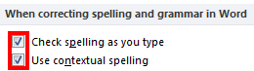 | Word Options, Proofing group; under When correcting spelling and grammar in Word:  - Check: Check spelling as you type and Use contextual spelling
Word Options, Advanced group. Under Editing options:
- Uncheck: Use CTRL + Click to follow hyperlink

Students should check with the instructor before changing this optional setting!
To specify a default Documents directory in Word to save files (optional):
- Word 2007: Click the Microsoft Office button, Word Options.
- Word 2010/2013/2016: From the File tab, click Options.
- Click Save in the left pane; in the right pane under Save documents, next to Default file location box, click Browse.
- Browse to the desired file location (perhaps the GDPFILES directory on the Windows Desktop or on your flash drive); click OK twice.

