
SETTING UP AN INTERIM GRADEBOOK
By Arlene Zimmerly
(Consult with McGraw-Hill support before attempting to set up a gradebook.)

Introduction 2
Benefits of Using a Gradebook 3
Assessment Plan 5
Configure Gradebook 6
Configure Scales 6
To create a new Grade Scale from a template: 6
To create a new Pass or Fail Grade Scale for Timed Writings assigned to Custom Grading: 7
Pass Grade: 7
Fail Grade 7
Configure Grading Categories 9
Create Categories and Assign Weights Based on Your Course Assessment Strategies 10
5' Timed Writings (Custom/50%) 12
DP Tests (20%), Practice DP Tests (5%), and DP Jobs (10%) 13
Proofreading Checks (5%) 14
Skillbuilding (10%) 15
EXTRA CREDIT and ATTENDANCE DEDUCTIONS 17
Configure Exercises 17
Configure Exercises (Custom) for 5' Timed Writings (Custom/50%) 17
Configure Exercises: WPM, E/Min Error, and Penalty WPM boxes 18
Configure Exercises (Manual) for DP Tests (20%), Practice DP Tests (5%), and DP Jobs (10%) 21
Configure Exercises (Manual) for Proofreading Checks (5%) 21
Configure Exercises (Completion) for Skillbuilding (10%) 22
Crosscheck IGB’s Required Exercises List Against Yours for Accuracy 23
To display the Required Exercises List (REL): 23
To export a generic REL: 24
To post a generic REL as a File Resource: 25
Identify Missing Required Exercises (pending work) via the REL 25
To display a list of pending exercises via the REL: 25
Enter Grades for Nonbook Categories: EXTRA CREDIT and ATTENDANCE DEDUCTIONS 27
Use Lock Grade and Unlock Grade for Individual Grades 29
Locks and Manual Grading Method 29
To lock a Manual grade: 29
To unlock and reset a Manual grade: 29
Locks and Automatic Completion and Custom Grading Methods 30
To lock an automatic grade: 30
To unlock and reset an automatic grade: 30
Use Toggle Grade Inclusion 30
Use Lock and Unlock Buttons for Grading Category and Course Grade 31
To lock a Grading Category and/or Course Grade: 31
To unlock a Grading Category and/or Course Grade: 31
Use the Portfolio and Advanced Portfolio Filters 31
Copy Gradebook 33
Troubleshoot 33
Configure Ten-Key Exercises 35


Note! The screen shots in this handout in some cases represent Classes and Sections in which the Interim Gradebook is enabled and in use. If you do not have a Gradebook enabled, your views and some features will vary. The enabling or disabling of Messaging, Resources, Formatting Assistant, Hide Format Scoring from Student, Score Keystroking, and Proofreading Viewer also affects the appearance of GDP screens:

Introduction
Before you begin, review the “Interim Gradebook Guide” to familiarize yourself with the gradebook concepts. Whenever you have questions as I walk you through the process of creating my gradebook, refer to the IGB for related information. In this handout, I will focus on the gradebook I set up for my own course based on the assessment categories and weights explained in the Course Outline page of the Computer Keyboarding 1 course Web site. Hopefully, as you move through this process, you will see parallels for your own assessment strategies and thus be better prepared to develop a gradebook for your own course that will return the grading results you expect.

The choices I made as I set up my gradebook, in my opinion, represent the simplest, most direct approach to end up with Category Grades and Final Grades in GDP’s Interim Gradebook (IGB) that mirrored those in the spreadsheet I used to calculate grades before IGB was available. I used the list of required assignments in the course Progress Folder as I configured exercises in each grading category. Here are the fundamental guidelines and personal preferences I used to set up my gradebook:

- I used these Grading Methods, which will be explained in more detail later:

- Manual Grading Method: I assign manual grades to all grading categories related to document processing including document processing tests and document processing daily work. Students can see the abbreviation M for Manual Grading Method work under the date in the Date column.

Note: Late penalties are not automatic in any manual grading method; therefore, I will need to incorporate such penalties when I enter a manual grade. Nonbook categories for extra credit and attendance deductions are entered manually at the end of the grading period.
- Completion Grading Method: I use this automatic grading method for daily work such as skillbuilding and language arts. Automatic late penalties can be specified and will be automatically incorporated by IGB in this grading method. Missing work is assigned an automatic grade of F until it is submitted, and late penalties do not apply to missing work. Students can see the abbreviation C for Completion work under the date in the Date column.
- Custom Grading Method: I use this automatic grading method to assign a grade average to the best two timed writings of the grading period. Automatic late penalties, WPM ranges, and accuracy goals for a grade of A, B, C, D, or F can be specified and will be automatically enforced by IGB. Students will see “Custom” in parentheses at the end of the Category Name for Custom Grading Method work.

- I assign only one grade to each document processing job rather than assigning two separate grades for keystroking and formatting. To accomplish that, when I configure related Grading Categories, I assign a 100% of Weight for the Keystrokes Grade and a 0% of Weight for the Format Grade.
- My category weights total 100.
- I use a 100-Point Grade Scale in which I enter grades as a percent and IGB displays grades as the letter-grade equivalent based on breakdowns in the 100-Point Grade Scale. IGB uses this 100-Point Grade Scale to translate my manually entered numeric grades into a letter grade in the Portfolio.
- IGB enforces automatic late work penalties only for a category that uses an automatic grading method of either Custom as used in 5' Timed Writings (Custom/50%) or Completion as used in Skillbuilding (10%) . Since I use Manual grading for most of my categories, I will need to refer to the Portfolio Date column to incorporate any late penalties when I enter a manual grade.

Always remember, in the Portfolio, regardless of the grading method in use:
- You can manually override or exclude any individual assigned exercise grade from a given Grading Category for the purpose of grade averaging.

Always remember, in the Final Grading Category Grade list, regardless of the grading method in use:
- You can manually override any individual category grades.
- You can manually override the final Course grade.

Note: When you override any grade with a manual entry, that grade is locked; so it is best to override at the end of the grading period for that category after the time period to accept work in that category has ended; otherwise, subsequent attempt results won’t be considered by IGB in the mathematical averages for the category grade.

Benefits of Using a Gradebook
One of the biggest benefits of using a gradebook is the new information that will become available to you and your students in the Portfolio and the Advanced Filters once your gradebook is setup. This information will make more sense to you after you read this handout, but for now, here is a list of benefits you and your students will enjoy:

- Students can see the Grading Category and the category weight (shown in parentheses at the end of the category name) for each assigned exercise and will therefore know where to best concentrate their efforts.
- In the Grade column, students can see their assigned grade and see a Lock or Unlock icon next to it to know whether their instructor will accept any additional attempts on that item.
- At the bottom of the screen, students can see the abbreviations R for Required work, ? for Grade Pending, M for Manually Graded jobs and C for Completion Graded jobs so they know the status of submitted work at all times.
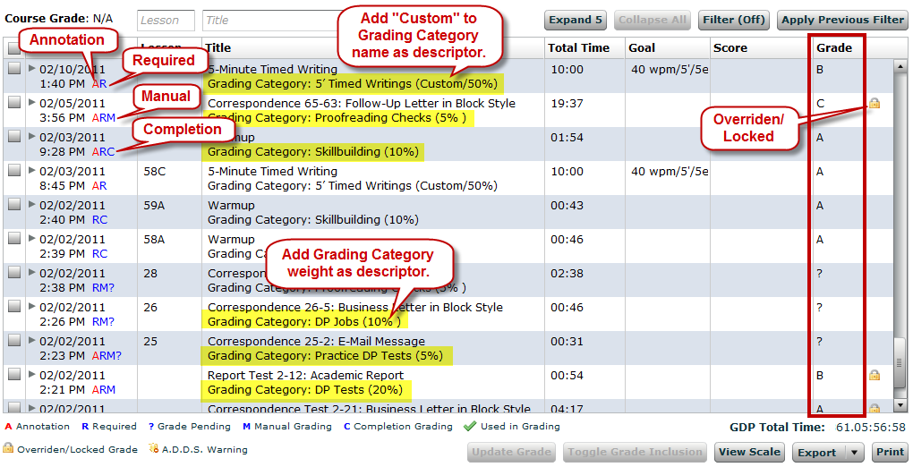

- Students can see a check designating the best attempt used for grading purposes when they use the Expand arrow to see a complete listing of multiple attempts for any exercise.
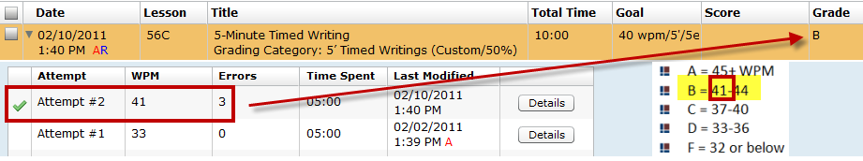

- If students point to Course Grade, they can see a Screen Tip with all the Grading Categories and the final Category Grade on any categories that have been locked down by their instructor, such as 5' Timed Writings in this example.
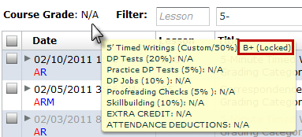

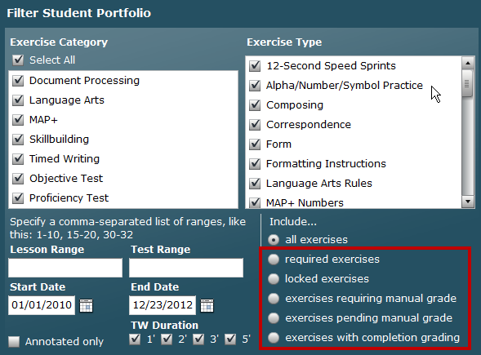
- Students and instructors can use these Advanced Filters to filter for required exercises, locked exercises, exercises requiring a manual grade, exercises pending a manual grade, and exercises with completion grading.


Tip: You will have access to a Required Exercises List that you can display and export to an Excel file, which you could assign as a File resource. Click here for details.

Assessment Plan
- Clearly delineate the Grading Categories and Weights you wish to use in your course.
- List all stipulations to be factored into any of these categories. You should be very clear in your own mind on these details before beginning so that you can configure your gradebook more easily. The assessment strategies below for Computer Keyboarding 1 are the basis for my gradebook.

50% | 5-Minute Timed Writing, 5-Error Limit, by Touch: If your timed writings are not  within the 5-error limit, 2 WPM (words per minute) will be subtracted from the GWPM (gross words per minute) for each error over the maximum number of errors allowed.
 | - A = 45+ WPM  - B = 41-44  - C = 37-40 | - D = 33-36  - F = 32 or below
20% | Document Processing Tests: Late tests will include an automatic 10% deduction.
5% | Practice Document Processing Tests: Late tests will include an automatic 10% deduction.
10% | Document Processing Jobs: All document processing jobs must be mailable (error free) to be assigned a grade of A. For document processing jobs that include errors (keystroking or formatting), the severity of the error will be considered when assigning a grade. A document assigned a D or F may be resubmitted one time by editing the document and uploading again. The lower grade will be dropped.
5% | Proofreading Checks: A successful Proofreading Check will be assigned 100%, and an unsuccessful one will be assigned 0%.
10% | Skillbuilding
Up to +10% | Extra Credit: Extra Proofreading Checks, documents, and skillbuilding. Your final course grade may be raised up to a maximum of 10% if you proofread any documents (other than designated Proofreading Checks) with 0 errors on the first Started attempt; you may also earn extra credit by completing extra skillbuilding and document processing jobs.
Up to -10% | Deductions: Excessive absences will result in deductions of up to 10% from the final course grade average.

Configure Gradebook
- Enable the Gradebook Feature. Refer to “Enabling the Gradebook” on page 5 of the “Interim Gradebook Guide.”
- If desired, create a gradebook that will serve as a template you can use for multiple classes. Refer to “I would like to create a gradebook configuration that I can use for multiple classes.” on page 34 of the “Interim Gradebook Guide.” Basically, you will create a Class with one Section to serve as gradebook template to store your gradebook configuration. Then you will copy that Class and its Section (you must check Copy Sections, as the Section holds the gradebook) and reuse the embedded gradebook by editing it to reflect the assessment specifications for the new Class. Refer to the Managing Classes & Class Preferences in Course Manager, [PDF], Section “Copy or Create New Classes in Advance of a New School Term” for details on copying a Class and its Sections. You could also wait until your gradebook is completely finished it and you have tested it in a school term before copying. Now you’re ready to configure your gradebook.

Configure Scales
- From GPS, Gradebook tab, select the desired Section from the Section box.
- From the Select Scales drop-down list, click 100-Point Scale and review it; then click 4-Point Scale, and review it. I chose to use the default 100-Point Scale.

Note: The scale you choose here is the scale IGB uses when you enter a numeric Manual grade to display the corresponding letter grade. For example, in the 100-Point Scale, if you enter a grade of 98, GDP displays the letter grade in the Grade column. Two manual grades of 95 and 85 average as 90 and display as an A-.
100-Point Scale
4-Point Scale

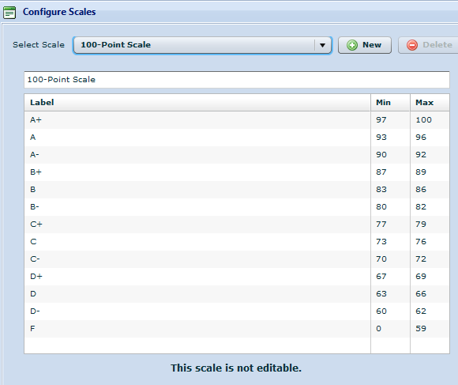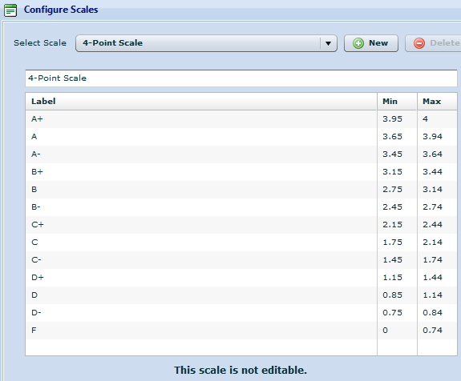

- Decide if either scale suits your needs. If you like one of the scales but prefer to change the Labels and/or the associated numeric values, create a new custom scale.

To create a new Grade Scale from a template:
- From GPS, Gradebook tab, select the desired Section from the Section box.
- Click New to create a new custom scale using either scale as a starting template.
- Edit the Labels (A+, A, and so forth) and the Min. and Max. values as desired.

Note: See “Configuring a Gradebook” on pages 8-12 of the “Interim Gradebook Guide” for more detailed steps and options.) After you create, name, and save your new custom scale, it will be available for use in the drop-down list of Grade Scales in Configure Categories.

To create a new Pass or Fail Grade Scale for Timed Writings assigned to Custom Grading:
The following information is a very specific example used to illustrate basic concepts related to a Pass/Fail Grade Scale used in conjunction with the Custom Grading Method for a Timed Writing Category. In this specific example, the Timed Writing exercise in Lesson 17 has been assigned to the Custom Grading Method in which the default wpm and error limits are in effect. Default wpm and error limits correspond to the lesson goals for a given lesson—in this example, Lesson 17 is set by default for a minimum speed of 25 wpm and a maximum error limit of 5e. A custom -1 Penalty Deduction was set for each error over 5.
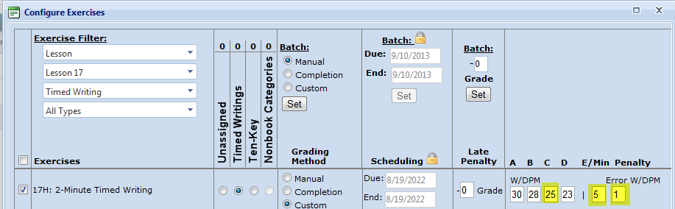

The Grade Values below were used.
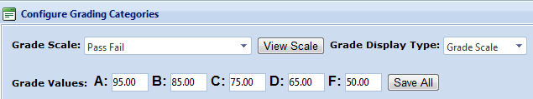

Pass Grade:
- The student will be assigned a Pass for 25wpm (or higher) and 5e (or fewer) or 26 wpm/6e (which is a net speed of 25wpm), for example.
- An exercise Minimum and Maximum grade range value of 70% to 100% is automatically assigned when a Pass is earned. If a student typed 25wpm/5e, that timing would be averaged in as a C with a Grade Value of 75% for a Pass—see the Configure Scales illustration.

Fail Grade
- The student will be assigned a Fail for 25wpm/6e (or more), for example, or 26wpm with 7e or more, for example.
- An exercises Maximum and Minimum grade range value of 69% to 0% is automatically assigned when a Fail is earned. If a student typed 25wpm/7e, that timing would be averaged in as an F with a Grade Value of 50% for a Fail—see the Configure Scales illustration.

Follow these steps for this specific example to create a Pass Fail Grade Scale:

- Click GPS, Gradebook tab, Scales button.
- From the Configure Scales window, click the New button; from the Create New Scale dialog box, next to Create from, click the Scratch option.
- In the Scale Name box, type the desired scale name (for this example, type Pass Fail; click Create.
- From the Configure Scales window, click the Add button.
- Under the Label column heading, click New Range to select the typed characters; type Pass to rename this label.
- Under the Min column heading, click 0 to select it; type 70 to change the Min value—click outside the box to accept the change.
- Under the Max column heading, the default value of 100 is correct for this example.
- Click the Add button again; under the Label column heading, click New Range to select the typed characters; type Fail to rename this label.
- Under the Min column heading, the default value of 0 is correct.
- Under the Max column heading, click 100 to select it; type 69 to change the Max value—click outside the box to accept the change.
- Click the Apply, Close.
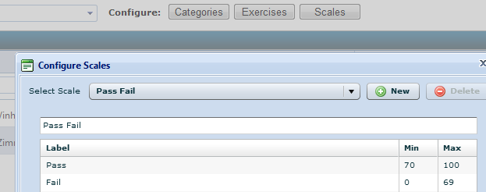

Example of the effect of the 1 WPM Penalty:
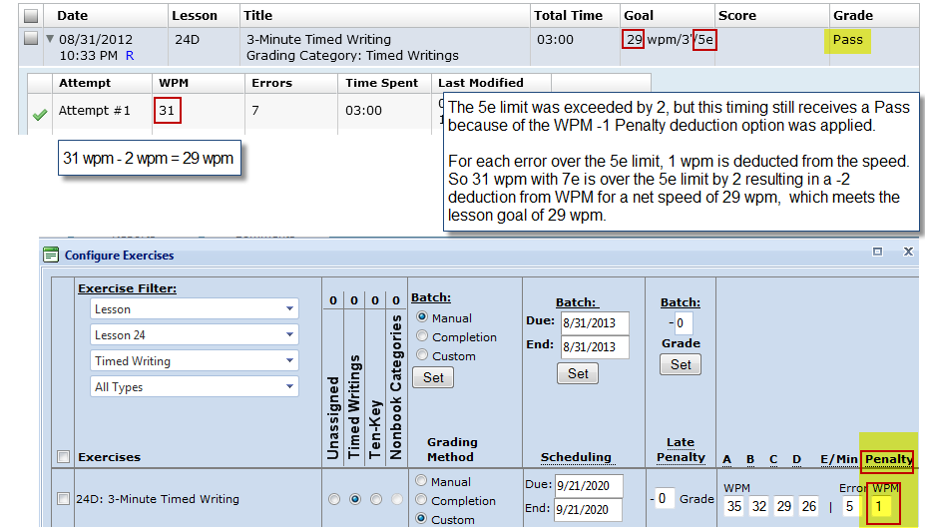

Follow these steps for this specific example to assign the Pass Fail Grade Scale:

- Click GPS, Gradebook tab, Categories button.
- From the Grade Scale box, click the newly created Pass Fail scale.
- From the Grade Display Type box, click Grade Scale.
- Set the Grade Values to the setting values shown here; click Save All, Close.

Follow the steps in Configure Exercises: WPM, E/Min Error, and Penalty WPM boxes changing the WPM, E/Min Error, and Penalty WPM boxes as applicable and desired to configure Timed Writing exercises.

Configure Grading Categories
- From the GPS Gradebook tab, click Categories.
- Click the list arrow next to the Grade Scale box, and click the desired scale—either 100-Point Scale, 4-Point Scale, or a new custom scale you created. The scale you choose has these effects:

  - When you manually enter or override grades, you will use the numeric point values in the selected the scale; for example, use either 97-100 or 3.95-4.0 to assign an A+.
  - GDP averages the numeric values to arrive at the appropriate letter grade category or course grades.
  - The grade is displayed as a letter if you elect to display grades as letter grades, as explained in step 3. For example, if you chose the 100-Point Scale and wanted to enter a manual grade to be displayed as A+, you could enter 97, 98, 99, or 100 for a more mathematically precise grade; if you chose the 4-point scale, you could enter any number in the range of 3.95 to 4.0.

- Click the list arrow next to the Grade Display Type box, and select Percent, Numeric, Grade Scale, or Ratio; this is a cosmetic choice that determines how your grades will be displayed in the Grade column of the Portfolio and in other places in the gradebook.

Note: Grades are always entered as a numeric value and averaged as a numeric value and displayed as a numeric value in the Update Grade boxes for Keystroking (when applicable), Format (when applicable), and Exercise and in the Score column (when applicable). From this point forward, keep in mind that the 100-Point Scales and its default values for the various letter grades I chose in Configure Categories will be the grading scale for my gradebook.

  - Percent: If I enter a manual grade of 95 or IGB assigns an automatic grade of 95, it displays in the Grade column as 95%.
  - Numeric: If I enter a manual grade of 95 or IGB assigns an automatic grade of 95, it displays in the Grade column as 95 without the percent sign.
  - Grade Scale: If I enter a manual grade of 95 or IGB assigns an automatic grade of 95, it displays in the Grade column as an A. (Grade Scale is the Grade Display Type of choice in my IGB.)
  - Ratio: If I enter a manual grade as 95 or IGB assigns an automatic grade of 95, it displays in the Grade column as 95/100.

- In each Grade Values box for A, B, C, D, and F, enter the desired values; click Save All to save all configurations—clicking Save All is a very important step, so remember to take it!

Note: These default Grade Values were carefully chosen as the median value for the grade range, except for the F, which is set to average in as 50%. If you change the F value to 0%, for example, keep in mind that assigning the F a value of 0% will grossly outweigh other grades when the grades are averaged and skew the student’s score downwards. The values for the 4-point scale have been determined in the same manner. If you decide to change these values and you wish to be consistent with the chosen Grade Scale, you must create a new custom scale.

- Note: These five grade values for A, B, C, D, and F (without plus or minus breakdowns) are used by IGB to assign automatic grades for Custom or Completion grading methods. The default numeric grade values in each box are the median value for the letter grade based on the 100-Point Scale with the exception of the F value. Using an F value of 50 rather than some number from 0-59 assures that grades will average without downwardly skewing any F grades. In my gradebook, only the categories of 5' Timed Writings (Custom/50%) and Skillbuilding (10%) have been configured for automatic grading. From this point forward, these Configure Categories settings are in effect for my IGB:
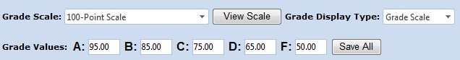

Create Categories and Assign Weights Based on Your Course Assessment Strategies
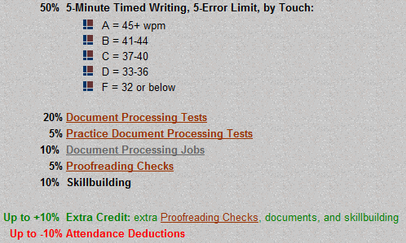
Next, I will name each category and assign weights based on my course outline specifications. You should also have your course outline handy with all your assessment strategies spelled out so that you can more easily draw parallels between my IGB and the one you envision for your own course.

Try to decide in advance which Grading Method (Manual, Completion, or Custom) you will use for each category. Review my choices carefully so you will understand why I made them.

Here are the naming conventions I followed as I assigned names to each Grading Category:

- I kept category names concise, but descriptive.
- I included the Grading Method in use and its weight in parentheses at the end of each Category Name. Identifying the weight will help students know where best to concentrate their efforts. Identifying the Grading Method will help me remember the following:

  - For my automatic Completion and Custom categories, IGB will take over and assign grades, including incorporating any late penalties I might have configured using these numeric grade values, and will then display the corresponding letter grade. I’m losing some granularity in grading values by using an automatic method of grading:

  - For my Manual categories, which include everything else, I can enter a grade using any number I like for a much more precise (granular) grade assignment. If I wish to penalize for late work, I must consult a list of due dates and compare it to the Date recorded in the Date column of the Portfolio. These numeric grades and their corresponding letter values are based on the 100-Point Scale I chose earlier.

Here is a list of my Grading Category names:

- Custom Grading Method: 5' Timed Writings (Custom/50%) tells me that for this category, IGB will be assigning automatic grades based upon Custom configurations for timed writings I will set when I configure Exercises later. Once I configure the timed writings, no further action will be necessary on my part in terms of assigning grades for timed writings unless I choose to manually override any automatic grade. I chose not to build in any automatic late penalties.
- Manual Grading Method: DP Tests (20%), Practice DP Tests (5%), DP Jobs (10%), and Proofreading Checks (5%) reminds me that for each of these categories, I will need to enter one manual grade for each document I include in this category when I use Configure Exercises later. I must manually incorporate any late penalties I might wish to enforce. Students can see the abbreviation M for Manual Grading Method work under the date in the Date column.
- Completion Grading Method: Skillbuilding (10%) tells me that for all assigned skillbuilding, IGB will calculate automatic grades based upon skillbuilding routines I will designate as part of this category when I configure Exercises later. I have built in automatic late penalties. Missing work is assigned an automatic grade of F until it is submitted, and late penalties do not apply to missing work. Students can see the abbreviation C for Completion work under the date in the Date column.
- Nonbook Categories: EXTRA CREDIT and ATTENDANCE DEDUCTIONS are typed in all caps and are weighted as 0, which tells me these are categories that do not have specific skillbuilding routines or document processing jobs assigned to them. I know that I will enter grades for these categories manually at the end of the semester.

Here’s how I set up and named each of my categories. 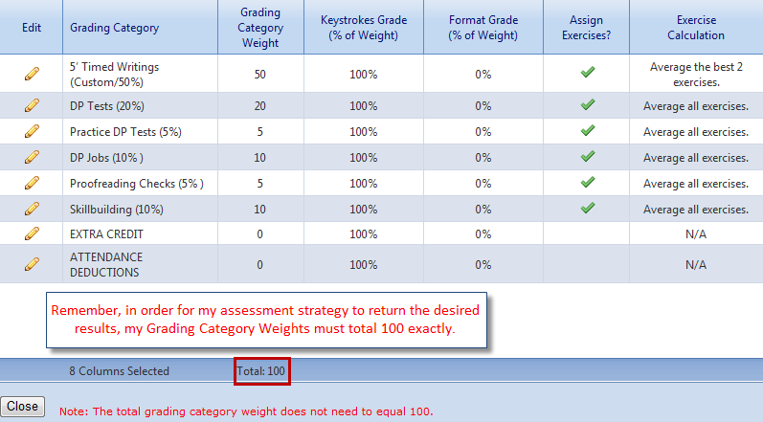

5' Timed Writings (Custom/50%)
- I named my first category 5' Timed Writings (Custom/50%), and I set the Grading Category Weight at 50 to mirror my course outline. (I followed these same conventions as I named and assigned weights to all the other categories.)
- Because a format grade does not apply to timed writings or skillbuilding of any type, you can ignore these settings.
- I checked Yes to Assign Exercises, which means that I will assign selected timed writings from the textbook to this category when I configure exercises.
- Under Exercise Calculation, Average, I set Best 2 so that IGB’s Custom grading method will automatically average the grades for the 2 best assigned timed writings (based on the WPM/error configurations specified in Configure Exercises later) to set the Category grade.
- I unchecked Always include test exercises in average so that only the “Best 2” timed writings will be included in the in the calculation of the 5' Timed Writings (Custom/50%) category average. Outcomes Assessment timed writings will be included in the average only if they are among the “Best 2” timed writings assigned for this category.

Note: If you check Always include test exercises in average, GDP will include test exercises assigned to this category in the average even if they are not among the “Best 2.” If All Exercises is chosen, this box is not applicable.

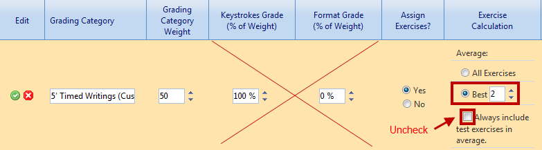

See Configure Exercises: WPM, E/Min Error, and Penalty WPM boxes for steps to use Configure Exercises to configure each assigned timed writing:
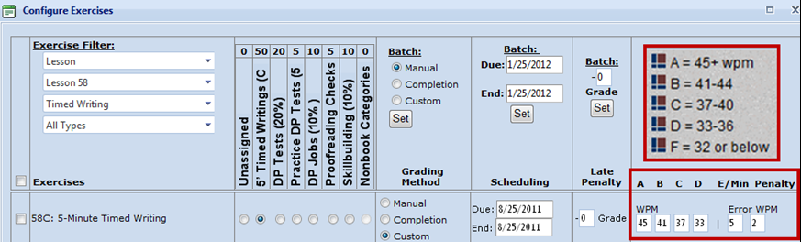

DP Tests (20%), Practice DP Tests (5%), and DP Jobs (10%)
- I named my next category DP Tests (20%), and I set the Grading Category Weight at 20 to mirror my course outline. (I followed these same conventions as I named and assigned weights to Practice DP Tests (5%), and DP Jobs (10%).
- Because I am electing the Manual Grading Method and will be assigning only one grade per document, I set Keystrokes Grade to 100% and Format Grade to 0%.
- I checked Yes to Assign Exercises, which means that I will assign selected jobs from the textbook to this category when I configure exercises.
- Under Exercise Calculation, Average, I checked All Exercises so that all required jobs will be averaged
- I unchecked Always include test exercises in average so that only the required jobs in this category will be averaged.
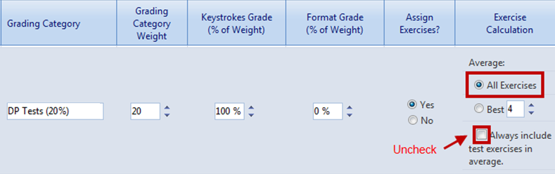

Proofreading Checks (5%)
I chose to use the Manual Grading Method for the five documents I assigned as Proofreading Checks. In my course’s assessment strategy, a successful Proofreading Check is defined as a document in which the student’s work is scored with 0 Keystroking Errors on a Started Attempt, which means the student began the job from a blank screen with no Scoring Results to refer to while proofreading the job.

In my scenario, I manually assign 100% (a grade of A+) to any successful Proofreading Check.
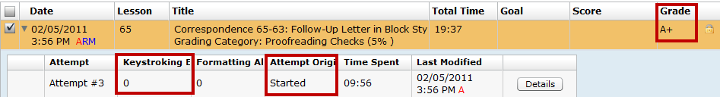

In my scenario, I manually assign 0% (a grade of F) to any unsuccessful Proofreading Check.
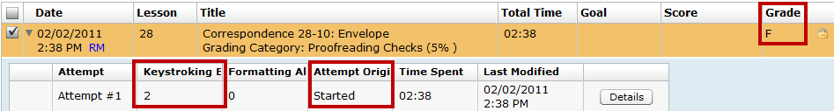

Although this attempt has 0 Keystroking Errors, it is an Edited attempt, which means the student had access to a Scoring Results window, which disqualifies it as a successful Proofreading Check.
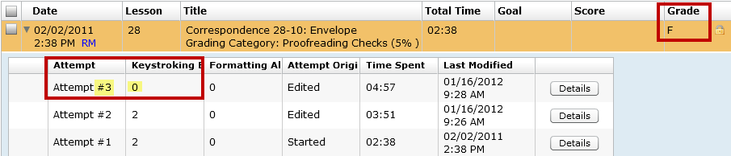

- I named my category Proofreading Checks (5%).
- I set the Grading Category Weight at 5 to mirror my course outline. I deliberately weighted this category at exactly 5% and assigned exactly 5 documents. This weighting combined with the exact number of corresponding documents and entering a manual grade of 100% for a successful attempt and 0% for an unsuccessful attempt results in a 1% increase in the final Course Grade for each successful Proofreading Check and a 1% decrease in the final Course Grade for each unsuccessful Proofreading Check.
- I set Keystrokes Grade to 100% and Format Grade to 0%
- I checked Yes to Assign Exercises, which means that I will assign selected jobs from the textbook to this category when I configure exercises.
- Under Exercise Calculation, Average, I checked All Exercises so that all required jobs will be averaged
- I unchecked Always include test exercises in average so that only the required jobs in this category will be averaged.

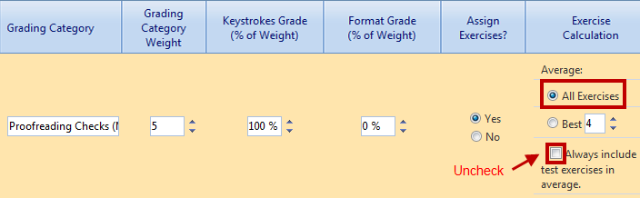

Skillbuilding (10%)
I chose to use the Completion Grading Method for all skillbuilding that will be assigned as daily work. In the Completion Grading Method, in Configure Exercises, I will configure a Due Date for each exercise so I can incorporate an automatic late penalty. Missing work is assigned an automatic grade of F until it is submitted, and late penalties do not apply to missing work. The Completion Grading Method has many grading nuances, and requires some detailed explanation before you can truly understand all its implications.

Note: If you include any “read only” exercises (no keystroking required) such as Lesson 1A and 1B or Lesson 25-E, Basic Parts of an E-Mail Message (formatting information only), such items are marked as complete only when students have viewed the screen for 5 or more seconds and then click Next. If the student clicks Next without waiting at least 5 seconds, the exercise will not be marked as complete.

- When students complete an exercise in this category on or before the Due Date assigned in
Configure Exercises, that exercise will be automatically assigned a grade of A. The numeric Grade Value of that A is set by the A value in use in the Configure Grading Categories screen. In my scenario, an A corresponds to a numeric value of 95%. If I have designated a Late Penalty of -1 Grade, for example, and the exercise is completed after the Due Date, the automatic grade assigned will be 85% (95% minus a 10% late penalty). I can set a late penalty in the range of -1 Grade to -9 Grade.

- An F is automatically assigned and averaged into the Category Grade from day one to each exercise that uses a Completion Grading Method. The grade changes from an F to an A only when the exercise is completed. The Due Date is not applicable for any exercise that is not completed—no late penalty would be enforced. The numeric Grade Value of that F is determined by the F value in use in the Configure Grading Categories screen. In my scenario, an F has a numeric value of 50%. Click here for a detailed explanation of default Grade Values.

  - So if, for example, I had two exercises assigned and one was completed on time and the other was never completed, IGB would average an A (95% in my scenario) and an F (50% in my scenario) for an average category grade of C- (72.5% in my scenario).
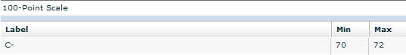

  - If, for example, I had two exercises assigned and one was completed late with a Late
Penalty of -1 Grade, and the other was never completed, IGB would average a B (85% in my scenario) and an F (50% in my scenario—late penalties do not apply to work that was never completed) for an average category grade of D+ (67.5% in my scenario).
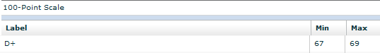

- Exercises that are assigned to this Skillbuilding (10%) category that are never completed can be found only in the Required Exercises list. This list includes a Status column that displays the number of days late or early for these exercises and their assigned grade. If you wish to override individual automatic grades for exercises that have been completed, you can do so in the Portfolio by entering a manual grade. You cannot override individual grades for exercises that have never been completed because they do not appear in the Portfolio. You can only override the Grading Category Grade in the Final Grading Category Grades screen.

- I named my category Skillbuilding (10%), and I set the Grading Category Weight at 10 to mirror my course outline.
- Because I am electing the Completion Grading Method and will be assigning only one grade per document, I set Keystrokes Grade to 100% and Format Grade to 0%
- I checked Yes to Assign Exercises, which means that I will assign selected jobs from the textbook to this category when I configure exercises.
- Under Exercise Calculation, Average, I checked All Exercises so that all required jobs will be averaged
- I unchecked Always include test exercises in average so that only the required jobs in this category will be averaged.

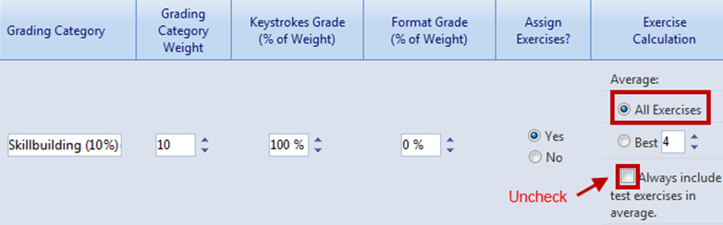

Later, I will explain these Late Penalty settings as I use Configure Exercises to configure each assigned skillbuilding exercise for completion. In this exercise, I chose an automatic Late Penalty of -1 Grade:

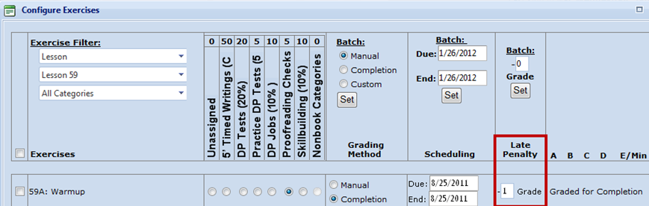

EXTRA CREDIT and ATTENDANCE DEDUCTIONS
Because the final two Grading Categories, EXTRA CREDIT and ATTENDANCE DEDUCTIONS are
“Nonbook” Categories in which exercises are not assigned, it is necessary only to name the categories (I use all caps to visually distinguish these non-exercise categories) and configure them with a Grading
Category Weight of 0 and Assign Exercises as No. Because no exercises are assigned, the crossed-out areas can be ignored.
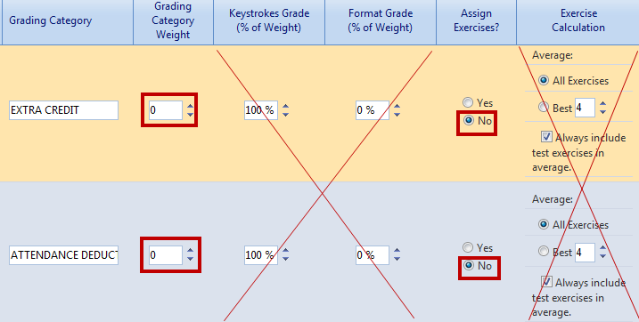

Configure Exercises
I have already described how I configured exercises in some of the Grading Categories. Now I will give some specific examples for each Grading Category. If you have a list of required exercises, such as the Progress Folder I have posted on the Assignments page of the Computer Keyboarding 1 Web site, this would be a good time to have it available. You can use it as a checklist as you decide how you want to configure all required work in your own course. You should also have your course outline breakdown for timed writing WPM ranges and your specific grading policies handy.

Configure Exercises (Custom) for 5' Timed Writings (Custom/50%)
In my scenario, my first grading policy “The best two timed writings are averaged to determine your speed.” is enforced automatically via the Best 2 setting below when I set up my Grading Categories.

Best 2 grades for timed writings: The “Best 2” grades that are used are based on the A, B, C, etc., associated with a specific WPM for a specific timed writing. In my IGB, I’m setting the same WPM scale on all the timed writings in this category. If you are setting lower timed writing WPM speeds for the timed writings in earlier lessons, understand that IGB averages the “Best 2”
grades, not the best WPM! I unchecked Always include test exercises in average to be sure that only the “Best 2” timed writings are included.

I chose not to assign late penalties to this category, so I will not set any as I configure exercises in this category. To set the WPM numbers in the A, B, C, and D boxes, I must refer to the breakdowns specified in my grading policies.

- I entered the minimum wpm for each letter grade: A, 45; B, 41; C, 37; D, 33; there is no box for F—anything below a D, 32 or below, will return an F.
- I entered 5 in the Error box since that is the maximum allowable limit for errors.
- I entered 2 in the Penalty WPM box to mirror my grading policy: “If your timed writings are not within the 5-error limit, 2 wpm (words per minute) will be subtracted from the GWPM (gross words per minute) for each error over the maximum number of errors allowed. For example, if your speed was 40 and your errors were 6, your NWPM (net words per minute) would be 38.”
Note: In Configure Exercises, you must enter a value in the E/Min Error box and a value in the Penalty WPM box to return an automatic grade that enforces your maximum error limit! See the next section for details.

Configure Exercises: WPM, E/Min Error, and Penalty WPM boxes
In order for the E/Min Error box (the value here represents the maximum allowed error limit for a timing) to have any effect on the grade assigned to a given timed writing, you must also enter a value of 1 or greater in the Penalty WPM box (the value here represents the number subtracted automatically from the WPM for each error over the maximum number of errors allowed to arrive at a net speed). For example, if you set E/Min Error box to 5 and the Penalty WPM box to 1, and a student types 45 wpm with 9 errors, the net speed would be 41 (45 – 4), with an automatic grade of B returned. If you set E/Min Error box to 5 and the Penalty WPM box to 0 (the default), and a student types 45 wpm with 50 errors, an automatic grade of A would be assigned—your maximum error limit of 5 has no effect on the automatic grade, which is probably not your intent.

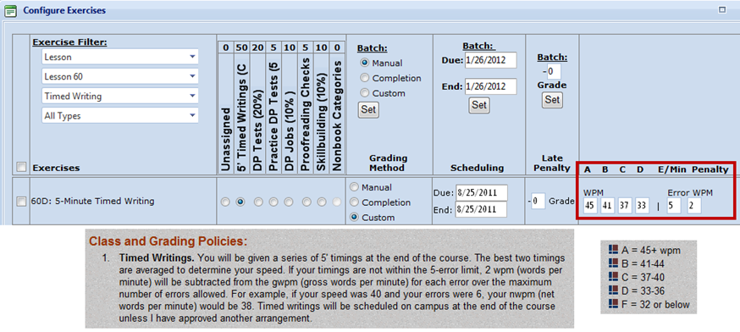

Note: IGB will automatically calculate timed writing results for the “Best 2” timed writings without any manual input from this point forward. I will continue using the Exercise Filters and manually enter this information for every Timed Writing I wish to assign to this category. I unchecked Always include test exercises in average to be sure that only the “Best 2” timed writings are included.

These WPM scales and their associated letter grade have many grading implications:

- Any assigned timed writing within the 5-error limit that is 45 wpm or faster will be assigned a grade of A and averaged as 95%. If I wish to have more granularity in the grade (for example, I want a timed writing at 46 wpm or higher to be assigned an A+ and averaged as 100%), I must override IGB’s automatic grade assignment for that timed writing and enter a manual grade in the Portfolio.

- If one of the two best attempts for the grading period is 37 wpm/2e, for example, IGB automatically assigns a grade of C and average this best attempt as 75%. To have a more granular grade breakdown for each speed in the C range of 37-40 wpm as shown in my course outline, I must override IGB’s automatic grade assignment for that timed writing. In this example, I want 37 wpm
to average as 71% (not the automatic 75%). I must use Update Grade to enter a manual grade of 71. The timed writing grade for this best attempt would update and display as a C- rather than a C.
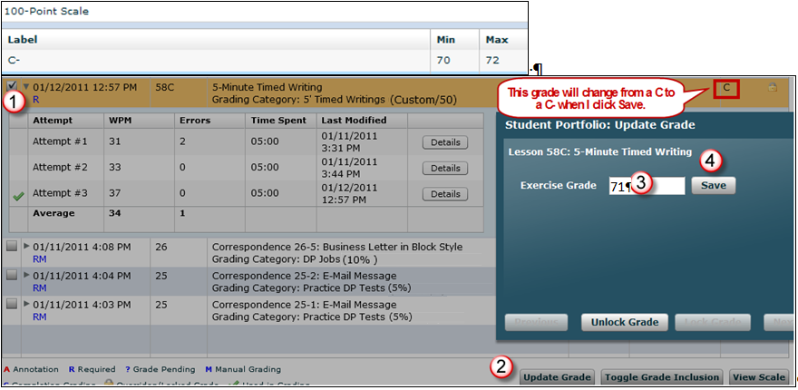
After I enter a manual grade of 71, the letter grade updates to reflect a more granular grade.

Columns B and C show the WPM and desired % breakdown as shown in my course outline, which are the standards I want to enforce for the two best timed writings of the grading period. Therefore, I will need to manually enter grades for any timed writings that are at 40, 38, or 37 wpm; otherwise, IGB will assign all these speeds the same grade of C averaged as 75%.

Automatic  Custom  Grade | WPM | Course Outline  Desired %  Breakdown | Grade  Entry  Method
C (75%) for  37-40 wpm | 40 | 78% | Manual
C (75%) for  37-40 wpm | 39 | 75% | Automatic
C (75%) for  37-40 wpm | 38 | 74% | Manual
C (75%) for  37-40 wpm | 37 | 71% | Manual

You might wonder why you would use a Custom automatic grade if three out of the four grades in a typical range must be entered manually. The answer is that IGB will automatically and continuously check for the two best timed writings throughout the grading period. As better timed writings appear, the grades remain visible in the Grade column, but the lower grades automatically drop out from the grades to be included when calculating the category grade. At the very end of the semester, if I want more granularity in the final category grade average, I will have to enter only two manual grades for the two best timed writings of the semester.

Custom grading of timed writings is a very powerful feature. If you set the same WPM standards for all timed writings in the semester, students should continuously see the automatic grades assigned to their best timed writings improve throughout the grading period, which will be highly motivational. If you use the default WPM values for the timed writings, these WPM values increase to reflect the WPM goals in the lesson. So if a student is keeping pace with the lesson goals stated in the textbook, they might see continuous As, Bs, Cs, and so forth.

I will inform my students that at the end of the grading period, a more granular grading scale will be used so that timed writings at the higher end of the WPM range will be rewarded with a higher grade (in my example, higher than a C at 75%) and timed writings at the lower end of the WPM range will be penalized with a lower grade (in my example, lower than a C at 75%).

At the end of the grading period, IGB will average the grades (not the WPM) for the two best timed writings and assign the 5' Timed Writings (Custom/50%) grading category a final category grade based on the 100-Point Grade Scale applied to all Grading Categories.

Configure Exercises (Manual) for DP Tests (20%), Practice DP Tests (5%), and DP Jobs (10%)
Assigning exercises to these categories requires only that you set Exercise Filters to display the desired jobs in the most efficient way, click each desired job, click the desired Grading Category, and set the Grading Method to Manual. If a student has multiple attempts at one exercise, IGB will use the attempt you assign the Manual grade to when averaging the Category Grade.

In the Scheduling column, there’s no need to schedule any desired due dates because Manual grading methods do not enforce any automatic late penalty. Therefore, if you do wish to enforce a late penalty, you will need to examine the Date column in the Portfolio and incorporate any late penalty into your manual grade entry. The Due dates will show up in the Required Exercise List (REL) report along with the submission date. The REL reports the number of days late or early. So if you want to track that information, you might want to set a date here. Keep in mind that you can export the REL report and use that data however you wish.

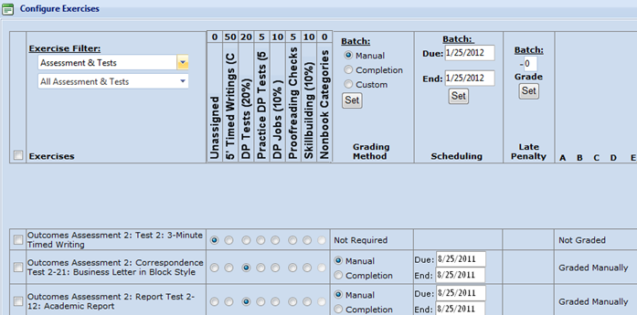

If you wish to use Scheduling to schedule an End Date, the result will be that on the day after the End Date, that item will no longer be accessible on the GDP lesson menu. If students select that item from the GDP menu after the end date, a pop‐up message will alert them that they may not access that exercise. This End Date Scheduling feature is useful if you wish to control access to practice test documents or regular test documents. For details, see the Resources & Tests page, Scheduling and Report Strategies for Testing.

Configure Exercises (Manual) for Proofreading Checks (5%)
To assign exercises to this category, I set Exercise Filters to display the desired jobs in the most efficient way, clicked each desired job (in this case, only Correspondence 27-6), clicked the desired Grading
Category, and set the Grading Method to Manual. I chose to set Exercise Filter to display by Lesson, only Lesson 27, only Document Processing, and only Correspondence. I assigned only five documents as Proofreading Checks, so this went very quickly.

There’s no need under Scheduling to schedule any desired Due Dates because Manual grading methods do not enforce any automatic Late Penalty. Therefore, if you do wish to enforce a late penalty, you will need to examine the Date column in the Portfolio and incorporate any late penalty into your manual grade entry. The Due dates will show up in the Required Exercise List (REL) report along with the submission date. The REL reports the number of days late or early once the item is submitted. So if you want to track that information, you might want to set a date here. Keep in mind that you can export the REL report and use that data however you wish. If you wish to make the item inaccessible after a date, add an End Date.
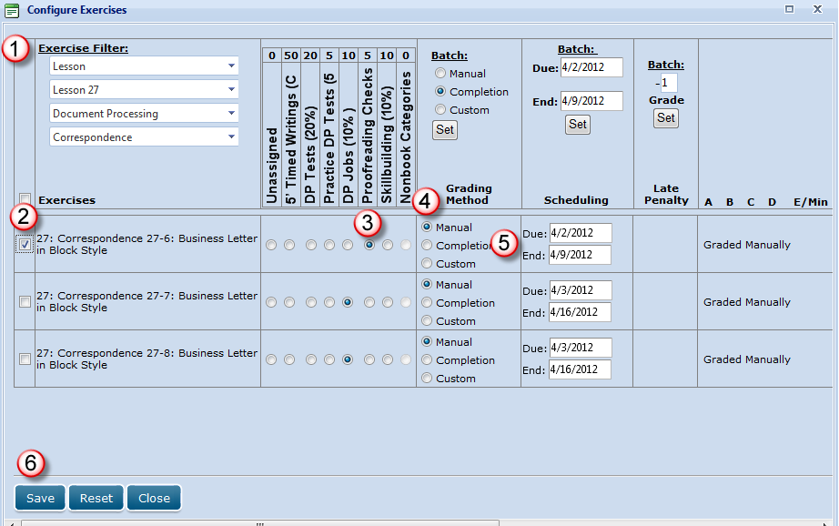

Configure Exercises (Completion) for Skillbuilding (10%)
Because I want to assign only skillbuilding exercises to this Skillbuilding (10%) category, I set the Exercise Filter to Skillbuilding and continued through each configuration column in sequence as indicated by the numbered callouts. For Lesson 1, I wanted the specific due date to correspond to the end of the first week of that grading period so that GDP would apply an automatic -1 Grade Late Penalty for late work. I then proceeded in like manner through all exercises in this category.

Note: This process will take a long time as I require skillbuilding from all 60 lessons to be completed by the end of the semester. However, once it’s done, IGB takes over and assigns all these Completion grades automatically. As you do this, you will learn to set your filters in the most efficient way possible in conjunction with the desired Batch settings. In the Exercises column, always place a check in the checkbox next to the desired exercise when you are configuring an exercise initially and particularly when you are using the Batch feature. In this way when you click Set, your Batch configurations will be applied to all checked exercises. If you place a check next to Exercises, all exercises on that screen will be checked all at once.

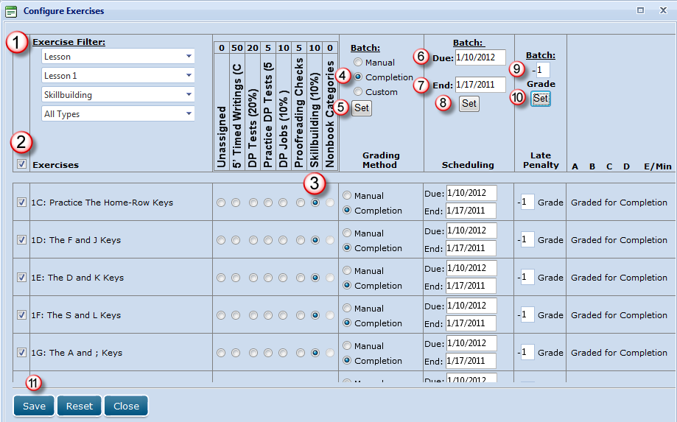

Crosscheck IGB’s Required Exercises List Against Yours for Accuracy
When you are completely finished assigning exercises, if you have a list of required exercises, such as the Progress Folder I have posted on the Assignments page of the Computer Keyboarding 1 Web site, that you used as you configured your exercises, this would be a good time to have it available.

To display the Required Exercises List (REL):
- From GPS, Gradebook tab, select the desired Section from the Section box or click Students, Students tab.
- Click the Required Exercises List icon next to any student in the Section.


- Set the Grading Category filter to display each category. (In this example, I’m verifying only the DP Tests (20%) category.
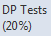
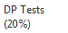
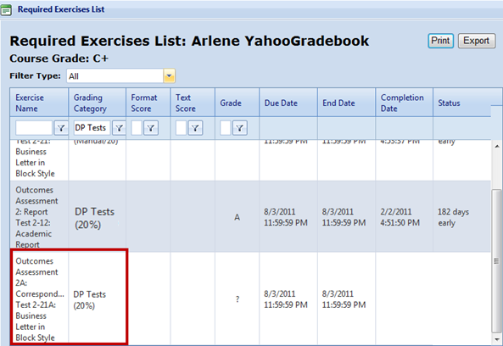

To export a generic REL:
- Click the Export button (upper right-hand corner) and Open or Save to export the list as an Excel file.
- In Excel, delete any columns that contain student-specific information.
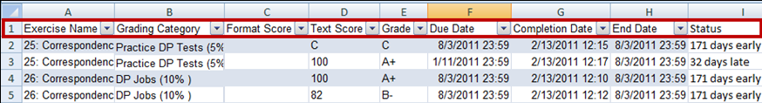

- Use Excel’s drop-down sort list in Row 1 to sort by Exercise Name and Grading Category to expedite crosschecking of entries with your own list; then make any adjustments as needed by revisiting Configure Exercises as needed.

To post a generic REL as a File Resource:
Tip: You can assign this Required Exercises List as a File resource rather than creating a Progress Folder manually. Just rename the exported file to something generic such as Required Exercise List.xls, delete any columns specific to a student (Columns C, D, E, G, and H), and keep only Exercise, Grading Category, Due Date, and End Date. See the file Managing Resources in Course Manager, “To create, assign, and schedule a File resource” for details. Here’s what part of this file might look like:
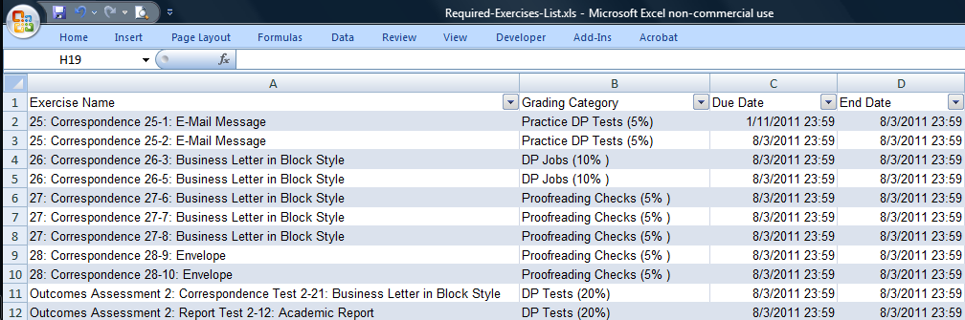

Identify Missing Required Exercises (pending work) via the REL
Students can filter their Portfolio using the Advanced Filter to display only required exercises, locked exercises, exercises requiring manual grade, exercises pending a manual grade, and exercises with completion grading. However, the Portfolio does not have a way to display pending (never completed) required exercises. The REL can be used to display missing work, but only instructors have access to that list via Course Manager. Here are some steps you can take to generate a list of missing work via the REL and export and post a generic REL as a File Resource accessible to students via My GDP.

To display a list of pending exercises via the REL:
To display the REL, click GPS, Gradebook tab and select the desired Section from the Section box or click Students, Students tab; next to the desired student, click the Required Exercises list icon to display the REL.

Click the Completion Date column heading to sort by Completion Date. All the required exercises with a blank Completion Date box will appear first in the list. Note an F is assigned by default to each missing exercise or job under the Grade Column. If you used Scheduling to schedule any desired Due Dates or End Dates, these dates will show up in the Required Exercise List (REL) report along with the Completion Date and a Status report.
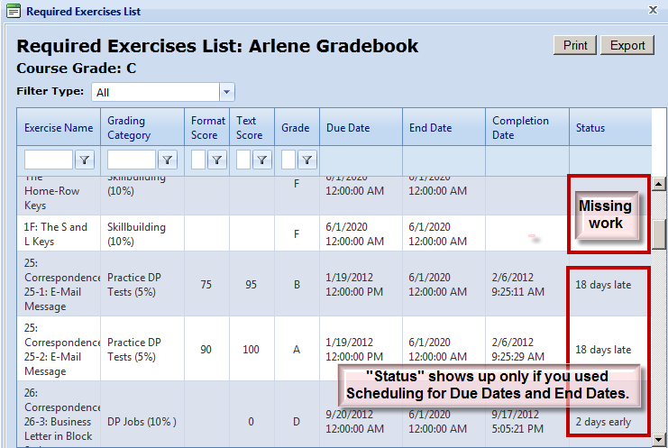

You can click inside the Exercise Name box for the first item in the REL, drag down through the last blank Completion Date item and across to select, copy, then paste this list identifying all missing work into an email to the student. You could also click Export to send the REL to Excel and copy/paste from there in like manner or send the entire spreadsheet as an e-mail attachment.
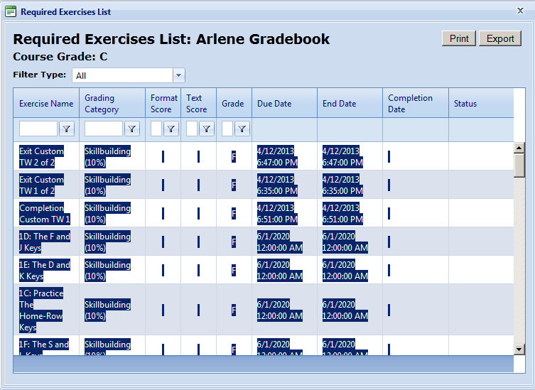

Here is an example of a pasted REL with a list of missing exercises. You could delete extraneous columns or add a row with column headings if desired.
Exit Custom TW 2 of 2 | Skillbuilding (10%) |  |  | F | 4/12/2013 6:47:00 PM | 4/12/2013 6:47:00 PM
Exit Custom TW 1 of 2 | Skillbuilding (10%) |  |  | F | 4/12/2013 6:35:00 PM | 4/12/2013 6:35:00 PM
Completion Custom TW 1 | Skillbuilding (10%) |  |  | F | 4/12/2013 6:51:00 PM | 4/12/2013 6:51:00 PM
1D: The F and J Keys | Skillbuilding (10%) |  |  | F | 6/1/2020 12:00:00 AM | 6/1/2020 12:00:00 AM
1E: The D and K Keys | Skillbuilding (10%) |  |  | F | 6/1/2020 12:00:00 AM | 6/1/2020 12:00:00 AM
1C: Practice The Home-Row Keys | Skillbuilding (10%) |  |  | F | 6/1/2020 12:00:00 AM | 6/1/2020 12:00:00 AM
1F: The S and L Keys | Skillbuilding (10%) |  |  | F | 6/1/2020 12:00:00 AM | 6/1/2020 12:00:00 AM

To further filter the list, from the Filter Type box, click Part, Unit, or Lesson.
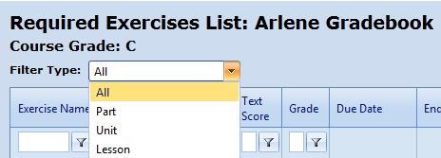

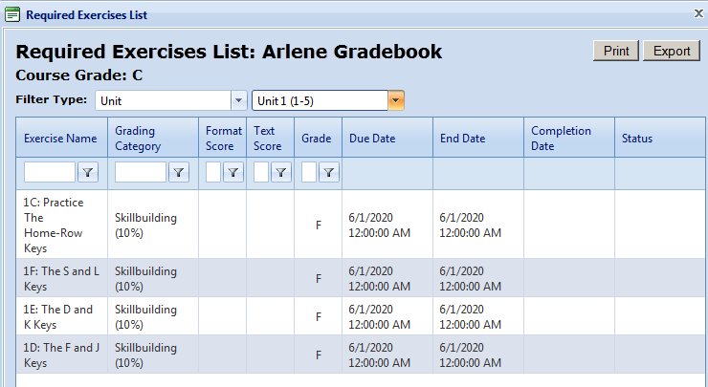

You could also make students responsible for tracking their own missing work by exporting and posting a generic REL as a File Resource. Making students responsible for managing their own work is a reasonable and easy alternative to the preceding suggestions. If desired, you could create a customized Progress folder such as the Progress Folder I have posted on the Assignments page of the Computer Keyboarding 1 Web site. You could create a custom spreadsheet for grading such as the spreadsheet I posted on the Assignments page of the Computer Keyboarding 1 Web site. Keep in mind I used this spreadsheet to calculate grades before IGB was available.

Enter Grades for Nonbook Categories: EXTRA CREDIT and ATTENDANCE DEDUCTIONS
Because the final two Grading Categories, EXTRA CREDIT and ATTENDANCE DEDUCTIONS are “Nonbook” Categories in which exercises are not assigned, the process of configuring exercises does not apply. These category grades must be manually entered at the end of the grading period.

In my Keyboarding 1 course (and in my Keyboarding 2 course), I use a spreadsheet to track EXTRA CREDIT for in these two areas: (1) Proofreading (assigned documents other than Proofreading Checks that are proofread on a Started attempt with 0 keystroking errors) and (2) Documents (additional unassigned documents that were completed successfully). If you are interested, download my Excel spreadsheet for Keyboarding 1. Note the information in the following cells:

- Cell C32: EXTRA CREDIT, Proofreading
In Row 34 and 36, click in the box under the desired job and click the desired grade from the drop-down list. To remove a grade, click in the box and press Delete.
- Cell C37: EXTRA CREDIT, Documents
Row 38: Type the document id number. The spreadsheet will automatically assign 1% point of extra credit for every 3 documents completed.

In my Keyboarding 1 course (and in my Keyboarding 2 course), I use the same spreadsheet to track ATTENDANCE DEDUCTIONS. Note the information in the following cells:

- Cell C39: ATTENDANCE DEDUCTIONS, Absences
In Row 41, type a 1 under the week in which the student was absent. The spreadsheet will automatically add the absences for the term and enter the amount to be deducted from the final course grade in Cell C35.

Once you have determined the total points to be added for EXTRA CREDIT and the total points to be deducted for ATTENDANCE DEDUCTIONS, go to the GPS Grading tab, click the desired student; then click Edit Selected Student Grade. From the Edit Final Grading Category Grades dialog box, enter the desired amounts for each Nonbook Category.

Note! In this example, note that these Nonbook Categories are weighted at 0. This means that regardless of the numbers I enter for each category, the course grade of 83.43% remains unchanged. Entering numbers here is simply a way for me to have a written record of the percentage points I want to add to the Course Grade for any extra credit earned (in this example, 1%) and the percentage points I want to subtract from the Course Grade for any attendance deductions (in this example, -3%).
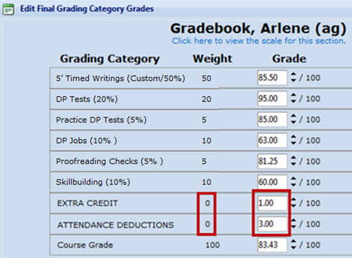

Factoring +1 and -3, results in a net deduction from the final Course Grade of -2% for a final grade of 81.43% (83.43% - 2% = 81.43%). At this point, I can either manually override the Course grade of 83.43% and replace it with 81.43% and lock in that Course Grade or I can just leave it at 83.43% knowing that when I submit my final grades for school records, I will adjust it accordingly.

Use Lock Grade and Unlock Grade for Individual Grades
It is important to understand the ramifications of locking and unlocking individual grades for grades that are entered manually and for grades that are calculated automatically by GDP.

Locks and Manual Grading Method

To lock a Manual grade:
Note: When you enter a Manual grade or override an automatic grade, that grade is automatically locked and displays a lock icon. In the case of manual grades, the lock is simply a visual cue that you will not accept further attempts for that item. Therefore, enter Manual grades for specific exercises only at the point where you would not accept later submissions or attempts. A locked manual grade does not prevent you from further editing of the grade nor does it prevent further submissions from students. The grade can be edited without unlocking, and you can unlock the grade at any time.

- Select the desired exercise in the Portfolio.
- Click Update Grade, enter the desired grade, and click Save.

Note: Before saving this Manual grade, note that there is a ? in the Grade column of the Portfolio, and no lock icon is present. After you click Save: (1) the ? is replaced by the assigned grade and a lock icon displays to the right of the grade in the Grade column, (2) the Lock Grade and Save buttons dim, and (3) the Unlock Grade button becomes active. The lock icon is hard to distinguish, so look carefully.

To unlock and reset a Manual grade:
Note: Unlocking a manual grade returns the exercise to the ungraded state—in this case, the grade would revert to a ?. The ? is a visual cue that you will continue to accept additional work submissions.

- Select the desired exercise in the Portfolio
- Click Update Grade, Unlock Grade.
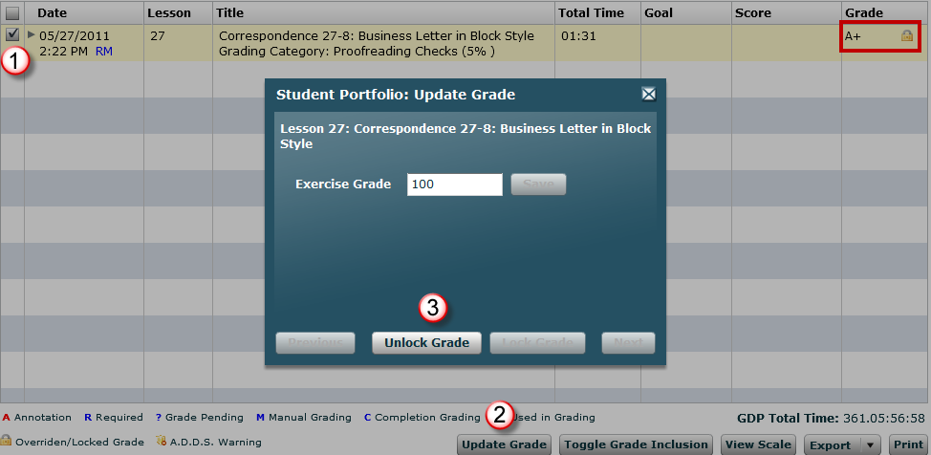

Locks and Automatic Completion and Custom Grading Methods
A locked grade that has been calculated automatically by GDP using a Completion or Custom Grading Method will not be automatically changed (either raised or lowered) by GDP even if the student submits additional attempts. This ensures that further submissions of student work will not affect the related exercise grade. For example, Attempt #1 was locked for a grade of D. Even though the student made a second attempt after that for a higher speed of 41 WPM, which would have raised the grade to a B, the second attempt was ignored by GDP for grading purposes.
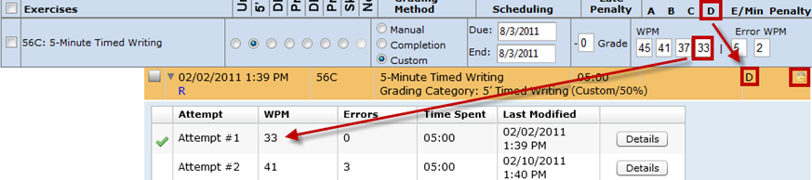

A locked manual grade does not prevent you from editing of the automatic grade nor does it prevent further submissions from students. It just means that further submissions from the students (either better or worse) will be ignored by GDP for grading purposes. The grade can be edited without unlocking, and you can unlock the grade at any time.

To lock an automatic grade:
- Select the desired exercise in the Portfolio.
- Click Update Grade, and click Lock Grade.

Note: A locked grade does not prevent you from further editing of the grade nor does it prevent further submissions from students. The grade can be edited without unlocking, and you can unlock the grade at any time.

To unlock and reset an automatic grade:
Note: Unlocking an automatic grade returns the exercise to the autograded state—in this case of a timed writing, the grade would revert to the numeric grade associated with the WPM boxes set when the timed writing was configured. Any unlocked grade remains open to further update by additional work submissions.

- Select the desired exercise in the Portfolio.
- Click Update Grade, and click Unlock Grade.

Use Toggle Grade Inclusion
To eliminate a particular exercise from inclusion in the category grade average, click the checkbox next to the exercise and click the Toggle Grade Inclusion button at the bottom of the screen. The exercise will be dimmed in the Portfolio. Repeat these steps for any dimmed exercise to again include it in the category grade average.

Use Lock and Unlock Buttons for Grading Category and Course Grade

To lock a Grading Category and/or Course Grade:
- From GPS, Gradebook tab, Section box, click the desired Section.
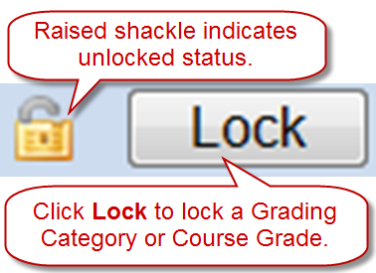
- From the Section Summary list, check the box next to the desired student.
- Click the Edit Selected Student Grades button.
- From the Edit Final Grading Category Grades dialog box, note that you will see Unlock and Lock buttons displayed.
- Note that a padlock with the shackle slightly raised appears to the left of a Lock button to indicate the unlocked status.
- Click the Lock button to lock the Grading Category and/or Course Grade.
- Note that the newly lowered padlock shackle now indicates a locked status, and the displayed button name changed to Unlock.
- Click Save.

To unlock a Grading Category and/or Course Grade:
- From GPS, Gradebook tab, Section box, click the desired Section.
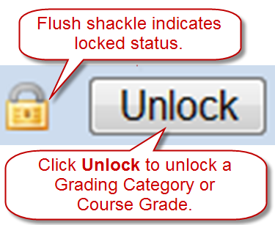
- From the Section Summary list, check the box next to the desired student.
- Click the Edit Selected Student Grades button.
- From the Edit Final Grading Category Grades dialog box, note that you will see Unlock and Lock buttons displayed.
- Note that a padlock with a lowered shackle appears to the left of an Unlock button to indicate the locked status.
- Click the Unlock button to unlock the Grading Category and/or Course Grade.
- Note that the newly raised padlock shackle now indicates an unlocked status, and the displayed button name changed to Lock.
- Click Save.

Note: Unlocking a locked grade will restore to the GDP automatic calculation of that grade, using all work submitted to date in the category. Once the final Course Grade is locked, it will be displayed in the Portfolio and in the Required Exercises List. (Until the grade is locked, N/A is displayed for the Course Grade in those locations).

Use the Portfolio and Advanced Portfolio Filters
One of the benefits of using a gradebook is the additional information available to you and your students in the Portfolio as shown in this screen shot. Also, various Advanced Filters are now applicable and can be used.

- Students can see the Grading Category and the category weight for each assigned exercise and will therefore know where to best concentrate their efforts.
- In the Grade column, students can see their assigned grade and see a Lock or Unlock icon next to it to know whether their instructor will accept any additional attempts on that item.
- At the bottom of the screen, students can see the abbreviations R for Required work, ? for Grade Pending, M for Manual Grading, and C for Completion Graded jobs.
- They can see a check designating the best attempt used for grading purposes for that exercise when they use the Expand arrow to see a complete listing of multiple attempts for any exercise.

Note: Keep in mind that a checked attempt is the best attempt used to calculate the grade for that individual exercise but the grade on that attempt is not necessarily the grade that will be used/included when IGB calculates the category grade. In my course, it would be used only if that attempt is one of the “Best 2” attempts for the 5' Timed Writings (Custom/50%) category.
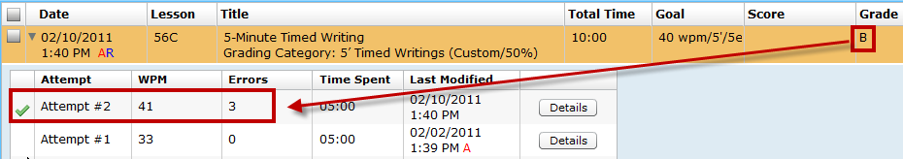

- If students point to Course Grade, a display of all the Grading Categories and the final Category Grade on any categories that have been locked by their instructor will appear; for example, “B” is the category grade for 5' Timed Writings (Custom/50). Locking a category does not place a lock icon on individual grades within that category. However, when a category grade has been locked, any additional attempts in a given category will be ignored until the category grade is unlocked. Refer to page 31 of the “Interim Gradebook Guide” for information on locking category grades and the final course grade.

- They can use these Advanced Filters to filter for required exercises, locked exercises, exercises pending a manual grade, and exercises with completion grading.

Copy Gradebook
See Configure Gradebook, step 2.

If you prefer to copy your gradebook after you have used it for a term and know it is tried and true, copy the Class and its Section (s) with the desired gradebook and be sure to check Copy Sections when you copy the Class because the Section is what holds the gradebook. Refer to the Managing Classes & Class Preferences in Course Manager, [PDF], Section “Copy or Create New Classes in Advance of a New School Term” for details on copying a Class and its Sections. Refer to “I would like to create a gradebook configuration that I can use for multiple classes.” on page 34 of the “Interim Gradebook Guide.” Edit Class and Section names as desired and edit the embedded gradebook as desired to reflect the assessment specifications for the new Class. An Administrator can copy one instructor’s gradebook to another instructor at the same school by using the Copy Class command. When the Class is copied, the gradebook goes with it. After the Class has been copied, it would be assigned to the new instructor.

Troubleshoot
If your gradebook is not returning expected results, try this:

- If you are using a Gradebook in your course and are using Configure Exercises in order to filter to ten-key numeric keypad drills only, you must set the Exercise Filter to Category; the first subfilter to Skillbuilding; and the last four subfilters shown below one by one to achieve that result. See Ten-Key Numeric Keypad Routines [PDF] for details.

- Alpha/Number/Symbol Practice
- New Key Drill
- Pretest/Practice/Posttest
- Ten-Key Numeric Keypad
- Recheck your category configurations. Verify all details such as automatic late penalties, WPM box entries, error limits, and WPM penalties.
- If you do not want to include test exercises in your average, verify that the Always include test exercises in average box is unchecked in each category when you created categories.
- For categories that use the Completion Grading Method, keep in mind that jobs that are never submitted are assigned an automatic F by IGB. Check the Required Exercises List to see a list of non-submitted items that are lowering the Completion grade for the category.
- Check the Required Exercises List for accuracy to be sure you did not accidentally include unexpected items. (Remember you can Export the REL to Excel to view the list more efficiently.) In this example, I included Correspondence Test 2-21A by mistake. It should be
unassigned. Even when you use a Manual Grading Method as I have, IGB will still automatically average in any missing assignments as an F. In my gradebook, an F would average in as a 50%.

Configure Ten-Key Exercises
Only ten-key Timed Practice routines can be assigned to the Custom Grading Methods so that DPM (digits per minute) speed standards and maximum Error limits can be set and enforced automatically. For example:

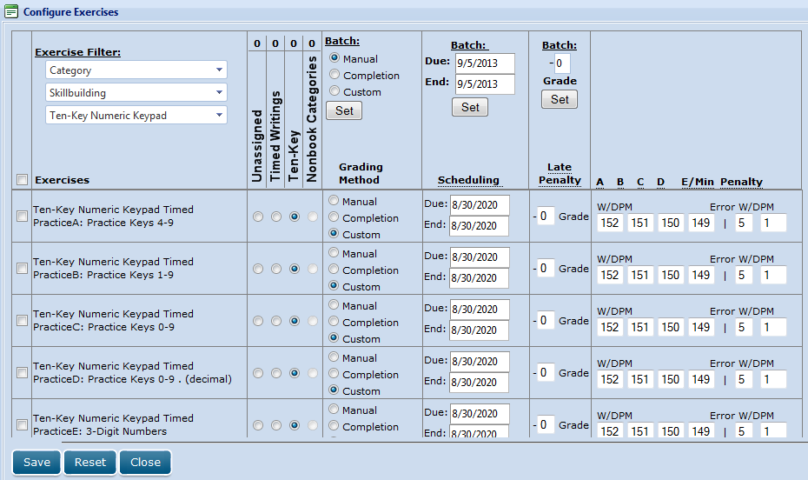

Ten-Key Numeric Keypad Timed Practice* (25 minutes) Filter
 | SL-A: Practice keys 4-9 | Ten-Key Numeric Keypad
 | SL-B: Practice keys 1-9 | Ten-Key Numeric Keypad
 | SL-C: Practice keys 0-9 | Ten-Key Numeric Keypad
 | SL-D: Practice keys 0-9 . (decimal) | Ten-Key Numeric Keypad
 | SL-E: 3-Digit Numbers | Ten-Key Numeric Keypad
 | SL-F: 3-Digit Numbers | Ten-Key Numeric Keypad
 | SL-G: 4-Digit Numbers | Ten-Key Numeric Keypad
 | SL-H: 4-Digit Numbers | Ten-Key Numeric Keypad
 | SL-I: 2- to 4-Digit Numbers | Ten-Key Numeric Keypad
 | SL-J: Short Decimal Numbers | Ten-Key Numeric Keypad
 | SL-K: Long Decimal Numbers | Ten-Key Numeric Keypad
 | SL-L: Long Decimal Numbers | Ten-Key Numeric Keypad
 | SL-M: Short and Long Decimal Numbers | Ten-Key Numeric Keypad
 | SL-N: Short and Long Decimal Numbers | Ten-Key Numeric Keypad
*Note: Gradebook allows you to set DPM (shown in Gradebook as WPM), Error, and WPM penalty when you select Custom Grading Method; WPM defaults to 0—you must enter values.

The Ten-Key Numeric Keypad Lesson, Ten-Key Numeric Keypad Enrichment, and the Numeric Keypad Pretest>>Practice>>Posttest (3-Digit Numbers, 4-Digit Numbers, Short Decimal Numbers, 1- to 4-Digit Numbers, and Long Decimal Numbers) routines can only be assigned to the Manual or Completion Grading Methods.
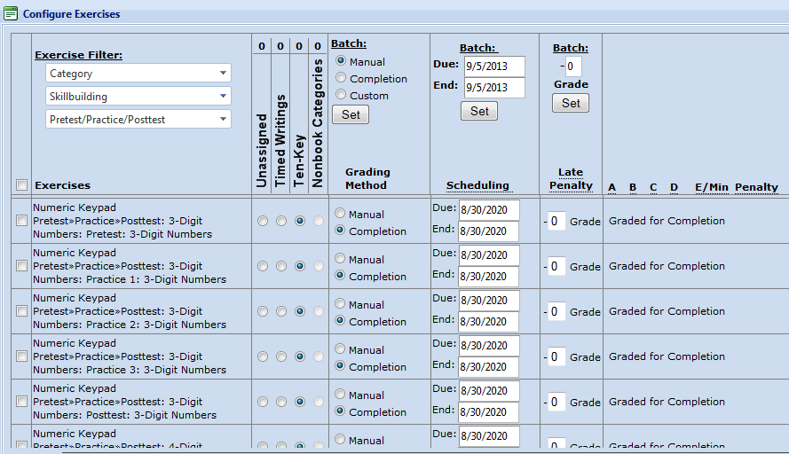

See the movie INSTRUCTOR: Ten-Key Competency (password is instructor) for ideas on how to arrive at students’ exit competency for ten-key routines via GDP’s Detailed WPM Report.

In Configure Exercises, Exercise Filter, set the first subfilter to Skillbuilding; and the last four subfilters shown below one by one to set a Grading Method to address all ten-key exercises available in GDP:

- Alpha/Number/Symbol Practice (displays Ten-Key Numeric Keypad Lesson, New-Key Review only)
- New Key Drill (displays Ten-Key Numeric Keypad Lesson, except for New-Key Review)
- Pretest/Practice/Posttest (displays Numeric Keypad Pretest>>Practice>>Posttest
- Ten-Key Numeric Keypad (displays Ten-Key Numeric Keypad Timed Practice)
See Ten-Key Numeric Keypad Routines [PDF] for helpful details on ten-key exercises including filtering for them in the Portfolio and in Excel.

