
MANAGING CLASSES & PREFERENCES IN COURSE MANAGER
Understand Instructor Roles 2
Create a Limited Instructor: 2
Create New Class (*BP) 3
Create New Class and Choose Preferences 5
Preferences—Formatting Assistant 6
Forcing Preferences from Class to Section 6
Create New Section (*BP) 7
Copy or Create New Classes in Advance of a New School Term: 8
Edit Existing Preferences for a Class or Section 10
Close Self-Registration for a Class or Class Section: 10
Create New Section in Existing Class 11
Summary of Force Preferences in All Sections 11
Edit an Existing Class Name 11
Edit an Existing Class Section Name 11
Delete an Existing Class (BP*) 12
Delete an Existing Class Section (BP*) 12
Archive an Existing Class and All Class Sections (and vice versa) 13
Archive an Existing Class Section (and vice versa) 13
Use Simulated Student 14
End-of-Term Activities 14
Delete Unregistered, Available (unassigned) Students 15
Delete Unregistered, Assigned Students 16
Archive Classes, Class Sections, and Students (BP*) 17
Consider Emptying the Portfolio for Archived Students 18
To empty a Student Portfolio—auto archive old student data: 18
To view archived student data: 18
Archive Full (registered), Available (unassigned) Students 19
Archive Full (registered), Active, Assigned Students 20
To activate an Archived student: 21
Set Self-Registration to No for Old Classes 21
Copy or Create New Classes for the Next Term and Set Registration Preferences 21
Consider Disabling Scoring in Archived Classes 21
Start-of-Term Activities 21
Reassign Returning Students 22
To reassign an Archived student: 22
To reassign an Active student: 22
To view a list of all Available (unassigned) students and Assigned students: 22
To edit the Student ID and Username of a returning student: 23
Create and Pre-Enroll New Students 23
Set Up Class Preferences and Resources for New Classes 23
Set Registration Preferences—Self Register, Enrollment Password, and Edit Profile 23


*BP: Indicates a “Best Practice” routine in GDP.
Note! The screen shots in this handout in some cases represent Classes and Sections in which the Interim Gradebook is enabled and in use. If you do not have a Gradebook enabled, your views and some features will vary. The enabling or disabling of Messaging, Resources, Formatting Assistant, Hide Format Scoring from Student, Score Keystroking, and Proofreading Viewer also affects the appearance of GDP screens:

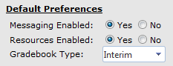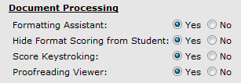

Understand Instructor Roles
There are six instructor roles: Administrator, Campus Administrator, Full Instructor, Limited Instructor, Assistant, and Inactive Instructor. See the Course Manager User’s Guide in GDP Help and Instructor Roles Permissions in Course Manager for details on the permissions for each role. One person on your campus is assigned to the Administrator role, and this person’s responsibilities will vary—check with your school regarding Administrator roles and assignments. Generally, the Administrator is charged with creating Full Instructors, Classes, and Sections for your campus.

- To create Full Instructors, see “Creating a New Instructor” in the GDP11 Course Manager User’s Guide in GDP Help.
- To change your role from Full Instructor to Administrator or add an additional Administrator, see the steps under “Instructors—Creating a New Campus Administrator” in the GDP11 Course Manager User’s Guide in GDP Help.

Full Instructor is the most common role in GDP. When the Administrator designates Full Instructors and assigns credentials (usernames and passwords), Full Instructors can log on to their school’s custom URL with their assigned credentials and get started with GDP.

Full Instructors and Administrators can create Classes and Class Sections, assign them, and add students. Consider assigning one or more individuals as Limited Instructors or Assistants to help Full Instructors administer tests, add annotations, and so forth. Check with your school regarding your own duties and assigned roles. The actions in this handout, therefore, can be accomplished by logging in either as an Administrator or Full Instructor.

Create a Limited Instructor:
- Log on as an Administrator; under Instructors, click the Create tab.
- Under Personal Information, enter the user's first and last name.
- Click the Role box list arrow, and click Limited Instructor.
- Under Contact Information, Email box, type in the desired e-mail. (The system automatically sends a message to this email address when the account is created to notify the new instructor of the username and password.)
Under Login Information, enter information in the Username, New Password, and Confirm Password boxes. (Usernames must be unique within the account.)
- Click Next to create the account. The system will verify that the account was created and display instructor details.
- From the Assign Classes tab, assign any desired Classes to the new Limited Instructor—click the desired Classes and/or Sections under Available Classes; click Add to send them to the right under Assigned Classes.

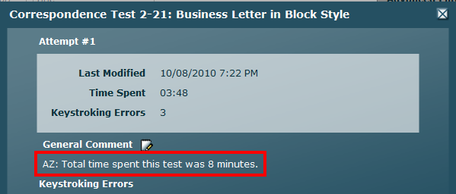
Tip: If Limited Instructors add General Comments or annotations, consider asking them to include their initials in annotations to distinguish their comments from yours.

Create New Class (*BP)
When you create a Class, a Class Section named “Default” is automatically created. Initially, you might think you should use the course name as the Class name (Keyboarding 1, for example); then create one Section for each instructor teaching that course. However, doing so can lead to inadvertently forcing Preferences, Scheduling, and Resources meant for one Class and its Sections on another Class and all its Sections. Therefore, a different approach to creating Classes is recommended as a best practice.


Best Practice! To ensure autonomy between instructors in terms of Class and Section settings, create one Class and one corresponding Section per instructor and force Class Preferences and Scheduling Preferences immediately. If an instructor teaches more than one course, create another Class and Section for that instructor for the additional course. Consider naming a Class using the instructor’s last name in caps so that Class owner is easily recognizable. If one instructor has a second course, perhaps add a number after the instructor’s name, such as MORIMOTO [1] and MORIMOTO [2]. Doing so maintains autonomy between this instructor’s Sections and can prevent inadvertent mistakes when setting Preferences and Scheduling Preferences later. See “Scheduling & Report Strategies for Testing & Document Processing” [PDF], “Scheduling—Designating Your Campus, Class, and Section,” for details.

For example, a Class might be named MORIMOTO[1] (instructor’s last name) and one Section in that Class might be named CAOT 1/F/1006/Spring 12 (departmental course name/day of class/section number/date. Adding a date distinguishes Class Sections from one semester to the next). If you forget to change the Section name, it will appear as “Default.” However, you can always go back and edit the Section name later. A second Class for that instructor might be named MORIMOTO[2] and a Section in that course might be named CAOT 1/Online/1013/Spring 11. Name Classes and Class Sections in a consistent format so they are clear, easy to recognize, and unique.


Caution! If you decide to disregard this Best Practice recommendation and choose to create one Class with multiple Sections, your school should designate one individual responsible for overseeing all Sections. That overseeing instructor should be assigned as sole instructor at the Class level. Adjunct instructors should be assigned to their own Section, not to the Class to prevent such instructors from making edits at the Class level, which would affect everyone’s Sections.
Also, the overseeing instructor at the Class level should set Yes to Force these preferences in all sections if your school wants this overseeing instructor to control settings for all Sections, thereby removing all control from the subordinate instructors. The overseeing instructor should set No to Force these preferences in all sections if your school wants to let each instructor control his or her own Section’s settings (but still start with the defaults the overseeing instructor has set).

Tip: If you decide to copy a Section to reuse it in your next school term, you won’t have to repeat Section setup routines again. Click here for details.

Class Name: MORIMOTO[1]
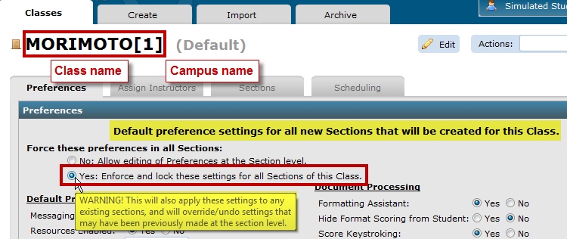

Section Name: CAOT 1/F/1007/Spring 11
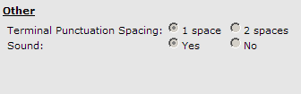
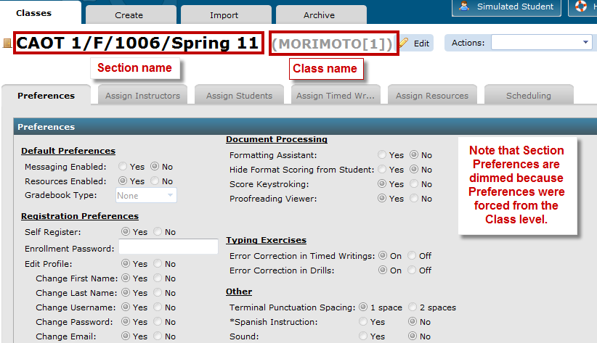

Compare these examples: Example 1 ensures the greatest level of autonomy. Such a hierarchy is more likely to achieve expected results for Preferences and Scheduling. Be sure to discuss all options with your Administrator.

EXAMPLE 1:
Each instructor (BELL) is assigned a separate Class with one Section per Class;
an instructor with more than one course (MORIMOTO) creates
two separate Classes (MORIMOTO[1] and MORIMOTO[2]), each with one Section.
Class Name: instructor last name (all caps)
Section Name: departmental course name (all caps)/meeting day/section/semester
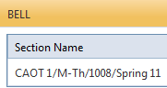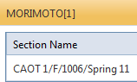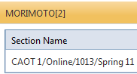

EXAMPLE 2:
MORIMOTO has two Sections under one Class because she wants
both Sections to share the same Preferences and Scheduling Preferences,
which she will force down to each Section.
Class Name: instructor last name (all caps)
Section Name: departmental course name (all caps)/meeting day/section/semester
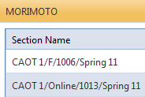

You can pre-enroll new students, adjust Class Section Preferences, and add and assign Resources to a Class, such as a course outline, assignment sheets, handouts, links to videos, or links to anything on the Internet. This powerful feature is a simple alternative to a course Web site. See “Managing Resources in Course Manager” for details.

Create New Class and Choose Preferences
- Under USERS, click Classes, Create tab.
- In the Class Title box, type the Class title (MORIMOTO, for example); click Next.
- Note that a screen with a secondary set of four tabs appears: Preferences, Assign Instructors, Scheduling, and Sections.
- From the Preferences tab, click the desired preferences, and click Save. You will see a confirmation in red under the Save button: “Your changes have been saved.”
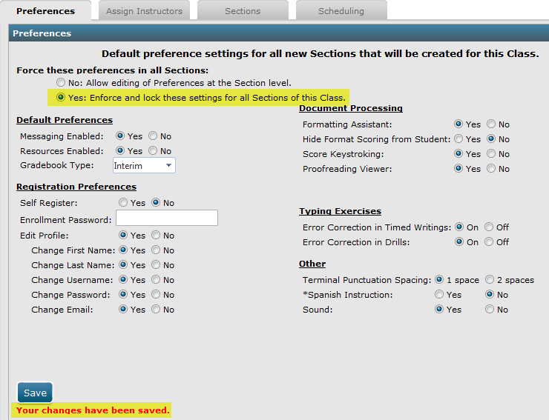

Preferences—Formatting Assistant
To enable the Formatting Assistant, click Yes next to Formatting Assistant. GDP looks for the expected formatting elements and reports them in the Scoring Results window below Keystroking Errors as Formatting Alerts. Formatting Alerts are an aid to identifying possible formatting errors, but are never a substitute for an instructor’s analysis. Formatting Alerts are not always literal. Thus, the Format Scoring feature was rebranded as “Formatting Assistant” to emphasize that an instructor’s visual analysis of a student’s document is the only reliable method for assessing formatting.

Note: See GDP Instant Help, December 2011 Updates and Formatting Assistant Changes, “GDP Formatting Assistant,” for detailed information on the Formatting Assistant feature and the types of formatting errors that are analyzed.

Forcing Preferences from Class to Section
Best Practice! Force Preferences and Scheduling Preferences at the Class level to all Sections of a Class to make those Preferences the default for any new Sections created and to change the Preferences in any existing Section. When you create a Class initially, a Section named Default is automatically created and will inherit the Class and Scheduling Preferences that first appear on the Class tab. If at that point you change Class Preferences and force them to all Sections, only then will the newly created “Default” Section (or whatever you rename it) mirror the Class Preferences settings. This recommendation assumes that you have set up your Classes and Sections as described previously to ensure instructor autonomy. See “Managing Classes & Class Preferences in Course Manager” PDF for details on Preferences. See “Scheduling and Report Strategies for Testing and Document Processing” for details on Scheduling.

Note: If a Section already exists (not the first Default Section but others created subsequently), forcing Preferences from the Class level at that point changes existing Class Section Preferences. If Preferences choices are dimmed, check with your school Administrator who may have forced Preferences in all Classes and/or Class Sections.

Create New Section (*BP)
- Click the Sections tab next; click Add Section.
- Note that a new screen appears with these tabs: Classes, Create, Import, and Archive, with the Create tab active. In the Section Title box, type the Section title (for example,
CAOT 1/F/1006/Spring 11); click Next.
- Note that a new screen appears with the Section name followed by the Class name (shown dimmed in parentheses); note that a secondary set of tabs appears with the Preferences tab active.
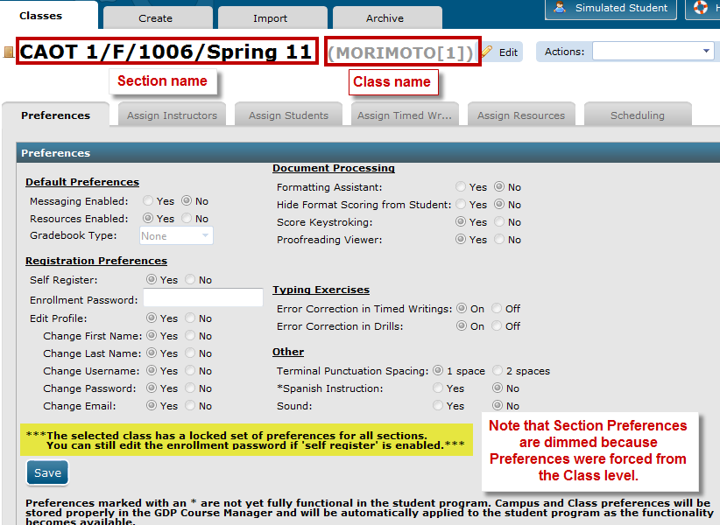

- Note that on the Preferences tab, choices are dimmed because Class Preferences were forced to the Section level.

Note: To activate Preferences in a Section in which they are dimmed, check with your school Administrator who may have forced preferences in all Classes and/or Class Sections. Or go back to step 4 to Force these preferences in all Sections and select No.

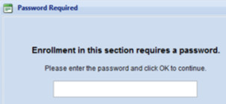
Note: If you have closed self-registration for a Class or a Class Section, you will see a “closed door” icon next to the Class or Section Name, and setting an Enrollment Password under Registration Preferences is therefore not applicable. If you have not closed registration and you have an “open door” To enter a password in the Enrollment Password box, check Self Register: Yes; then enter the desired password in the Enrollment Password box. Your students will be prompted to enter the password in 3: Enroll just after they select their Class when they attempt to self register. If the password they enter is correct, they will automatically be directed to the next step. If it is incorrect, they will not be allowed to proceed.

- Click the Assign Instructors tab; under Available Instructors, click the desired instructor; click the Add button to move that instructor to the right pane under Assigned Instructors.
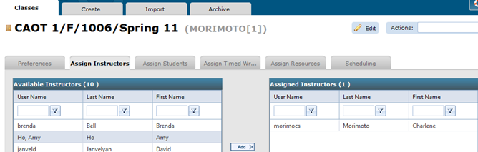

Note: If you were logged in as a Full Instructor when you create a Class, your name will automatically appear under Assigned Instructors. If you have pre-enrolled any students, click the Assign Students tab, and assign the desired students: highlight the desired student under Available Students; then click Add to move the student to the right pane under Assigned Students. See “Managing Resources in Course Manager” for details.

- Click the Assign Resources tab to assign any available resources (added by the Administrator) to that Class Section. If you have not created any resources, see “Managing Resources in Course Manager” for details for steps to create and use resources.
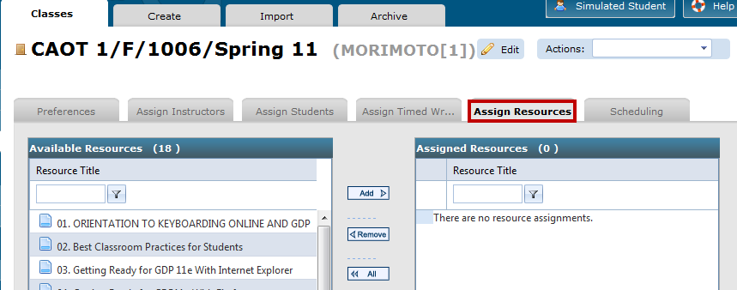

Copy or Create New Classes in Advance of a New School Term:
Tip: If you have already created Classes in a previous semester, Course Manager includes an option to copy a Class, a Class and all its Sections, or just a particular Section so that you won’t have to repeat Section setup routines again.

To copy a Class and its Class Section(s): From Classes, click the Actions menu for the desired Class; click Copy to Class; from the Create tab, in the Class Title box, edit the default title as desired; check the Copy Sections box (leave the Copy Sections box unchecked if you do not wish to copy Class Sections); click Next; review the Preferences, Assign Instructors, Sections, and Scheduling tabs, and make any desired changes.

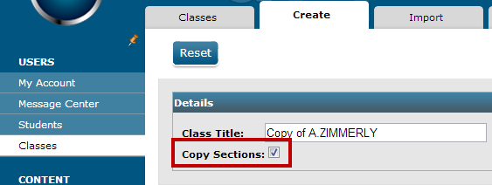

Note: When you create a Class by copying it and you leave Copy Sections unchecked, a new Class Section named “Default” is automatically created. (See “Create New Class (*BP)” for details.)

If you copy a Class and its Section(s), these items will be inherited by the copied Class and Section(s):

- Instructors
- Preferences
- Scheduling (if applicable), such as Enable/Disable, Start/Due/End Dates, Delay Results, Password, and IP Restrictions
- Student Resources (if applicable)
- Custom Timed Writings (if applicable)
- Gradebook (if applicable) and all settings, such as Categories, Exercises, and Scales

Note: Students assigned to the original Class and Section(s) are NOT inherited.

If you copy a Class and NOT its Section(s), these items will be inherited by the copied Class and newly created Default Section:

- Instructors
- Preferences
- Scheduling (if applicable), such as Enable/Disable, Start/Due/End Dates, Delay Results, Password, and IP Restrictions

Note: These items are NOT inherited by the copied Class and newly created Default Section: Student Resources, Custom Timed Writings, Gradebook, and students.

To copy one Section: From Classes, expand the desired Class; click the Actions menu for the desired Section; click Copy to Section; from the Create tab, in the Section Title box, edit the default title as desired; click Next; review the Preferences, Assign Instructors, Assign Students, Assign Timed Writings, Assign Resources, and Scheduling tabs, and make any desired changes.
See “Copying Classes and Sections” in the GDP 11 Course Manager User’s Guide in GDP Instant Help for more details. If you are creating new Classes and Sections for a new semester but don’t want the copied Class to appear on the Enroll screen in step 3 of the self-registration process, disable self-registration for these new Classes and/or Sections. Or to temporarily remove Section names from the Enroll screen or and Class lists in Course Manager, archive the Class and Class Sections after they are created. Remember to change these settings later when you want the Class and Section(s) to reappear.

Edit Existing Preferences for a Class or Section
- Under USERS, click Classes.
- From the Classes tab, click the Class Name to be edited; or expand the Class Name, and click the Class Section to be edited.
- From the Actions menu, click Edit.
- From the Preferences tab, make the desired changes; click Save.

Close Self-Registration for a Class or Class Section:
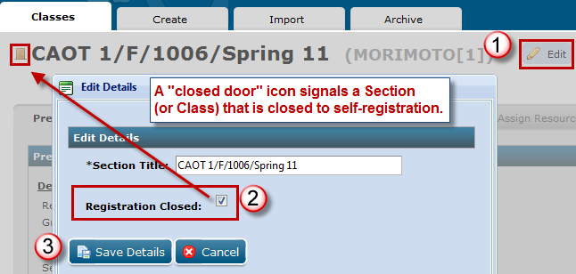
- Follow steps 1-3 in Edit Existing Preferences for a Class or Section.
- Click the Edit details button (top right of screen). From the Edit Details dialog box, check Registration Closed, Save Details.

Note: The Class Section in this example will not appear in the list of Sections available for registration in step 3, Enroll, of the self-registration process; a “closed door” icon appears next to the Section name (or Class name if you set this Preference at the Class level). However, any student you have pre-enrolled can log on initially with their credentials and will be prompted to enter a Registration Code.

Note! When you close registration for a Class, GDP automatically closes registration for all Sections in that Class. To re-open registration for a single Section, editing that Section’s Preferences individually.

- Note the “closed door” icon now appears next to the Section name on the Classes tab:
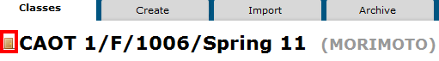
When a Class Section is open for registration, the “open door” icon appears:
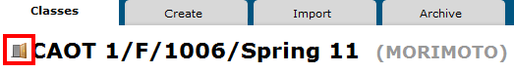

Create New Section in Existing Class
- Under USERS, click Classes; from the Classes tab, click the desired Class.
- From the Actions menu, click Add Section. Move to step 2 in “Create New Section (*BP),” and repeat all applicable steps until all Sections are added and all instructors are assigned.

Summary of Force Preferences in All Sections
When you create a Class, a “Default” Section is automatically created with whatever Class Preferences settings are in place at the Class level at the time the Section is created, regardless of the Force preference settings. A Preferences tab appears below the Classes tab that displays the Class name, and if:

Force these Preferences in all Sections: Yes: | Force these Preferences in all Sections: No:
When you make any change and click Save, all existing Class Sections (including the automatically created “Default” Section, will change to mirror those made here.  To change Section Preferences for the newly created “Default” Section (or any existing Section), move to the Class level, change Preferences there, and click Save. You cannot edit Preferences at the Section level—the screen will be dimmed. Above the Save button, you will see The selected class has a locked set of preferences for all sections. | When you make any changes and click Save, only new Sections, not the already existing “Default” Section and not any other existing Class Sections Class will inherit these Class Preferences.  If you want to change Preferences displayed on the Preference tab under the Class, which have just been inherited by the newly created “Default” Section, do so at the Section level: click the Sections tab; under Assigned Sections, click the Edit icon; repeat for any other Sections that might be created subsequently.

Note: When you click the Scheduling tab at the Class level, and click Force these preferences in all sections, the same forcing principles are in effect.

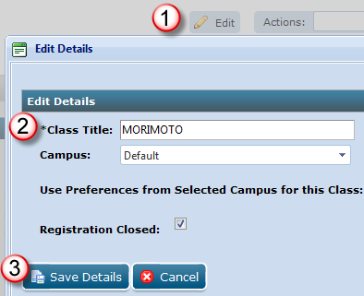
Edit an Existing Class Name
- Under USERS, Classes, Classes tab, click the Class Name to be edited; from the Actions menu, click Edit.
- Note that the desired Class to be edited appears; click the pencil Edit icon at the top right; in the Edit Details dialog box, type the new name in the Class Title box; click Save Details. Make any desired changes in the Preferences, Assign Instructors, and Sections tabs.

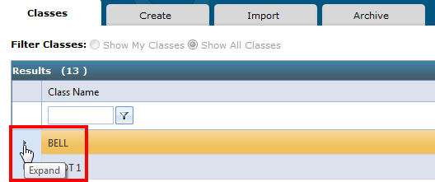
Edit an Existing Class Section Name
- Under USERS, click Classes.
- From the Classes tab, click the desired Class Name and click the Expand arrow to display the Section Name(s).

- Click the desired Class Section name to be edited; from the Actions menu, click Edit.
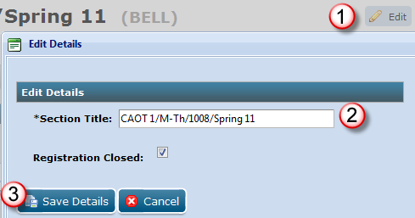
- Note that the Class Section to be edited appears; click the pencil Edit icon at the top right; in the Edit Details dialog box, type the new name in the Section Title box; click Save Details.

Delete an Existing Class (BP*)
Best Practice! The only time you should consider deleting a Class or Section is before students have been assigned to it. Archive a Class and Class Section rather than deleting them when preparing for a new term, particularly if you are interested in preserving the grades recorded in the Gradebook tab, Required Exercises List. Although you can still edit pre-existing grades in the Portfolio of a student who was assigned to a deleted Class Section, because the Class Section no longer exits, the associated Required Exercise List no longer exists. Both Full Students and Unregistered students are preserved along with their Portfolio when a Class and Section have been deleted. However, all grades revert to a ? when students are reassigned to another class. If you wish to save a record of student grades, from GPS, Gradebook tab, click the desired Section from the Section box; under Section Summary, click the Required Exercises List icon for the desired student; from the Required Exercises List dialog box, click Export, and follow the prompts to save the exported Excel file.

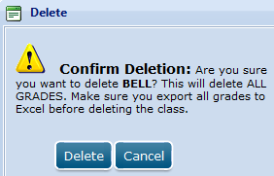
- Under USERS, click Classes.
- From the Classes tab, from the Actions menu of the desired Class, click Delete Class.
- From the Delete dialog box, click Delete to confirm deletion—both the Class and the Class Sections for that Class are deleted.

Delete an Existing Class Section (BP*)

Best Practice! Archive a Class and/or Section rather than deleting them when preparing for a new term, particularly if you are interested in preserving all grades. Click here for details.

- Under USERS, click Classes.
- From the Classes tab, click the desired Class Name and expand the Class list to display the Sections.
- From the Actions menu of the desired Class Section, click Delete Section.
- From the Delete dialog box, click Delete to confirm deletion. (Click here for details on exporting grades to preserve them.)

Archive an Existing Class and All Class Sections (and vice versa)
- Under USERS, click Classes; click the Archive tab.
- From the Active Classes pane, click the desired Class; click Add in the center to move that Class and all Sections of that Class from the Active Classes pane to the Archived Classes pane.
Or:
In the center, click Remove to move the Class and all its Class Sections to Active Classes.


Note! When a Class is archived:
- That Class and all its Sections are basically “invisible” in Course Manager and can be accessed only from this Archive tab. It removes the Class from the Class box list on the Students tab.
- Any students in the archived Class can still be seen in the list of students on the Students tab, and you can still use Edit from the Actions menu for that student. When you edit the student in an archived Class and click the Assign Class Section, that student shows up as an unassigned student. The student can continue to log on, work, and work is saved to the Portfolio.
- To resume further actions to an archived Class and its Sections, move that Class from the Archived Classes pane to the Active Classes pane using Remove. Students are still assigned to the Class they were in originally.
- Both Full Students and Unregistered students are preserved along with their Portfolio when a Class has been archived and grades are preserved.
- Archiving a Class removes it from the Class Name/Section Name list in step 3 of the self-registration screens.

Archive an Existing Class Section (and vice versa)
- Under USERS, click Classes.
- From the Classes tab, click the Archive tab.
- From the Active Classes pane, click the Expand arrow for the desired Class to display the Section Name list.
- Click the desired Section and click Add in the center to move that Section from the Active Classes pane to the Archived Classes pane.
Or:
In the center, click Remove to move the Class Section to Active Classes.

Caution! Once a Class Section is archived:
- That Class Section is basically “invisible” in Course Manager and can be accessed only from this Archive tab. It removes the Class Section from the Section box list on the Students tab.
- Any students in the archived Class Section can still be seen in the list of students on the Students tab, and you can still use Edit from the Actions menu for that student. When you edit the student in an archived Class Section and click the Assign Class Section, that student shows up as an unassigned student. The student can continue to log on, work, and work is saved to the Portfolio.
- To resume further actions to an archived Class Section, move that Class Section from the Archived Classes pane back to the Active Classes pane using Remove.
- Both Full Students and Unregistered students are preserved along with their Portfolio when a Class Section has been archived and grades are preserved.
- Archiving a Class Section removes it from the Class Name/Section Name list in step 3 of the self-registration screens.

Use Simulated Student
When you log on as a Full Instructor and click Simulated Student, GDP launches and uses your instructor name in the role of a simulated student. The point is to give you, the instructor, a student view of GDP without needing a Registration Code, a separate log in, or a separate student account. To use Simulated Student:

- Log in as a Full Instructor and click Simulated Student.
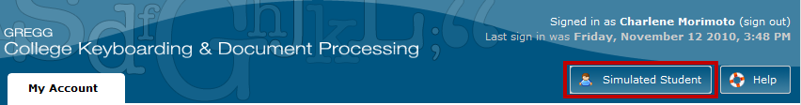

- From the dialog box, click the desired Class Section for the simulation; click Simulate.
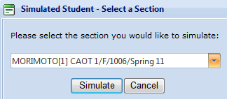

- Note that GDP launches with your name at the top right of the screen in the role of a simulated student.
- Test any desired features for that Class Section.

End-of-Term Activities
When the school term ends, there are several routines the Administrator and Full Instructors should discuss. They will need to determine the most appropriate way to manage existing Classes, Sections, and students in terms of deciding whether to delete or archive them for the term that is ending. The Administrator should explain the file-naming conventions for the Classes and Sections for the upcoming term and the resulting hierarchy. (Refer to the steps under “Create New Class and Manage Preferences and Resources” and “Create New Classes in Advance of a New School Term.”)

Certain housekeeping routines should be completed before the new term begins to (a) remove students who dropped out and/or just stopped attending Class but who still appear on student lists in Course Manager and to (b) archive Active, Full Students who finished their assigned Class for the school term that is ending. Once these housekeeping routines are successfully completed,
no students should appear under the Students tab for all Classes and all student types; for example:
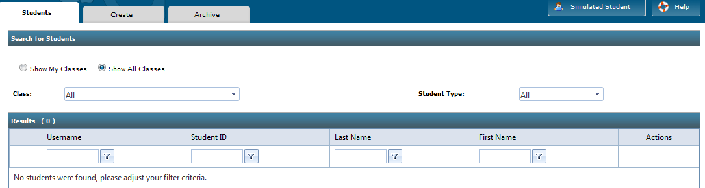

The most efficient way to accomplish this is as follows:
- Delete Unregistered, Available (unassigned) students.
- Delete Unregistered, Assigned Students.
- Archive Classes and Class Sections.
- Archive Full (registered), Available (unassigned) Students.
- Archive Full (registered), Active, Assigned Students.

Delete Unregistered, Available (unassigned) Students
The Administrator should delete any Unregistered, Available (unassigned) students. These students were likely created and pre-enrolled by an instructor at the beginning of the semester, but the instructor never assigned them to a Class and the students never registered for GDP using a Registration Code.

Note: A Full Instructor can also delete Unregistered, Available (unassigned) Students; however, it is generally more expeditious to have the Administrator complete this routine since these students were likely created by different instructors who simply forgot to delete them once the school term was underway. At the end of a school term, it is generally safe to assume (1) that these students were no-shows at the start of the term and/or (2) that they dropped out early in the semester. Such students should be deleted.

- Log on as an Administrator.
- Under USERS, click Classes.
- Expand any Class (it doesn’t matter which one).
- Under the Actions menu for any Section (it doesn’t matter which one), click Edit.
- From the second row of tabs, click the Assign Students tab.
- Note the names in the Available Students pane. (You will need this list of names to delete these students later. Consider pressing Print Screen on your keyboard to get a copy of this screen into your computer’s memory, opening Word and pressing Ctrl + V to paste the list, and then print the list.)
- Under USERS, click Students.
- Under the Students tab, set the Class filter to All.
- Set the Student Type filter to Unregistered Student.
- In the Username box, type the username of the first student on the Available Students list you printed in step 6, click the Filter button, and click Contains.
- When a result is returned for that username, verify that the Last Name and First Name also match the names listed on the Available Students pane; then you are sure that the listed student is an Unregistered, Available student who was never assigned a Class.
- From the Actions menu for that student, click Delete.
- From the Delete Confirmation dialog box, click Delete.

Note: If no results are returned and you see “No students were found; please adjust your filter criteria,” verify the characters typed in the Username box for accuracy, click the Filter button, and click Contains. If no results are returned, then you can be sure that student is an Available, Registered student who was never assigned a Class. You cannot delete such a student but you can archive that student. Follow the steps under “Archive Full Students” to archive Full Students in your Class Sections who dropped out.
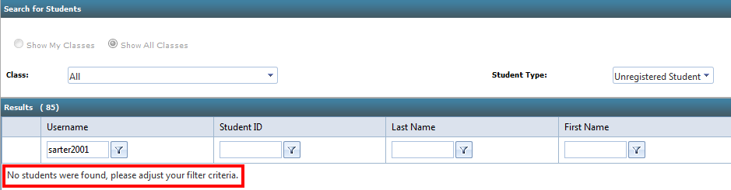

Delete Unregistered, Assigned Students
A Full Instructor (or Administrator) should delete any Unregistered, Assigned Students in any of their Class Sections. These students were likely created at the beginning of the semester, pre-enrolled by an instructor, and assigned to a Class Section. However, they did not register for GDP using a Registration Code.

Note: An Administrator can also delete Unregistered, Assigned Students; however, since these students are clearly on a particular instructor’s list of students, it is generally more prudent to let individual instructors handle this process unless it is mutually agreed that the Administrator should handle this.

- Log on as a Full Instructor; under USERS, click Students.
- Under the Students tab, set the filters to display your Class and (if applicable) your desired Section; then set the Student Type filter to Unregistered Student.

Note: Setting Class and Section boxes to display only your Class Section assures you that you are deleting your own students only and not another instructor’s unregistered student.

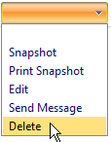
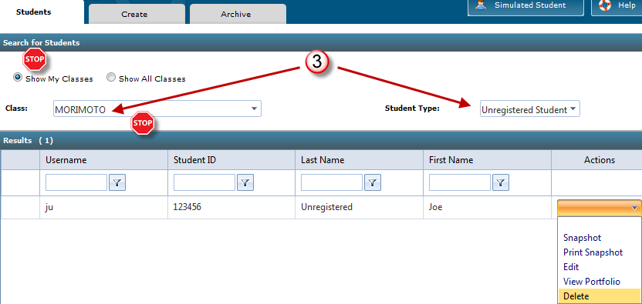
- From the Actions menu for each Unregistered Student, click Delete. (Delete is active only for Unregistered students.)
- From the Delete Confirmation dialog box, click Delete.

Archive Classes, Class Sections, and Students (BP*)
Best Practice! Deleting an existing Class or deleting an existing Class Section preserves both Full Students and Unregistered students and their Portfolio but deletes all grades. If you subsequently archive a student from a deleted Class, that student will be prompted to enroll in a different Class Section when logging on to GDP. (You would have to activate that student, reassign him to a random Class, archive him, and then he could log on without issue.) Therefore, it is advisable to archive rather than delete Classes and Sections when preparing for a new term, particularly if you are interested in preserving all related data. The only time you should consider deleting a Class or Section is before students have been assigned to it.

Best Practice! You also have an option to empty the Student Portfolio for any student so that completed work is no longer available for download—this could help prevent cheating and should be done before archiving.

The Administrator or Full Instructor should follow the steps under “Archive an Existing Class and All Class Sections (and vice versa)” to archive all Classes and the corresponding Class Sections for the present term. Click here for a complete list of all the effects of archiving a Class and its Sections.

- Once a student is archived, that student is basically “invisible” in Course Manager and can be found only from the Archive tab. To resume further actions to an archived student, move that student from the Archived list to the Active list, which reassigns these students to their original Class Section assuming that Class Section was archived and not deleted. Those students reappear on the list of students on the Students tab.
- When you edit a non-archived student who is assigned to an archived Class and click the Assign Class tab, under Student assigned to:, Class, None is displayed meaning that student is unassigned.
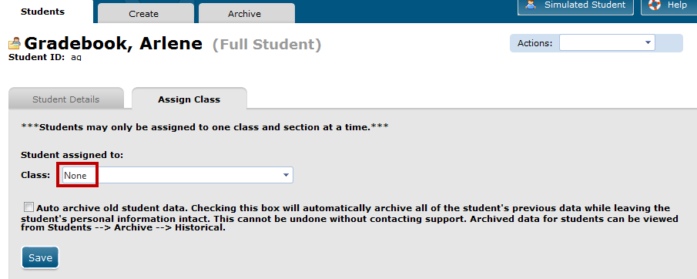Even so, the student can continue to log on, work, and work is saved to the Portfolio. When students are reactivated, they are automatically reassigned to their previous Class Section unless that Section was archived, in which case they must be reassigned to any active Class Section. Their work moves with them unless You choose to check Auto archive old student data from the Assign Class tab, which empties their Portfolio.

Consider Emptying the Portfolio for Archived Students


Note! Keep in mind that data travels with the student not the Class. Therefore, if you archive a Class Section and later reassign a student from an archived Class to a different Class Section, that student’s data moves to the new Class Section unless you to empty the Student Portfolio for that student. If you subsequently reactivate your archived Class to view historical data, that student’s data will not be in there—it will be in the most recently-assigned Class.

Also, if archived students attempt to exchange files with active students, A.D.D.S. will identify such files in the active students’ Portfolio and in the A.D.D.S. report as explained in Academic Dishonesty. Also, they are likely exchanging a file with errors, so there is not much purpose in attempting to cheat in this way. However, the surest way to prevent such cheating attempts is to empty the Portfolio (auto archive old student data).

To empty a Student Portfolio—auto archive old student data:
- From the Students tab, Actions menu, click Edit for the desired student.
- From the Assign Class tab, click Edit.
- Check Auto archive old student data.
- Note that checking this box will automatically archive all previous data for that student while leaving the student's personal information intact. Also note that this action cannot be undone without contacting support.
- Click OK, Save.
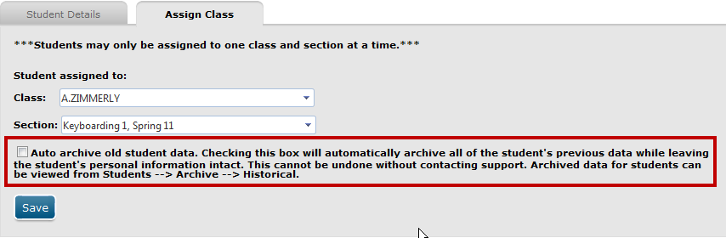

To view archived student data:
- From USERS, Students, click the Archive tab;
- From the Archive sub tabs, click the Historical tab.
- Filter to the desired student and click the Portfolio icon to open the Portfolio.
- Click Export if you want to export the Portfolio data to CSV, Excel, HTML, or Word format.
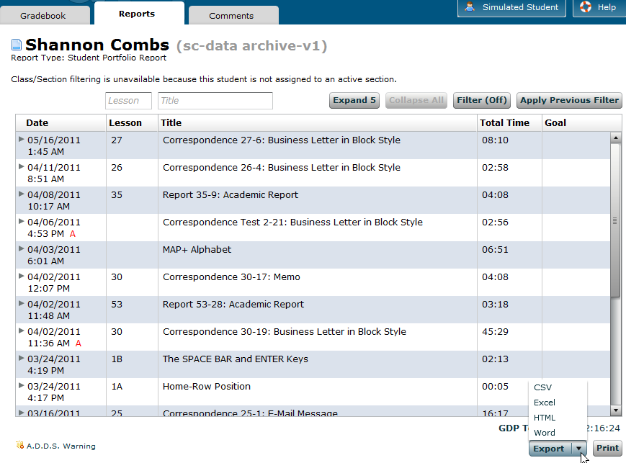

Tip: You also have an option to Archive students with a Class or a Section and you have an option to empty the Student Portfolio for any student so that completed work is no longer available for download—this could help prevent cheating.
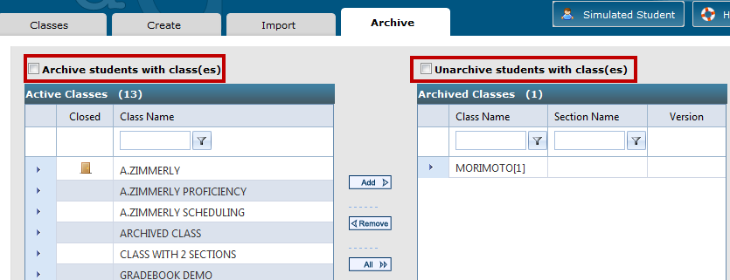

Archive Full (registered), Available (unassigned) Students
The Administrator should archive any Full (registered), Available (unassigned) Students. These students were likely created and pre-enrolled by an instructor at the beginning of the semester, but the instructor never assigned them to a Class. However these students did register for GDP using a Registration Code. If these unassigned students are archived, they can still use GDP, but they are not included in a specific Class list of students. Their Registration Code is still supported for two years from the date of GDP registration, and they can be reactivated and reassigned to a Class at any time during that two-year period. Click here for the steps to activate an Archived student. Click here for the steps to reassign an Active (non-archived) student.

Tip: Any Full Student who registered with a Registration Code cannot be deleted from the GDP system—Delete will be dimmed on the Actions menu for that student. Thus, you never have to be concerned that you might delete a registered student by mistake.

Archived students still have valid registration in GDP—they don’t have to purchase a new Registration Code if they later wish to register for another Section. Therefore, when a Full Student drops your class or when the student finishes your class, simply archive that student to remove that student from your active Class Section roster and from Course Manager student lists. If the student returns to repeat the class, either (1) reactivate the archived student and then reassign that student to a new Class Section (keep in mind that all their former work will follow them and will be displayed in their Portfolio); or (2) if you prefer to have a returning student start with a blank Portfolio, empty the Student Portfolio (auto archive old student data) when you reassign the student.

Remember that even if your Class and Section are archived, students in those archived Classes will still appear on student lists in Course Manager, which will be confusing and make student lists unnecessarily long for the next semester. Therefore, after archiving old Classes and Sections, next you need to archive any Full (registered), Active, Assigned Students who have completed your course at the end of your school term.

- If you prefer to have a returning student start with a blank Portfolio, empty the Student Portfolio (auto archive old student data).
- Under USERS, Students, Archive tab, Class box, set the filter to display the desired Class.
- From the Section box, set the filter to display the desired Class Section.
- In the list of Active Students in the left pane, select the desired student.
- In the center, click Add to move the student to the Archived Students list (right pane).

Archive Full (registered), Active, Assigned Students
- if you prefer to have a returning student start with a blank Portfolio, empty the Student Portfolio (auto archive old student data).
- Under USERS, Students, click the Archive tab.
- If desired, from the Class box, set the filter to display the desired Class; otherwise, go directly to step 3.
- In the list of Active Students in the left pane, select the desired student.

Note: To select a contiguous range of students in order to move a selected group of students all at once, click the first desired student name, scroll down, hold down the Shift key, and click the last desired student name; then continue to step 4.

- In the center, click Add to move the student to the Archived Students list in the right pane.

To activate an Archived student:
- Under USERS, Students, click the Archive tab.
- If desired, from the Class box, set the filter to display the desired Class.
- In the list of Archived Students in the right pane, select the desired student.
- In the center, click Remove to move the student to the Active Students list in the left pane.

Set Self-Registration to No for Old Classes
As soon as your school’s schedule of classes is published, it is advisable to set Self-Registration to No for Classes and Sections so that they are removed from the Enroll page. In this way, new students will not enroll in the last term’s Classes by mistake. See “Edit Existing Preferences” and “Disable Self-Registration for a Class Section” for steps. Archiving these Classes and Sections will also remove them from the Enroll page.

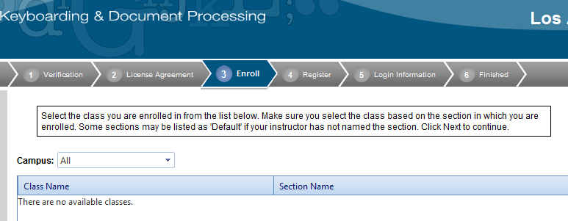

Copy or Create New Classes for the Next Term and Set Registration Preferences
Follow the steps under “Create New Classes and Choose Preferences” and “Copy or Create New Classes in Advance of a New School Term” first so that new Classes are in place so that Full Instructors can add and pre-enroll new students and possibly reassign returning students or create new accounts for returning students.

Full Instructors should decide if they want to close registration for a Class or Section so students cannot self-register. See “Edit Existing Preferences” and “Close Self-Registration for a Class Section” for steps.

Consider Disabling Scoring in Archived Classes
Archived students can continue to work in GDP without issue. Therefore, consider setting Class and Section Preferences for any archived Classes and Sections to disable the scoring of keystroking and formatting (Preferences tab, Score Keystroking/Score Formatting—No). In this way, archived students will not be able to see either the number of errors made or scored copy anywhere at any time for any document—not after using Edit Work or Submit Work and not for any work in the Portfolio.

Start-of-Term Activities
When the new school term begins, there are several things to consider:

Reassign Returning Students
If a Full Student (one who registered for GDP with a Registration Code) who was archived from a previous semester returns and wishes to enroll in your class, you must either activate the Archived student and then reassign that Active student understanding that all work from the previous term will still appear in the Portfolio unless you empty the Portfolio (auto archive all previous student data).

Note: Any Active (not Archived) students from a Class or Class Section that was archived in a previous semester can still be seen in the list of students on the Students tab, and you can still use Edit from the Actions menu for that student. If the student was archived, you cannot reassign that student until the archived student is activated.

To reassign an Archived student:
- First activate the student: follow the steps under “To activate an Archived student.”
- Once the Archived student is on the Active Students list, reassign that Active student to a Class Section.
- If you prefer to have a returning student start with a blank Portfolio, empty the Student Portfolio—check Auto archive old student data.
- Click Save; note the prompt in red below the Save button confirming the reassignment (auto archive old student data).

To reassign an Active student:
- Under USERS, Students, Students tab, click Show All Classes; set the Class filter to All and the Student Type to All.
- Find the desired student by Username, Student ID, Last Name, or First Name.

Tip: Consider using Last Name as the filter since it usually represents information that is memorable and constant regardless of the school term or Class. You won’t get a match using any of these filters unless they are identical to what the student used in a previous Class.

- From the Actions menu for that student, click Edit.
- From the new secondary set of tabs that appears, click the Assign Class tab; note that the Class box displays the assigned Class and the Section box displays the assigned Section.
- Click the Class box list arrow and click the desired Class.
- When the Section box appears, click the list arrow, click the desired Section.
- Note that all work from the previous term will still appear in the Portfolio unless you empty the Portfolio (auto archive old student data); if desired, check Auto archive old student data
- Click Save; note the prompt in red below the Save button confirming the reassignment.

To view a list of all Available (unassigned) students and Assigned students:
- Under USERS, click Classes.
- Click the right expand arrow to the left of the desired Class name to expand the Class.
- Under the Actions menu for the desired Section, click Edit.
- Click the Assign Students tab.
- The Available Students pane on the left displays a list of all unassigned students on a campus, and the Assigned Students pane on the right displays a specific list of assigned students only for the particular Class Section specified in the Actions menu in step 3.

Note: To assign the Available Student, select the student from the Available Students pane, click Add to move the student to the Assigned Student pane for that Class; the student will receive an automated e-mail with your school’s custom URL, a username, and password.

To edit the Student ID and Username of a returning student:
- Under USERS, click Classes.
- Under USERS, Students, Students tab, click Show All Classes; set the Class filter to All and the Student Type to All.
- Find the desired student by Username, Student ID, Last Name, or First Name. (Remember, if the student has been archived, you must first activate the archived student.)
- From the Actions menu for that student, click Edit.
- From the Student Details tab, click Edit.
- In the Student ID box, edit the Student ID—consider adding a date to the end such as the date of school term for that work so the student ID will be unique each term; for example, add “F10” to signify the fall term in the year 2010. If you created the student originally with the date of the term appended to the Student ID, just edit the term date.
- In the Username box, edit the username—consider adding a date to the end of the username, such as the school term date, as you did in step 6, so the username will be unique each term.
- Click Save.

Create and Pre-Enroll New Students
See the handout “Managing New Students in Course Manager” for steps and information related to all aspects of creating, assigning, and pre-enrolling new students.

Set Up Class Preferences and Resources for New Classes
See the “Edit Existing Preferences” for details. See the handout “Managing Resources in Course Manager” for details, particularly page 3, which includes a list of link addresses you might want to use as Link resources.

Set Registration Preferences—Self Register, Enrollment Password, and Edit Profile
- If you set Preferences, Registration Preferences, Edit Profile to Yes for all options under, a student can reassign himself to another Class. In GDP, he would click My GDP, My Info, Edit; next to Class, he would click the desired Class/Section, and click Save Settings. If you wish to prevent such reassignment to a particular Class/Section, go to Class/Section Preferences, and set a Password.
- If you wish to remove the Class from the list of available Classes, go to Class/Section Preferences, and click Edit; from the Edit Details box, click Registration Closed, Save Details. A Class with closed registration and/or Self Register set to No does not appear on the list for students not presently assigned to that Class. A Class with a password required displays with a red lock icon, which the instructor would need to provide to that student.

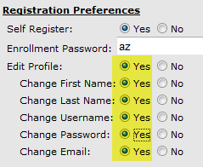 | 