
MANAGING RESOURCES IN COURSE MANAGER

Resources Overview 1
Creating and Assigning Resources as a Full Instructor (*BP) 2
To create, assign, and schedule a File Resource: 3
To create, assign, and schedule a Link resource: 6
To assign and schedule a resource later: 9
Editing Resource Details (Title/URL) 9
Creating and Assigning Resources as an Administrator 10
Removing (unassigning) a Resource From a Class or Section 10
Removing (unassigning) a Resource From All Classes/Sections 10
Deleting a Resource 11
Verifying Assigned Resources 11
Verifying Status of Assigned Resources as a Simulated Student 11


*BP: Indicates a “Best Practice” routine in GDP. Best Practice recommendations help ensure that GDP behaves seamlessly, predictably, and intuitively.

Note! The screen shots in this handout in some cases represent Classes and Sections in which the Interim Gradebook is enabled and in use. If you do not have a Gradebook enabled, your views and some features will vary. The enabling or disabling of Messaging, Resources, Formatting Assistant, Hide Format Scoring from Student, Score Keystroking, and Proofreading Viewer also affects the appearance of GDP screens:

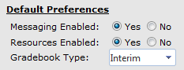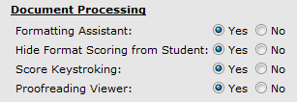

Both Full Instructors and Administrators can manage resources. (See “GDP Course Manager User’s Guide” in GDP Help for details.) Check with your school regarding your own duties and assigned role. The actions that follow, therefore, can be accomplished by logging in either as an Administrator or Full Instructor.

Resources Overview
Use the Resources feature to provide students with additional resource materials, such as links to external Web sites and related course handouts—perhaps a course outline, assignment sheets, a Required Exercise list (if you use GDP’s Interim Gradebook), and announcements. Consider linking to your school’s Web site or to a page or handout at the author Web site at http://gdpkeyboarding.com/. (Click here for a suggested list of Link Resources.) If desired, you can specify when a resource will be available. Students access resources from the My GDP tab.

GDP supports most documents and files but does not allow audio or video content. To upload audio or video files, use a video sharing site (YouTube, Flickr, Photobucket, Yahoo! Video, and so forth), and then create a Resource link to it. Resources can be created and assigned to any Class Section by the Administrator. A Full Instructor can also create and assign resources for any Class or Class Section assigned to him or her.

Creating and Assigning Resources as a Full Instructor (*BP)
- Log in to Course Manager as a Full Instructor
- Under CONTENT, click Resources to see a list of available uploaded resources that might have been posted to your class by the Administrator of your class.

Best Practice! You do not have rights to edit or delete any resources posted by your Administrator. Contact your Administrator to have such resources removed or edited and consider always posting your own resources to maintain autonomy.

- From the Create tab, type the resource name in the Resource Title box. (This is the resource title students will see. Students do not see the actual file name of the file you upload.)
- Continue to the steps for a File Resource or to the steps for a Link Resource.

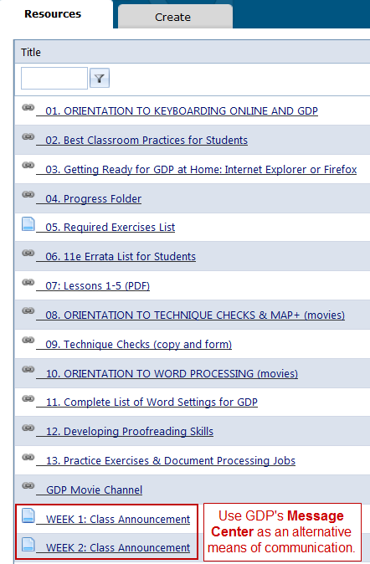
Tip: By default, Resource Titles appear on the Resource list in alphabetical order. To follow a different order, add a 2-digit number at the beginning of the Resource title. The first number would be “01” so that numbers higher than 9 will sort properly. (Click here to see how a Resources list appears to the students.) In the list of Resources at the right:

- PowerPoint presentations are shown in all caps to distinguish them.
- The “05: Required Exercises List” resource was created using GDP’s Interim Gradebook Export feature. (See Setting Up an Interim Gradebook, “Benefits of Using a Gradebook,” for details.)
- WEEK 1: Class Announcement does not include a number and therefore appears alphabetically at the bottom of the list. Add a week number to sort these announcements chronologically. Posting class announcements provides students with a handy archive of all class announcements. You could also use the Message Center as an alternative or in addition to the Resource feature as a means of internal communication with students.
- The “07: Lessons 1-5 (PDF)” resource is a PDF file of the first five lessons which students can use at the start of a term until they have their books. As an alternative to duplicating this file, you can teach students to open the PDF file and GDP simultaneously and resize windows so students can see the PDF as they type in GDP. For example:
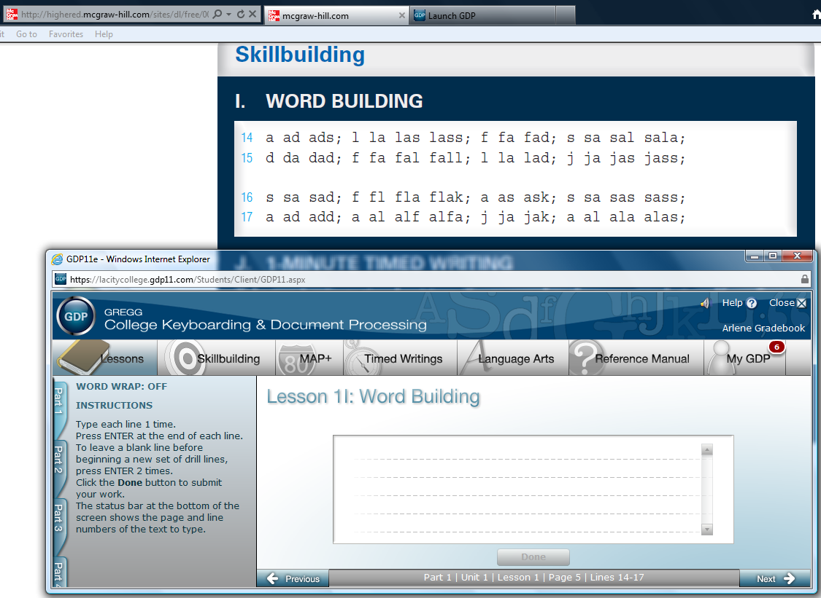

To create, assign, and schedule a File Resource:
- From the Resource Type box, click the list arrow and click File.
- Next to the File box, click Select and browse to the desired file.
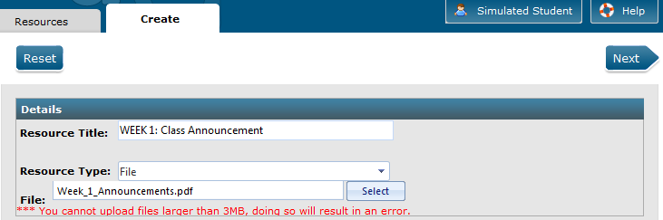
Note: Any File Resource should be created and saved in advance of this step. PDF files are generally a preferred, more seamless file format. There is a file size limit of 3 MB.

Tip: If you use GDP’s Interim Gradebook, you will have access to a Required Exercises List that you can display and export to an Excel file, which you could assign as a File Resource. Just rename the exported file to something generic such as Required Exercise List.xls, delete any columns specific to a student, and keep only Exercise, Grading Category, Due Date, and End Date. See the file Setting Up an Interim Gradebook, “To display and export the Required Exercises List (REL)” for details. Here’s an example:

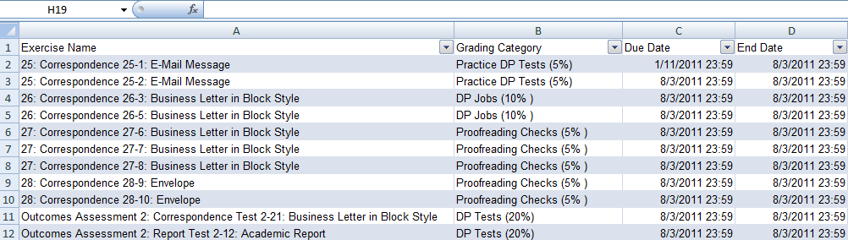

- Click Next to upload the file.
- From the Assign Classes tab, under Available Classes, click the desired Class or expand the Class and click the desired Section to move only a particular Class Section.
- Click Add; from the Resource Assignment Details dialog box.
- Click Save to move the Class or Section to the right under Assigned Classes.
OR: To set the File Resource to appear at a certain date and time and/or disappear at a certain date and time:
- From the Resource Assignment Details dialog box, if you wish to assign the resource to appear at a set date and time, check Enable Schedule by Date.
- Enter the desired Start Time (when the resource posts to My GDP, Resources) and End Time (when the resource is removed from My GDP, Resources) choices using your own local time—use the Calendar popup or Time View popup if desired, or just type in the desired times.
- Click Save.
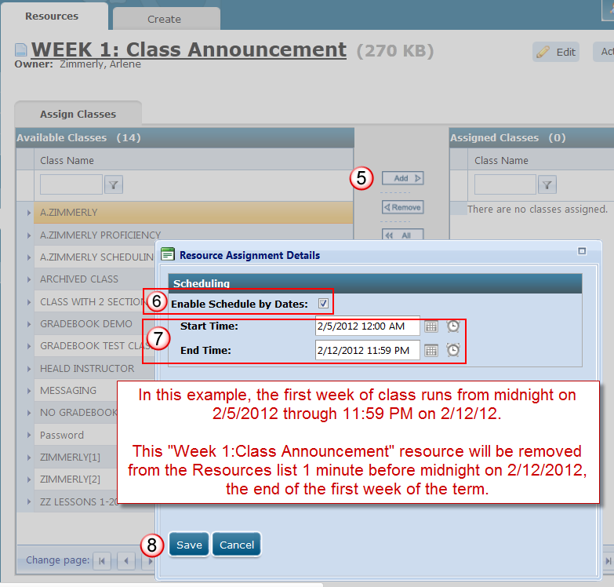

- Note that the selected Class or Section now appears under the Assigned Class column.
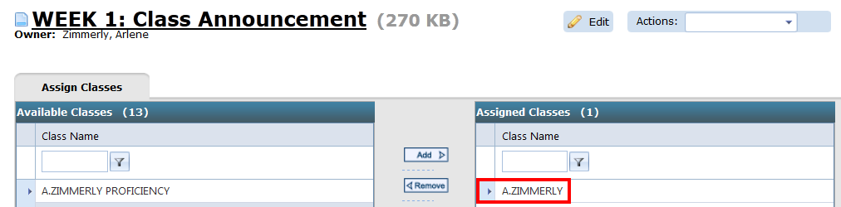

- Click the Resources tab, and note that a green checkmark now appears under the Assigned column for that File Resource.
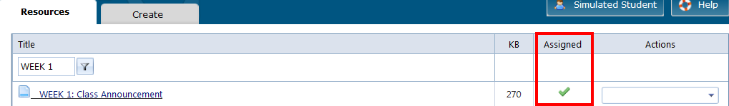

- Click Simulated Student; from the Simulated Student – Select a Section dialog box, select the desired Section from the drop-down list; click Simulate; when the simulated student window appears, click My GDP, Resources; note that the File Resource appears with any Scheduling End Time listed under the Due Date column.
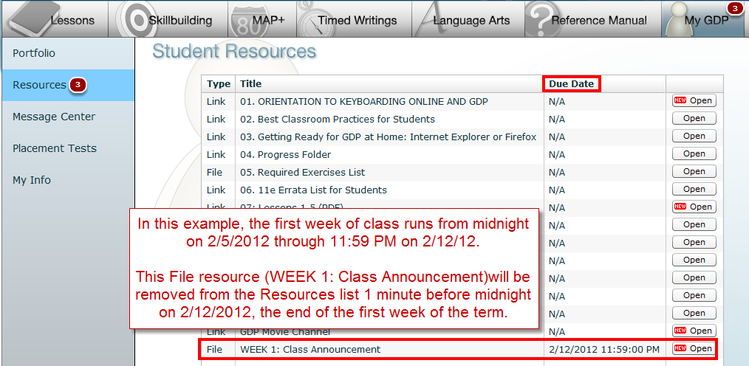

To create, assign, and schedule a Link resource:
- From the Resource Type box, click the list arrow and click Link.
- In the Link Location (HREF) box, type or paste in the desired link—make sure that “http://” is not entered twice.
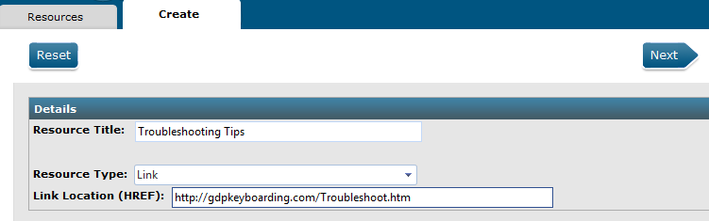

Tip: To copy a link address, try right-clicking a link on a Web page and clicking Copy link address (or whatever works in your browser. Consider including these resources:

RESOURCE LINK URLS
Orientation to Keyboarding Online & GDP
http://11e1.gdpkeyboarding.com/PowerPoint/Orient_Keyboarding_Online_GDP.pdf
http://11e1.gdpkeyboarding.com/PowerPoint/Orient_Keyboarding_Online_GDP.htm

Best Classroom Practices for Students
http://gdpkeyboarding.com/Word_Files/Best_Classroom_Practices_For_Students.doc
http://gdpkeyboarding.com/Word_Files/Best_Classroom_Practices_For_Students.pdf

Getting Ready for GDP 11e With Internet Explorer
http://gdpkeyboarding.com/Word_Files/Getting_Ready_for_GDP_11e_Internet_Explorer.doc
http://gdpkeyboarding.com/Word_Files/Getting_Ready_for_GDP_11e_Internet_Explorer.pdf

Getting Ready for GDP 11e With Firefox
http://gdpkeyboarding.com/Word_Files/Getting_Ready_for_GDP_11e_Firefox.doc
http://gdpkeyboarding.com/Word_Files/Getting_Ready_for_GDP_11e_Firefox.pdf

Technical Skills Tutorial
http://11e1.gdpkeyboarding.com/Tutorials_Technical_Skills/FRAMESET_TechSkills.htm

Placement Test B: Timed Writing
http://gdpkeyboarding.com/Word_Files/Placement_Test_B_TimedWriting.doc
(password protected)

Progress Folder
http://11e1.gdpkeyboarding.com/Word_Files/Progress_Folder.doc

11e Errata List for Students
http://gdpkeyboarding.com/Word_Files/11e_Errata_List_for_Students.doc
http://gdpkeyboarding.com/Word_Files/11e_Errata_List_for_Students.pdf

Unit 1, Lessons 1-5
http://highered.mcgraw-hill.com/sites/dl/free/0073372196/835662/Unit_1.pdf

Orientation to Technique Checks
http://11e1.gdpkeyboarding.com/PowerPoint/OrientTechCheck.pdf
http://11e1.gdpkeyboarding.com/PowerPoint/OrientTechCheck.htm

Message Center
http://gdpkeyboarding.com/Word_Files/Message_Center.doc
http://gdpkeyboarding.com/Word_Files/Message_Center.pdf

Technique Check Copy
http://gdpkeyboarding.com/Word_Files/Technique_Check_Copy_11e.doc
http://gdpkeyboarding.com/Word_Files/Technique_Check_Copy_11e.pdf

Technique Check Form
http://gdpkeyboarding.com/Word_Files/Technique_Form_11e.doc
http://gdpkeyboarding.com/Word_Files/Technique_Form_11e.pdf

Technique Self-Assessment
http://gdpkeyboarding.com/Word_Files/Technique_Self-Assessment.doc
http://gdpkeyboarding.com/Word_Files/Technique_Self-Assessment.pdf

Online Technique Self-Assessment
http://gdpkeyboarding.com/Word_Files/Online_Technique_Assessment.doc
http://gdpkeyboarding.com/Word_Files/Online_Technique_Assessment.pdf

Custom Timed Writings Copy
Business Timed Writings:
http://gdpkeyboarding.com/Word_Files/Word_Files_Misc/Business%20Timed%20Writings.doc
Legal Timed Writings:
http://gdpkeyboarding.com/Word_Files/Word_Files_Misc/Legal%20Timed%20Writing.doc
Medical Timed Writings:
http://gdpkeyboarding.com/Word_Files/Word_Files_Misc/Medical%20Timed%20Writings.doc

Orientation to Word Processing
http://11e1.gdpkeyboarding.com/PowerPoint/orientwp.pdf
http://11e1.gdpkeyboarding.com/PowerPoint/orientwp.htm

Complete List of Word Settings for GDP
http://gdpkeyboarding.com/Word_Files/Complete_List_of_Word_Settings_for_GDP.doc
http://gdpkeyboarding.com/Word_Files/Complete_List_of_Word_Settings_for_GDP.pdf

Developing Proofreading Skills
http://11e1.gdpkeyboarding.com/Word_Files/Developing_Proofreading_Skills.doc
http://11e1.gdpkeyboarding.com/Word_Files/Developing_Proofreading_Skills.pdf

Practice Exercises & Document Processing
http://gdpkeyboarding.com/Word_Files/Practice_Exercises_&_Document_Processing_in_GDP.doc
http://gdpkeyboarding.com/Word_Files/Practice_Exercises_&_Document_Processing_in_GDP.pdf

GDP Movie Channel (link to all GDP movies)
http://www.screencast-o-matic.com/channels/cXeeo3Vqg

- Orientation to Technique Checks
- Technique Self-Assessment
- Orientation to Skillbuilding and MAP+
- Sustained Practice
- 12-Second Speed Sprints
- Language Arts
- Orientation to Word Processing
- Quick Start to Word Processing (simplified)
- INSTRUCTOR: Message Center
(Students should seek to 8:20 for information on the Student Message Center.)
- INSTRUCTOR: Formatting Assistant
(Students should seek from :28-1:43, 3:13-3:42, and 3:52-5:52 for an explanation of Formatting Alerts.)

- Click Next to upload the link.
- From the Assign Classes tab, under Available Classes, click the desired Class or expand the Class and click the desired Section to move only a particular Class Section.
- Click Add >.
- From the Resource Assignment Details dialog box, click Save to move the Class or Section to the right under Assigned Classes.
OR: To set the Link resource to appear at a certain date and time and/or disappear at a certain date and time, follow steps 6-11 in “To create, assign, and schedule a File Resource.”

To assign and schedule a resource later:
To assign and schedule a resource at some point after you have created it:
- Under CONTENT, click Resources to see a list of available uploaded resources.
- Under the Actions column, click the list arrow for the desired resource, click Edit.
- From the Assign Classes tab, Assigned Classes column, click and expand the desired Class and click and expand the desired Section.
- Under Assignment Details, click the Edit button.
- From the Scheduling dialog box, schedule the resource as described in step 7 and 8 in “To create, assign, and schedule a File Resource.”

Editing Resource Details (Title/URL)
- Under CONTENT, click Resources to see a list of available uploaded resources.
- From the Action bar list for the desired resource, click Edit.
- From the Resources tab, click the Edit pencil button.
- From the Resource Title box for either a Link Resource or a File Resource, edit the title.
- For a Link Resource only, from the Link Location (HREF) box, edit the URL.
- Click Save Details.
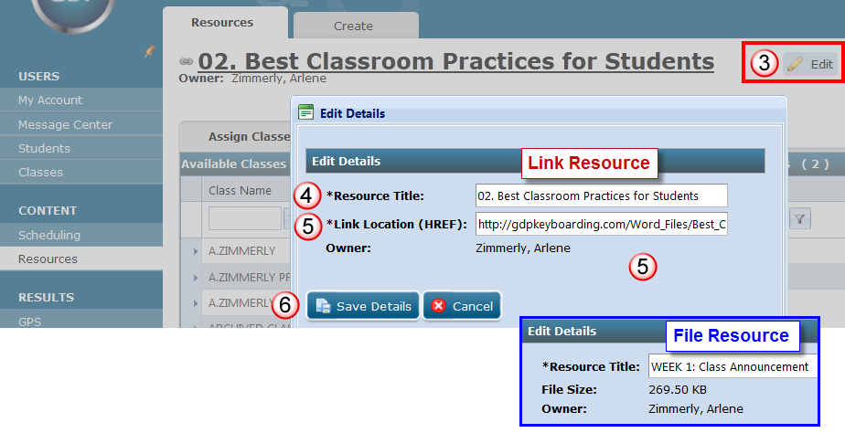

- From the Resource Assignment Details dialog box, if you wish to assign the resource to appear at a certain date and time, check Enable Schedule by Date; indicate the desired Start Time (when the resource posts to My GDP) and End Time (when the resource is removed from My GDP) choices using your own local times; click Save. That resource will not appear for the student under My GDP, Resources, until the assigned date and time.

Creating and Assigning Resources as an Administrator
Best Practice! Assigning resources as an Administrator takes away all control of such resources from the instructor. Make sure this control is desirable. Sometimes such control can end up being a stumbling block. Unless there is a special reason a GDP Administrator would need to control all instructor resources, it is preferable not to assign resources as an Administrator and instead to let Full Instructors assign their own Resources to their Classes and Sections.

- Log in to Course Manager with Administrator credentials.
- Under CONTENT, click Resources to see a list of available uploaded resources.
Note: If an Administrator has assigned any resources to a Class Section, the resources will appear on the list of Resources in Course Manager automatically and the list of Resources in My GDP, Resources, for all students in that section. If the Resource feature has been disabled by the Administrator, Resources will not appear in the side navigation panel.
- If desired, click any resource link to view it.
- From the Create tab, type the resource name in the Resource Title box. (This is the text students will see. Students do not see the actual file name of the file you upload.)
- Continue to and follow the same steps to create, assign, and schedule a File Resource or to the steps to create, assign, and schedule a Link resource as an Administrator.

Removing (unassigning) a Resource From a Class or Section
- Under CONTENT, click Resources to see a list of available uploaded resources.
- Under the Actions column, click the list arrow for the desired resource, click Edit.
- From the Assign Classes tab, under Assigned Classes, click the desired Class or expand the Class and click the desired Section to move only a particular Class Section.
- Click < Remove.
- Note that the removed Class (or Section under an expanded Class) appears under Available Classes.

Removing (unassigning) a Resource From All Classes/Sections
- Under CONTENT, click Resources to see a list of available uploaded resources.
- Under the Actions column, click the list arrow for the desired resource, click Edit.
- From the Assign Classes tab, click << All.
- Note that all Classes (and all Sections under an expanded Class) appear under Available Classes.

Deleting a Resource
- Under CONTENT, click Resources to see a list of available uploaded resources.
- Under the Actions column, click the list arrow for the desired resource, and click Delete.
- From the Delete dialog box, click Delete.

OR:

- Under CONTENT, click Resources to see a list of available uploaded resources.
- Under the Actions column, click the list arrow for the desired resource, and click Edit.
- From the Resources tab, Actions box, click the list arrow; click Delete.
- From the Delete dialog box, click Delete.

Note! If the Administrator created and assigned this resource and is the “Owner” of the resource, only the Administrator can delete the resource.

Verifying Assigned Resources
- Under CONTENT, click Resources to see a list of available uploaded resources.
- From the Actions list arrow for the desired resource, click Edit.


Note: If the Administrator created and assigned this resource and is the “Owner” of the resource, only the Administrator can click Edit to verify if the resource is assigned. Request a “Snapshot” of this Resources page from your Administrator.

- Look under Assigned Classes to see which Classes include this resource.
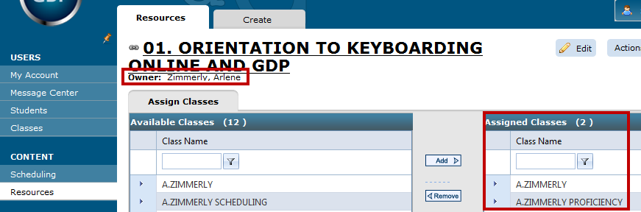

Verifying Status of Assigned Resources as a Simulated Student
Another way to verify the resources in a given course is to log on as a Simulated Student.
- Click Simulated Student, and select the desired course.
- When GDP launches, click My GDP, Resources, and verify your resources.
- Note the “4” alert bubble next to My GDP, which verifies the total number of posted, unopened resources and messages. As resources and messages are opened, the number will decrease and ultimately disappear when all items have been opened.
- Note the “3” alert bubble next to Resources, which verifies the total number of posted, unopened resources. (See Message Center for details on using this feature to send and receive internal messages between instructors and students.)
- Note the “1” alert bubble next to Message Center, which verifies the total number of unopened messages.
- Note the “New” icon on the Open button indicating 2 unopened Link Resources and 1 unopened File Resource.
- Note the Due Date on the File Resource “WEEK 1: Class Announcement,” which alerts the student that on the designated date and time, this resource will disappear from this list.
