MOVING FROM WORD 2007 TO WORD 2010
Contents
Lesson 21: File Tab 2
Lesson 24: Print Preview 2
Lesson 69: Find and Replace 3
Lesson 103: Text Boxes 3
Lesson 106: WordArt 5
Appendix C: Saving a Word File in PDF Format 6

Some key differences between Word 2007 and Word 2010 that are reflected in the Microsoft Office Word 2010 Manual, 11e, are listed here in their order of appearance in the Word Manual.

- Click here if you are interested in reading posts at the official blog of the Microsoft Word product team for Word 2010.
- Click “Office 2010—Changes in Microsoft Word 2010” for more in-depth coverage of Word 2010 at office-blog.net.

Lesson 21: File Tab
The File tab has replaced the Microsoft Office button (see the next illustration) and displays what is known as the “Backstage” view. It includes file management features and other features such as Save, Save As, Open, Close, Info, Recent, New, Print, Save & Send, and Help. A Recent Documents pane lists recently opened documents. Options and Exit buttons appear at the bottom of the menu.

Lesson 24: Print Preview
Print Preview has been replaced with a Print feature under the File tab. When the File tab is clicked, the entire right side of the screen shows a print preview of the open document. Print options appear in the center pane.

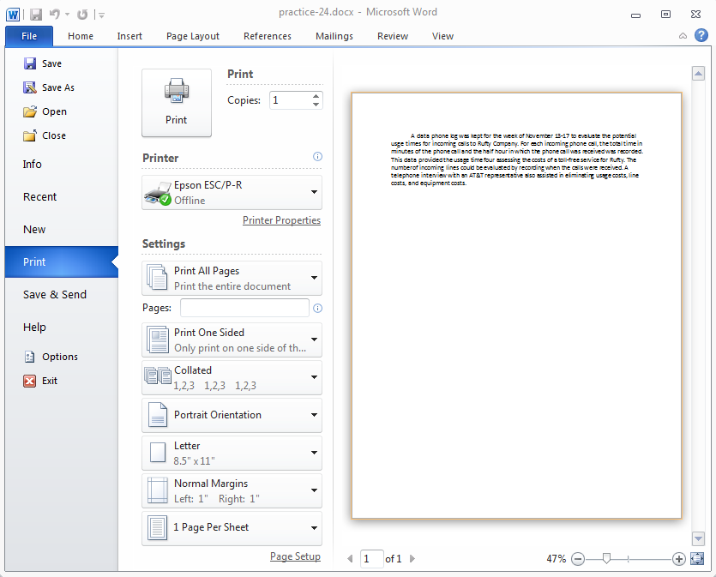

Lesson 69: Find and Replace
The Find feature has changed extensively and includes a dedicated Navigation pane. As you type the characters you want to find in the Search Document text box of the Navigation pane, Word highlights matches in the document and summarizes all search results in a scrollable Navigation pane.

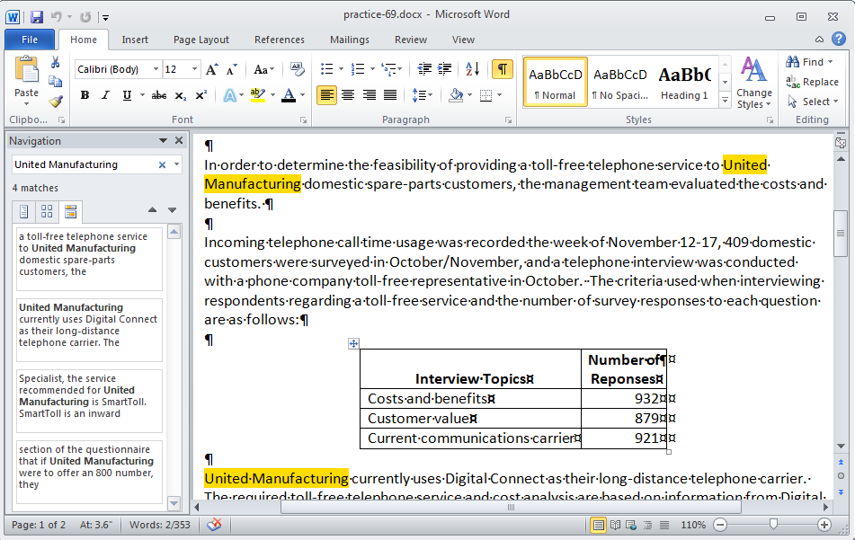

Lesson 103: Text Boxes
In Word 2010, when students start to format text boxes in letterheads, flyers, and so forth, such formatting changes are referred to as “shape” changes rather than as “text box” changes. Here is a list of terminology related to text boxes that has changed:

Word 2007 | Word 2010
Text Box Tools tab | Drawing Tools tab
Text Box Styles group | Shape Styles group
Text Box Styles group, Change Shape button | Insert Shapes group, Edit Shape button

The shape styles that are available for text box fills in Word 2010 vary slightly from the text box styles available in Word 2007. Because the textbook illustrations depict Word 2007 documents, the appearance of the text box fill and border will differ slightly. This difference in appearance is not cause for concern. Students are directed to use a comparable style when making a selection for a shape style in Word 2010 document processing jobs. For example, in Practice 103 in Word 2007, a text box style named “Diagonal Gradient–Accent 6” is not available in Word 2010. However, Word 2010 has a very similar text box shape style named “Subtle Effect—Orange, Accent 6.”

Word 2007
(Text Box Tools tab, Format tab, Text Box Styles group)
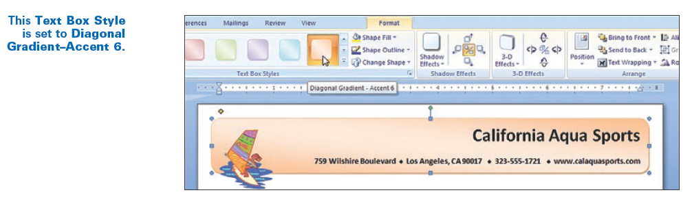

Word 2010
(Drawing Tools tab, Format tab, Shape Styles group)
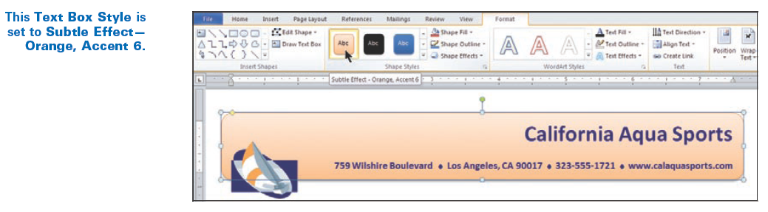

Lesson 106: WordArt
The WordArt Format tab, galleries, styles, and shapes in Word 2007 vary from those in Word 2010. Because the illustrations in the textbook reflect Word 2007 WordArt choices, the appearance of the shape, fill, and outline of WordArt will differ slightly. These differences are not cause for concern. Students are directed to use comparable choices when making selections for WordArt in Word 2010.

Note that the Word 2007 WordArt gallery includes shape effects, and the Word 2010 WordArt gallery does not. In Word 2010, the shapes are now found in the WordArt Styles group, Text Effects, Transform gallery.

Word 2007 (WordArt gallery)
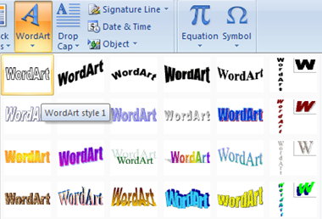

Word 2010 (WordArt gallery) |  | Word 2010 (Transform gallery)
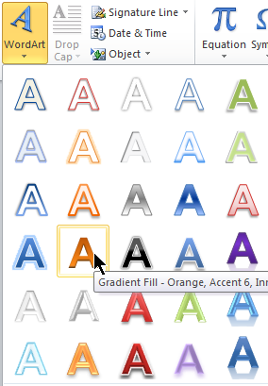 |  | 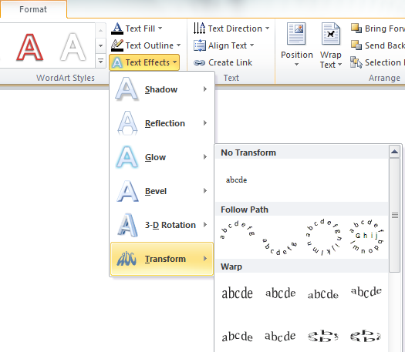
Note that the Text Box Styles gallery in Word 2007 includes slightly different styles than the Word 2010 Shape Styles gallery.

Word 2007 (Text Box Styles gallery) |  | Word 2010 (Shape Styles gallery)
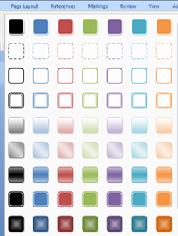 |  | 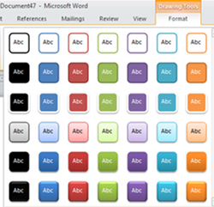

Appendix C: Saving a Word File in PDF Format
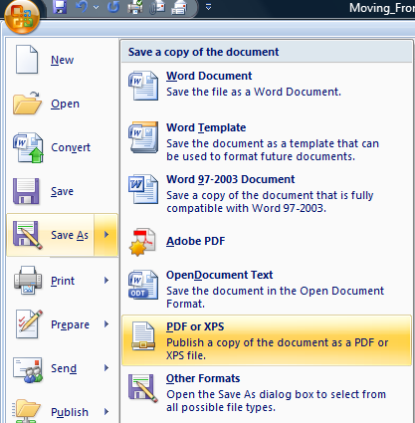
PDF file format continues to increase in popularity; therefore, this new feature is included in a new appendix. Word now allows you to convert your files to PDF format directly from Word without installing any type of add in.

Word’s PDF Save As feature as opposed to Adobe PDF ensures that all Word formatting, such as the page color in this document, is replicated in the PDF file. Saving this file using Adobe PDF will not replicate this page color in the PDF file. Word’s PDF feature also creates the PDF file much more quickly.

