
MOVING FROM WORD 2010 TO WORD 2013
Lesson 21 2
Sample opening screen 2
Sample blank document screen (Quick Access Toolbar buttons will vary) 2
Tab names 3
FILE Tab 3
View Ruler Button 3
Browse by Page Button 3
Lesson 24: Spelling and Grammar Check 3
Lesson 36: Table—AutoFit to Contents 3
Lesson 39: Table—Align Text Right 4
Lesson 76: Table—Insert, Delete, and Move Rows or Columns 4
Lesson 80: Table—Styles 4
Lesson 88: 4
Clip Art—Insert 4
Text wrapping 5
Visually position a picture 5
Lesson 103: Text Boxes 5
Lesson 106: WordArt 6
Lesson 107: Page Color 6
Lesson 111: Table—Borders and Shading, Custom 7
Appendix C: Modified Normal Style Set 7

Some key differences between Word 2010 and Word 2013 that are reflected in the Microsoft Office Word 2013 Manual, 11e, are listed here in their order of appearance in the Word Manual.

Lesson 21

Sample opening screen
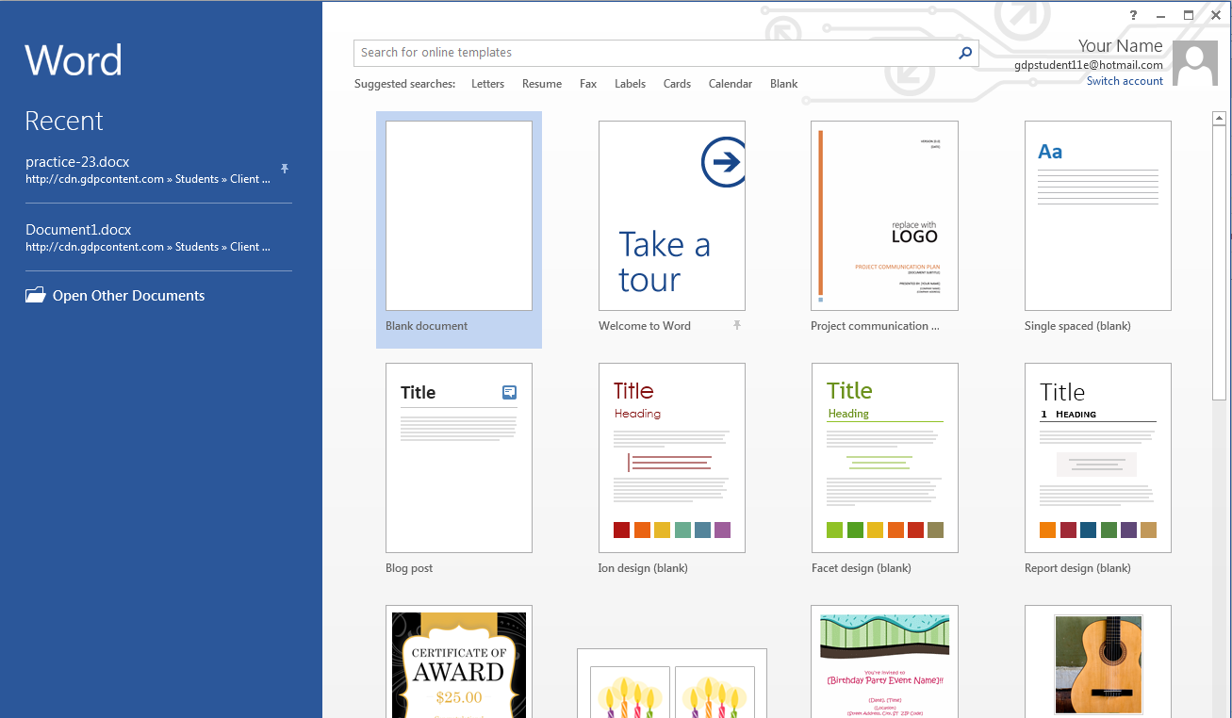

Sample blank document screen (Quick Access Toolbar buttons will vary)

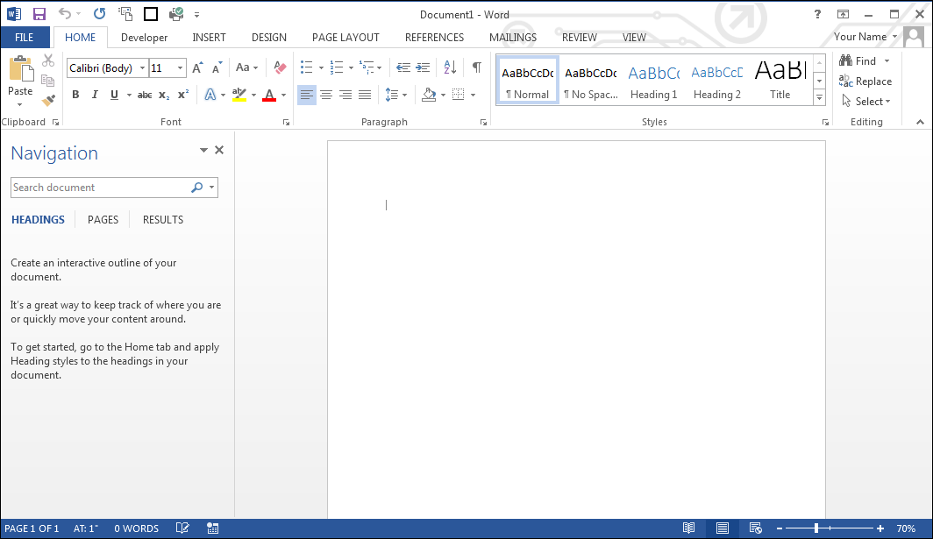

Tab names
All tab names now appear in solid uppercase.

FILE Tab
While not all of the FILE tab options are discussed in Lesson 21, you should familiarize yourself with all the options under the FILE tab. Several options are brand new to Word 2013. The FILE tab includes these features:
- Info: Protect Document, Inspect Document, Versions, Properties, Related Dates and People.
- New: Online template list.
- Open: Places and Recent Document lists and search box.
- Save
- Save As: Places, including SkyDrive, Other Web Locations, and Computer lists (Browse option).
- Print
- Share: Share list and Invite People with option to save to a SkyDrive or Cloud location.
- Export: Create PDF/XPS Document (content can be changed) and Change File Type options
- Close
- Account: User Information, Connected Services such as SkyDrive and option to Add a service, and Product Information.
- Options: Recent Documents pane with recently opened documents. Options and Exit buttons appear at the bottom of the menu.

View Ruler Button
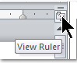 | The View Ruler button was removed from the Word 2013 screen. However, you can view the Ruler in a couple of different ways:
To view the ruler: From the VIEW tab, Show group, check Ruler.
To view the ruler via the Quick Access toolbar (QAT): From the QAT, click the list arrow, More Commands; under Choose commands from, click the list arrow and click All Commands; scroll down to Ruler and click it; click the Add>> button; click OK. Note that the View Ruler button is now the last button on your QAT.

Browse by Page Button
The Browse by Page button was removed from the Word screen’s bottom right-hand corner. To browse by page now, use Ctrl + Page Up and Ctrl + Page Down or drag the vertical scroll box until the desired page appears.

Lesson 24: Spelling and Grammar Check
Procedures for this feature are slightly different. Review this section in Lesson 24.

Lesson 36: Table—AutoFit to Contents
In order for AutoFit to Contents to appear on the shortcut menu after right-clicking a table, the table must first be selected.

Lesson 39: Table—Align Text Right
Cell Alignment is no longer an option on the shortcut menu when you right-click a table cell or row. You must click inside the cell or selected cells and from the TABLE TOOLS, LAYOUT tab, Alignment group, click the desired alignment button.

Lesson 76: Table—Insert, Delete, and Move Rows or Columns
Word 2013 added a convenient way to insert rows and columns.

To insert a row: Point just to the left of the row until you see an Insert Control (a circled plus sign) between rows; click the Insert Control, and a new row will be inserted at that spot.
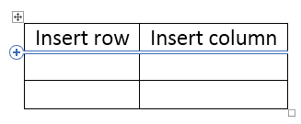

To insert a column: Point to the border of the desired column until you see an Insert Control (a circled plus sign) between the columns; click the Insert Control, and a new column will be inserted at that spot.

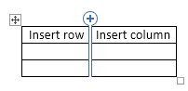

Lesson 80: Table—Styles
Word 2013 changed the selection of predesigned table styles slightly. This difference in appearance is not cause for concern. Students are directed to use a comparable style when making a selection for a table style in Word 2013 document processing jobs

Lesson 88:

Clip Art—Insert
From the INSERT tab, Illustrations group, click Online Pictures; the Insert Pictures dialog box includes these choices:

- Office.com Clip Art: Royalty-free photos and illustrations similar to old Clip Art pane choices.
- Bing Image Search: Search the Web for images.
- SkyDrive: For any users who store images on SkyDrive.

Text wrapping
When an image or text box is inserted, a handy Layout Options icon appears next to the image or text box with all layout options as choices: In Line with Text and With Text Wrapping for Square, Tight, Through, Top and Bottom, Behind Text, and In Front of Text.

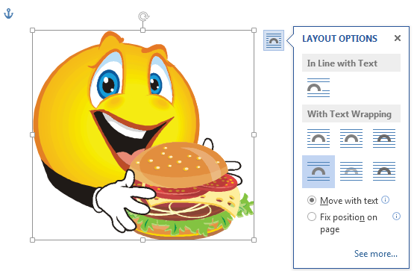

Visually position a picture
When an image or WordArt is inserted and you wish to position it at a margin or paragraph (left, right, bottom, or top) or at any edge of the page, or at the horizontal and/or vertical center of the page, drag the picture to the desired position until a green Alignment Guide line appears, and then release the picture at the desired position.

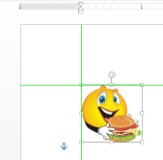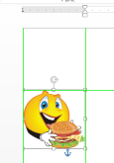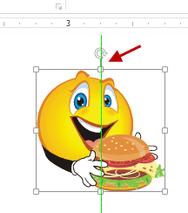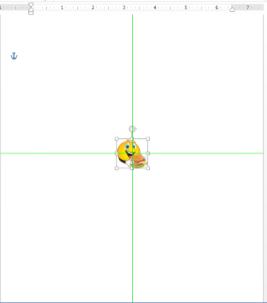

Lesson 103: Text Boxes
The shape styles that are available for text box fills in Word 2013 vary slightly from the text box styles available in previous versions of Word. Because the textbook illustrations depict Word 2007 documents, the appearance of the text box fill and border will differ slightly. This difference in appearance is not cause for concern. Students are directed to use a comparable style when making a selection for a shape style in Word 2013 document processing jobs.

Lesson 106: WordArt
The WordArt Format tab, galleries, styles, and shapes in Word 2007 vary from those in Word 2013. Because the illustrations in the textbook reflect Word 2007 WordArt choices, the appearance of the shape, fill, and outline of WordArt will differ slightly. These differences are not cause for concern. Students are directed to use comparable choices when making selections for WordArt in Word 2013.

Word 2007 (WordArt gallery)
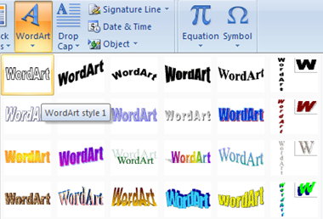

Word 2010 (WordArt gallery) |  | Word 2013 (WordArt gallery, Office theme)
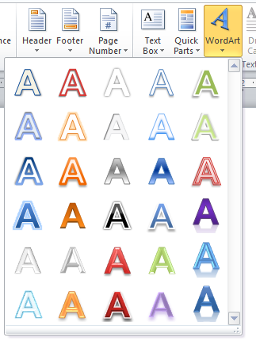 |  | 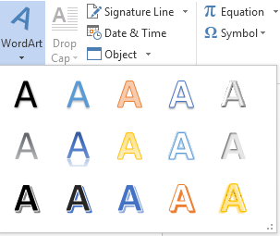

Lesson 107: Page Color
- The Page Color feature is now found under the DESIGN tab rather than the PAGE LAYOUT tab.
- The theme color choices are now found under the DESIGN tab, Document Formatting group, rather than the PAGE LAYOUT tab, Themes group, Colors button.

Lesson 111: Table—Borders and Shading, Custom
- A new Border Painter button has been added to the TABLE TOOLS, DESIGN tab, Borders group, which makes it much easier to apply custom borders to a table, such as in an online resume.
- The Themes feature is now found under the DESIGN tab, Document Formatting group, Themes button, rather than under the PAGE LAYOUT tab.

Appendix C: Modified Normal Style Set
A default Style Set is a group of embedded styles that control “normal” formatting for fonts, paragraph spacing, line spacing, and so forth. When you open a Word document via GDP, a modified “Normal” Style Set is in effect, which uses conventional document formats found in standard style manuals. The modified Normal style in place in GDP controls these Word settings:

 | GDP Modified  Normal Style Set | Word 2013 Default  Normal Style Set
Font | Calibri 12 | Calibri 11
Margins | 1 inch | 1 inch
Line spacing | Single | Multiple at 1.08
Spacing after paragraphs | 0 pt. | 8 pt.

To change the Word 2013 default Normal Style Set to the modified Normal Style Set used in GDP:

Note: After following these steps, all new blank documents will have settings shown in steps 3 and 4.

- Open Word 2013, and click Blank document.
- From the HOME tab, Styles group, right-click over the Normal style button; click Modify.
- From the Modify Style window, under Formatting, click the font size list arrow, and click 12.
- Click the Format button, then click Paragraph; from the Paragraph dialog box, under Spacing, set Before/After to 0 pt.; under Line spacing, click Single; click OK.
- At the bottom of the Modify Style window, click New documents based on this template; click OK.

To change the modified Normal Style Set used in GDP back to the Word 2013 default Normal Style Set:

Note: After following these steps, all new blank documents will have settings shown in steps 2 and 3.

- Open Word 2013, and click Blank document.
- From the HOME tab, Font group, click the dialog box launcher; from the Font window, Font tab, Size box, click 11; click the Set As Default button at the bottom of the Font tab; click OK; click All documents based on the Normal.dotm template, OK.
- From the HOME tab, Paragraph group, click the dialog box launcher; from the Paragraph window, Indents and Spacing tab, click in the Spacing, After box and type 8; under Line Spacing, click Multiple; click in the At box and type 1.08; click the Set As Default button at the bottom of the Font tab; click OK; click All documents based on the Normal.dotm template, OK.

