
MOVING FROM WORD 2013 TO WORD 2016, 11e (8.15.16)
INTRODUCTION 1
FEATURE CHANGES 2
Lesson 21, Word 2016 Screen 2
Lesson 88, Clip Art Replaced by Online Pictures 2
TECHNICAL NOTES 2
Microsoft Office Updates and Word 2016 2
Word Settings for Expected GDP Behavior 3

INTRODUCTION
Below is a list of substantive changes made to the 11e Word Manual for Word 2016:

- Five Word features were retired because they were technically impractical or unnecessary.
- Two Word features were added to help students proofread.
- A new Download icon was added to cue students to download a file from GDP, and the REFER TO and GO TO Textbook icons were redesigned.

Retired | Added | Icons
L. 25: E-Mail a Document  L. 29: E-Mail—Attachments  L. 32: Page Break  L. 44: E-Mail—Copies  L. 68: E-Mail—Blind Copies | L. 24: Navigation Pane—Search  L. 24: Speak | New icon cues students to download a file via GDP.  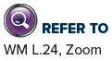  

- Appendix A includes new subheadings for easier reference to related Word settings.
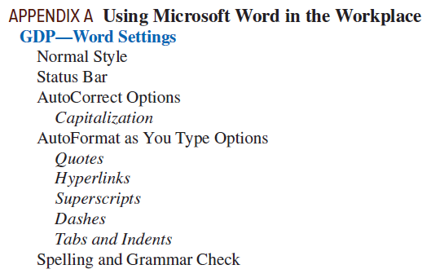

- Formatting codes are displayed in all illustrations to help ensure more accurate keystroking and scoring. These codes provide a visual cue to students so they know how many times to press ENTER or when to press TAB, for example.

FEATURE CHANGES

Lesson 21, Word 2016 Screen
- The Tell Me box is Word’s new search feature.
- The Ribbon Display Options button is used to view the Ribbon in various ways.
- The Share Options is used to share documents in the cloud.
- Tab names now appear with initial caps.
- The old PAGE LAYOUT tab is now the Layout tab.
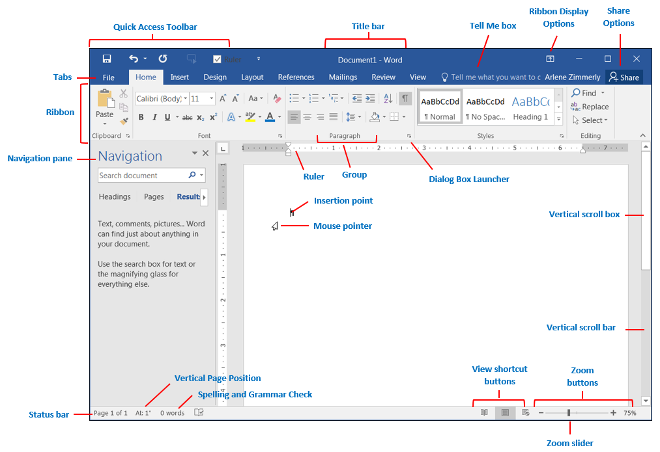

Lesson 88, Clip Art Replaced by Online Pictures
This Web-based feature is controlled by Microsoft and it changes dynamically. Microsoft’s Bing search engine populates the search results with images related to the search keywords. There is no longer a choice to display only Microsoft clip art. Copyrights to images must now be considered since the Internet is being searched. Search Word Help for “online pictures” for details.

TECHNICAL NOTES

Microsoft Office Updates and Word 2016
Microsoft is moving to Office 365 subscriptions vs. buying Office “out of the box.” Software updates are ongoing and unpredictable. To be sure you are using the current version of Microsoft Office, open Word. From the File tab, click Account. Under Product Information, click the Update Options button, and click Update Now. Click the What’s New button for more information on updates. You will need to decide how to handle updates in your classroom as well as how to direct your students to handle updates at home.
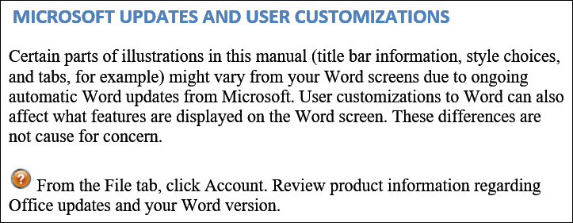
This disclaimer appears in Getting Started. We don’t anticipate that any updates will have a noticeable impact on any features we teach. If any future updates affect course content, we will address it at that time.

Word Settings for Expected GDP Behavior
For Word to behave as expected in Practice exercises and document processing jobs, all these Word settings must be in place both in your classroom and at home for your students. See Appendix A, Using Microsoft Word in GDP, in the Word Manual for a complete list of recommendations.
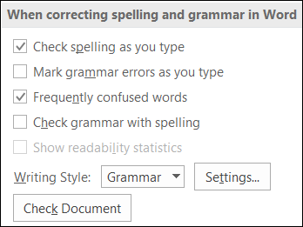
From the File tab, click Options at the bottom of the pane. Click the Proofing tab in the left pane. From the right pane, under When correcting spelling and grammar in Word group, check/uncheck these boxes in the illustration at the right:

From the File tab, click Options at the bottom of the pane. Click the Proofing tab in the left pane. From the right pane, click AutoCorrect Options, and change settings as shown in the illustrations below:

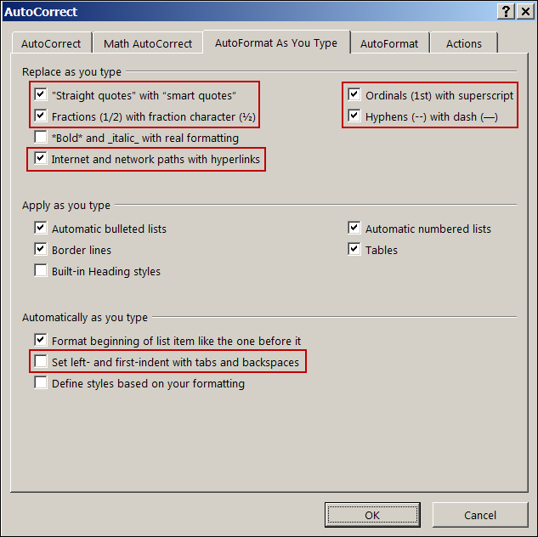
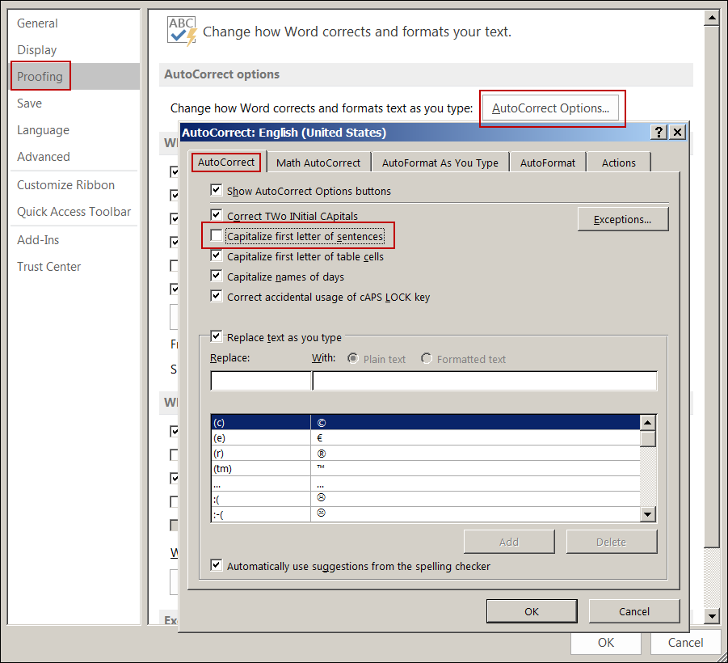

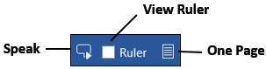
 Consider adding these features to Word’s Quick Access Toolbar in your classroom for these frequently used features: Speak, View Ruler, and One Page.

- Click the QAT list arrow, More Commands. From the Word Options window, under Choose commands from, click the All Commands list arrow. In the box below that, scroll down and click Speak. Click the Add >> button, OK.
- From the View tab, Show group, right-click Ruler; click Add to Quick Access Toolbar.
- From the View tab, Zoom group, right-click One Page; click Add to Quick Access Toolbar.

