
PRACTICE EXERCISES & DOCUMENT PROCESSING IN GDP

Understanding Browsing Concepts: 2
Completing Lesson 21E, Practice Exercise 3
In Internet Explorer (*BP): 3
In Firefox: 4
Completing Lesson 30, Correspondence 30-19 5
GDP—Start Work (Download File to Begin Work)(*BP) 5
Reference Manual in GDP 6
GDP—Return to GDP (*BP) 6
GDP—Browse (Upload/Save File to GDP) 6
Work at a Second Location 7
GDP—Submit Work (Score Your Work) and View Scoring Results 7
Proofreading Check 8
GDP—Edit Work (Download Previous File) and View Scoring Results (BP*) 9
Changing a Previous Document Processing Job 9
Using Reference Initials 10
Viewing Comments in the Portfolio 10
Understanding Time Spent and Total Time in the Portfolio (*BP) 14
Understanding Attempt Origin in the Portfolio (*BP) 15
Understanding Proofreading Checks and Attempt Origin in the Portfolio 15


Tip: GDP uploads all skillbuilding activities automatically. Downloading and uploading files does not begin until the Practice exercise in Lesson 21. This practice exercise is ideal to practice downloading a resource file, which happens in Practice exercises for Lessons 21E, 22D, 24E, 29L, and 89H, to save files, and to close Word and return to GDP. Similar routines are used to download files to be inserted in document processing jobs for Lessons 89, 109, and 110.

- Begin with, Part 2, Unit 5, Lesson 21E: Orientation to Word Processing—A, and the corresponding Practice exercise in your Word Manual. You will download a resource file to be used during the Practice exercise, launch the Practice exercise, and open and save files.
- Next, move to Part 2, Unit 6, Lesson 26, Correspondence 26-3: Business Letter in Block Style. Type this typical document processing job in which you download and save files, close Word, and return to GDP. Use Browse and Submit Work to display the Scoring Results window.
- Before beginning any of these steps, close all other instances of Word that might be open; if possible, close all other browser windows and any other software programs. Launch Internet Explorer or Firefox, go to the custom URL (Web address) for your school, and log in to GDP.

Understanding Browsing Concepts:
Depending upon your Windows version, the Save As dialog box will differ. The one shown next is from Windows Vista. Basic browsing concepts explained here should apply to other Windows versions:

- The Save As box displays a path to the active directory. In this case “hp” is the user name, and Desktop will move you to directories and files stored on the Desktop.
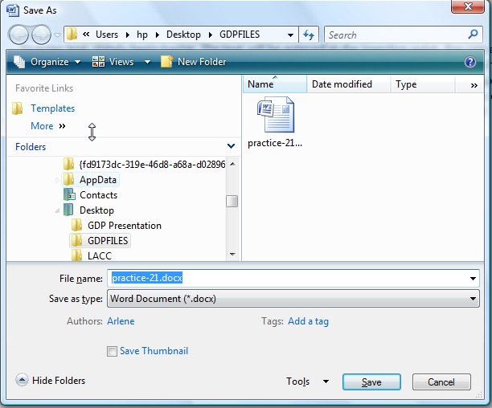

- If you click “Desktop,” you will back up in the directory path to “Desktop,” and under Folders, you could click Downloads to save to that directory or continue scrolling though the directories listed under Folders until you find the desired one (creating a GDPFILES directory is recommended as a best practice); then verify that the correct file name is still displayed in the File Name box, and click Save.
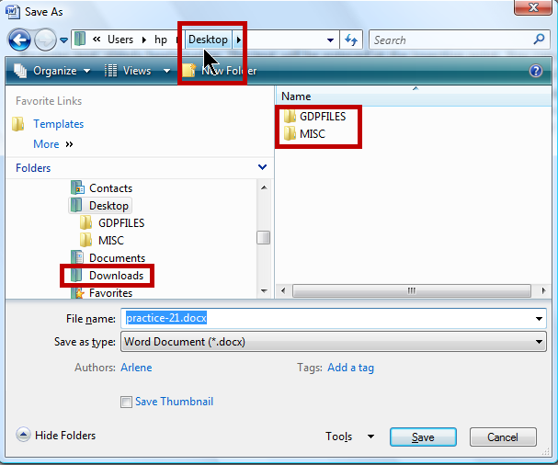

Tip: Whenever you wish to verify the location of the directory where you are saving a file, click F12 (or Save As from the Microsoft Office button in Word 2007 or the File tab in Word 2010).

Completing Lesson 21E, Practice Exercise
Navigate to the desired Practice exercise (in this case, go to Part 2, Unit 5, Lesson 21E).

Note: This particular Practice exercise is highly unusual in that it requires you to download and save a Resource file first before clicking Start Work to begin the actual Practice exercise. This hands-on activity will reinforce basic Windows file management skills you’ll need to complete any future Practice exercise or document processing job. No practice exercises are ever permanently saved in the GDP Portfolio. You should save them in the GDPFILES directory on the Windows Desktop or any desired location in case you need to refer to them later.

Your steps from this point forward will vary depending on your browser and any defaults you might have set to save downloaded files from the browser and to save files in GDP.

In Internet Explorer (*BP):

Best Practice! When you save a file, always save to the same location (GDPFILES directory is recommended) so you can find this file easily when you need to open it later. See Getting Ready for GDP11e With Internet Explorer or Getting Ready for GDP11e With Firefox, “Create GDPFILES Directory,” for steps.
- Click Download File. Note that a new browser window appears with a File Download dialog box on top. Do either of these things:
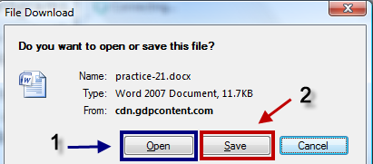
Either: Click Save to open the Save As dialog box to save the file to the GDPFILES directory (or any desired location)—you may edit the file name if desired; then click Open.
Or: Click Open to download the file and launch Word; then you can press F12 to open the Save As dialog box and save to the GDPFILES directory (or browse to any desired location).

- Complete the Practice exercise.

For Internet Explorer 9:

- Click Download File. Note that a new browser window appears with a Windows Internet Explorer dialog box on top. Do either of these things:

Either: Click Save As to open the Save As dialog box; browse to the GDPFILES directory (or any desired location), and click Save—you may edit the file name if desired; from the View Downloads dialog box, click Open to launch Word.
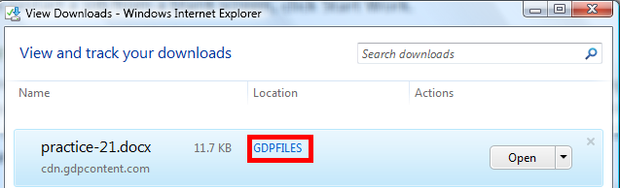
Note: If you see a Save button, click the list arrow next to the Save button and click Save As; browse to the GDPFILES directory and click Save; click Open to download the file and launch Word.

Or: Click Open to download the file and launch Word; then you can press F12 to open the Save As dialog box and save to the GDPFILES directory (or browse to any desired location).

- Complete the Practice exercise.

In Firefox:
- Click Download File.
- Note that a dialog box opens with options to Open with or Save File.
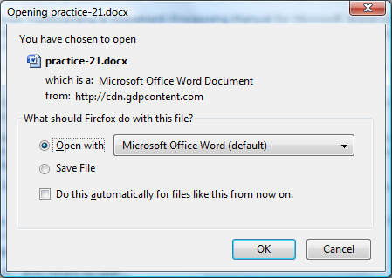

Either: Click Open with, and be sure Microsoft Office Word (default) is selected; click OK to open in Word.

When the download is complete and you open Word, you’ll see this Downloads list. To see where the downloaded file is saved, right-click the file name and click Open Containing Folder; close the Downloads list if desired.
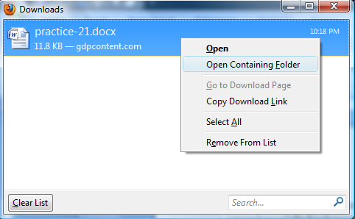

Or: If you wish to save the downloaded file elsewhere, click Save File. To see where the downloaded file is saved, right-click the file name and click Open Containing Folder as shown in the previous screen shot; close the Downloads list if desired. Double-click the file in the Downloads list to open it.

The file will open in Word and you can press F12 to open the Save As dialog box and browse to the desired folder.
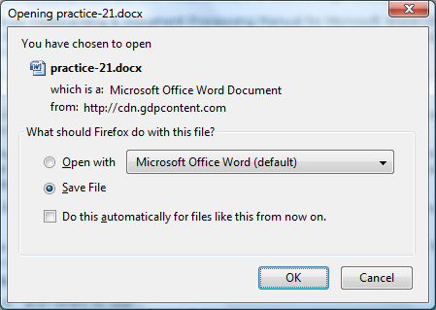

Completing Lesson 30, Correspondence 30-19

GDP—Start Work (Download File to Begin Work)(*BP)
- Navigate to the desired document processing job in GDP; click Start Work.

Best Practice! Time Spent begins from the moment you click Start Word to the moment you click Submit Work. If Time Spent is a grading factor, work quickly to complete these file management activities.
Note: When you click Start Work, any previous attempts at this job are not used. GDP opens a starting file for this document (typically, a blank screen with an assigned file name), and this is considered a new attempt at this job starting from a blank screen with time reset to zero.
- Download the file. See the steps for either Internet Explorer or Firefox.

Best Practice! When you use Start Work, save your Word file to the same location each time. Creating a GDPFILES directory on the Windows Desktop or in any desired location such as your flash drive is recommended.

- Complete the document processing job.

Note: To restart a job from a blank screen, click Start Work.

Reference Manual in GDP
Always review any formatting information or special steps in the textbook before beginning so you will correctly format the document. Also use the Reference Manual in the front of the textbook and Word Manual or the electronic Reference Manual in GDP (click Reference Manual, CORRESPONDENCE, block style, Business Letter in Block Style) if desired. Online Reference Manual, 11e [PDF] is a handout that includes enlarged copies of the documents and formatting notes in the Reference Manual found in GDP and in the front of the textbook and Word Manual. Each item is enlarged on a single page and includes rollover screen tips with helpful formatting information.

GDP—Return to GDP (*BP)
- To return to GDP, click Save As to save the file—browse to the desired directory as needed.
- Close Word by clicking the Close (X) button at the top right of the Word screen.
Best Practice! When you save a file before closing it, always use Save As (F12) rather than Save. to verify the save location (GDPFILES directory is recommended) so you can find this file easily when you use Browse. You may change the file to anything you like if that makes finding the file easier when you use Browse.
- Resume GDP activities from the GDP11e – Internet Explorer browser window, which should now be open.
Or: In the Windows Taskbar, click the task button named GDP11e – Internet Explorer or GDP11e – Mozilla Firefox to resume GDP activities.
- If necessary, close the window with the scored copy.

GDP—Browse (Upload/Save File to GDP)
- Under Upload, click Browse—the active directory should be GDPFILES, or you may browse to the desired directory.
- Click the most recent version of the document to be uploaded; click Open. When the Browse box displays the path to the uploaded file, several things happen:
  - That file is now saved on the Internet but will not yet appear under My GDP, Portfolio. You can now move to a second location, if desired, and resume work at a second location.
  - A time stamp has been added. Time Spent begins when you click Start Work and ends when the file name appears in the Browse box after clicking Browse. When you click Submit Work to score work and send it to the Portfolio, Time Spent is recorded. However, if you leave the GDP screen for that job and return later, Time Spent continues to accumulate. See Understanding Time Spent and Total Time in the Portfolio for details.

Work at a Second Location
After you use Browse to the desired file, that file is now saved on the Internet. If you wish to move to a second location to continue work, open GDP at the second location, navigate to the same document in the Lessons menu, click Edit, and the file you uploaded using Browse will download and open ready for you to resume work. Remember that Time Spent continues to accumulate until you click Submit Work. See Understanding Time Spent and Total Time in the Portfolio for details.

GDP—Submit Work (Score Your Work) and View Scoring Results
- Under Submit, click Submit Work; your work will now be scored and sent to your instructor and to your GDP Portfolio, a Scoring Results window will display your scored copy, and Time Spent ends.
- Note that a Scoring Results (aka Proofreading Viewer) window appears with your scored text.
- Review your color-coded keystroking errors and any Formatting Alerts that might be present; click Close (X).
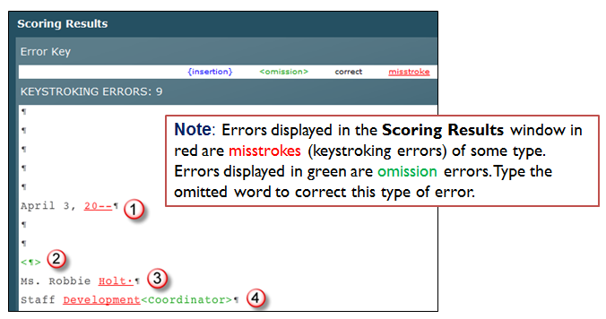
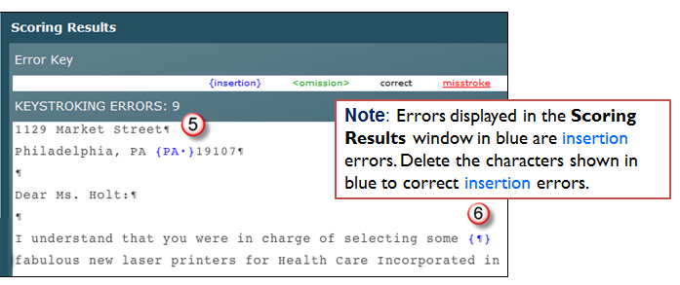
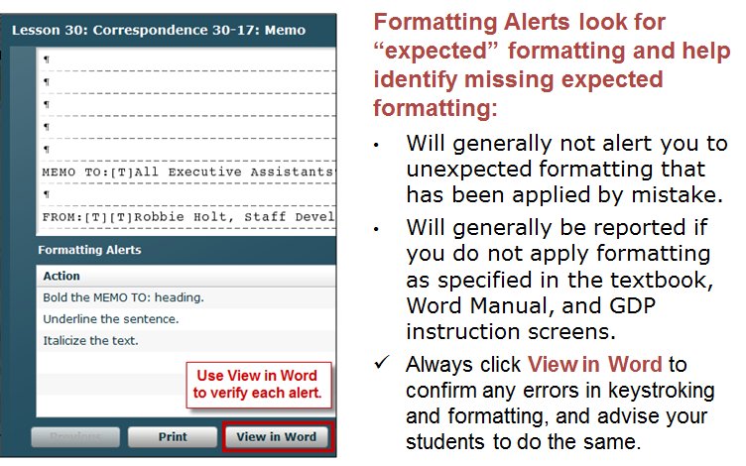

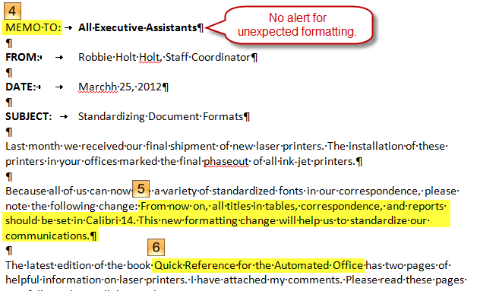

Note: To correct errors, follow the steps under GDP—Edit Work; when you click Submit Work, the scoring results for the newly edited job will appear in the scoring window.

Proofreading Check
Correspondence 30-19 is marked as a Proofreading Check in your textbook; however, your instructor may designate another document to be treated as a Proofreading Check. Check with your instructor for your own course requirements. See “Understanding Proofreading Checks and Attempt Origin in the Portfolio” for special procedures in completing a Proofreading Check job.

Instructor Note: Use the Delay Results Scheduling feature for jobs you designate as Proofreading Checks so students will not see their scored copy until the Delay Results date has passed—perhaps at the end of the school term. You could also use an End Date so they cannot access the job to edit it until after an End Date has passed. See Scheduling and Report Strategies for Testing & Document Processing for details.

GDP—Edit Work (Download Previous File) and View Scoring Results (BP*)
- Navigate to the desired document processing job in GDP; click Edit Work.
- Internet Explorer: A new browser window appears with a File Download dialog box on top; click Open to download the file and launch Word.
Internet Explorer 9: A new browser window appears with a View Downloads dialog box on top; click the list arrow next to the Save button and click Save As; browse to the GDPFILES directory and click Save; click Open to download the file and launch Word.
Mozilla Firefox: A dialog box appears; click Open with and click the Microsoft Office Word (default) button to launch Word and open the file immediately, or click Save, OK, to save the file (a Downloads window opens with the newly downloaded file at the top of the list) and double-click the downloaded file from the Downloads window list to then open it in Word.
Best Practice! Note that the most recent version of the document that was last uploaded when you used Browse in GDP opens with the end of the original name changed (you might see “[1]” added to the end of the name) to help you identify this file as an edit of the most recently uploaded attempt.
- Note that a Scoring Results window displaying your scored copy opens behind the Word window. To view both the Scoring Results window and the Word window:

Best Practice! To move back and forth from the Scoring Results window to the Word document:
Either: Press Alt + Tab.
Or: Use the Windows Taskbar and alternately click the buttons for GDP11e and the Word file.

- Edit the document, click Save As to save the file to the desired directory, and return to GDP.

Note: You may name this file anything you like to distinguish this file name from previous attempts if that makes it easier to find this file when you use Browse in the next step. Close the Scoring Results window, which is no longer current—it still displays the scored copy for the previous attempt.
- Under Upload, click Browse—the active directory should be GDPFILES, or you may browse to the desired directory.
- Click the most recent version of the document to be uploaded; click Open, which replaces the previous version of this job with your most recent attempt.
- Click Submit Work to rescore this most recent attempt and open the scored copy window.

Changing a Previous Document Processing Job
In certain document processing jobs, you will open a previous job and change it. For example, in Part 2, Unit 6, Correspondence 26-4, you are directed to open the file for Correspondence 26-3:
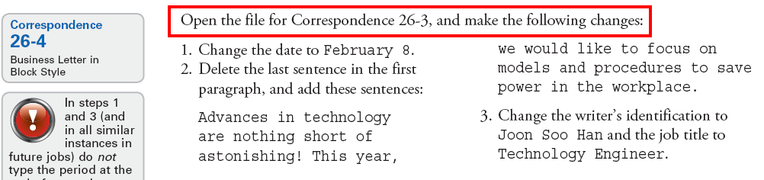

In the textbook, when you are directed to open a previous job to change it, follow these steps:

- In GDP, navigate to the desired job (in this example, navigate to Part 2, Unit 6, Lesson 26, Correspondence 26-4).
- Click Start Work; note that GDP downloads the most recent attempt of the job to be edited (in this case, GDP11-2007-Unit06_Cor026-3.docx) and the file opens with the file name of the most recent attempt of the original job.
- After you open the file in Word, edit the file following the steps in the textbook for that job (in this example, steps for Correspondence 26-4 are found on page 91 of the textbook).
- Save the edited file with a new name (in this case, simply change the “3” to a “4” in the file name so the file would be named GDP11-2007-Unit06_Cor026-4.docx).

Using Reference Initials
In certain document processing jobs, students are directed to use reference initials. For example:
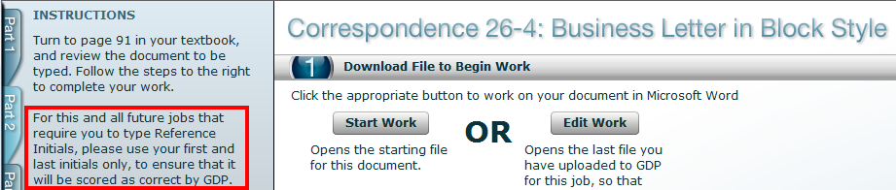
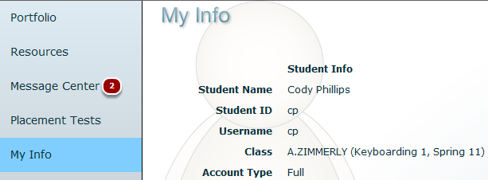
GDP will score your reference initials based upon the initials in the Student Name under My GDP, My Info. Therefore, the student in this example should type “cp” in place of “urs” when he types reference initials in documents.

Viewing Comments in the Portfolio
- Under My GDP, click Portfolio.
- To refresh your screen, click Show All to display all work (including recently submitted work).
- Click on Date, Lesson, Title, and Total Time column headings to sort and reverse sort—note that a “1” appears with a down or up arrow to indicate the primary sort column and the sort direction.
- Click the desired item to expand it; then click on Attempt, Keystroking Errors, Formatting Errors, Time Spent, and Last Modified column headings to sort and reverse sort.
- Note that a red “A” flags all items with annotations—always scroll down in case any annotated items are hidden, and click Show All to be sure that all work is displayed.
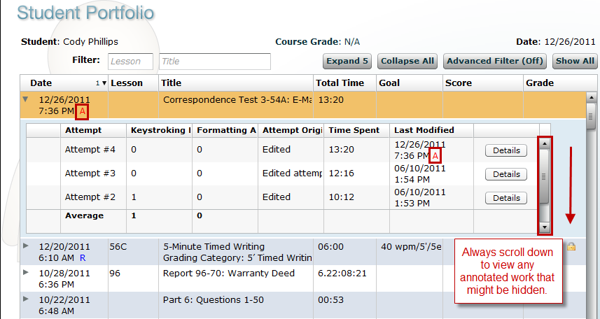

- Click Advanced Filter (Off); in the Filter Student Portfolio dialog box, check Annotated only to view only annotated work; click OK to apply any checked filters.
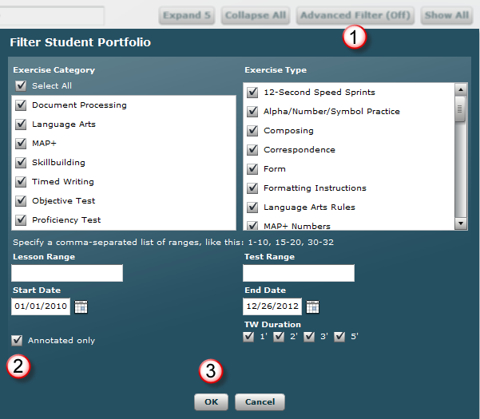
- When you return to the Portfolio, note that only annotated work is displayed; when you point to Advanced Filter (On), you will see which advanced filters are in effect. 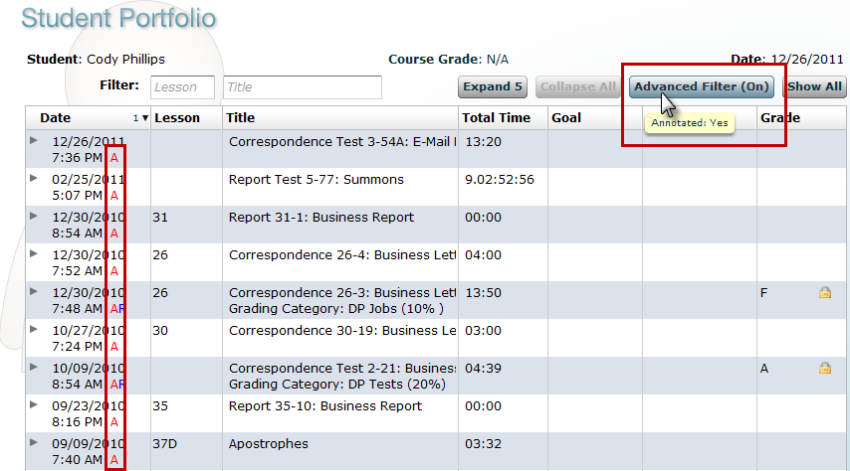
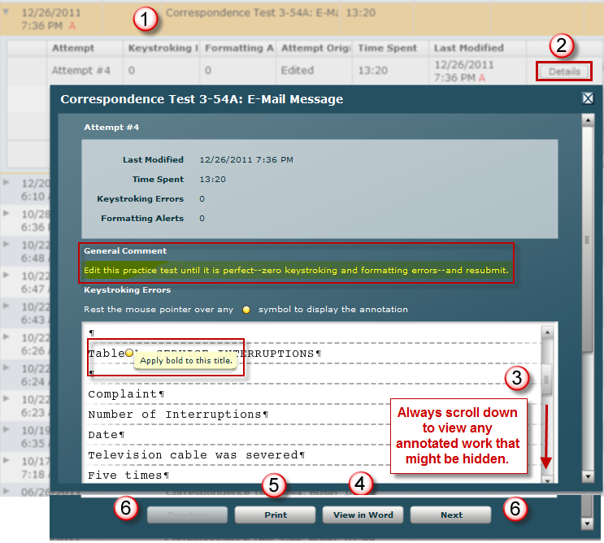
- To view work:
(1) Click the desired exercise to expand it.
(2) Click Details to view details such as Comments (General Comments and Annotations).
(3) Always scroll down to view any annotated items that might be hidden;
(4) Click View in Word to download and open a document processing job in Word.
(5) Click Print to print the document.
(6) Click Next to browse to the next attempt or Previous to browse to the previous attempt or close the window.

Tip: Because printouts include all instructor comments (unless your instructor has a Scheduling restriction in effect for the item), consider printing any desired job to use it as a study guide, particularly for any practice tests you might be assigned.

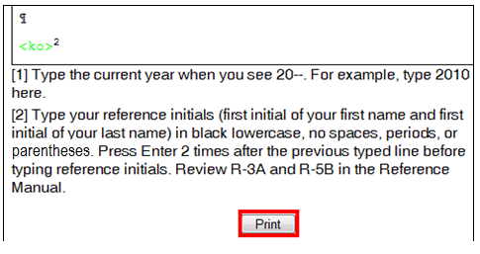
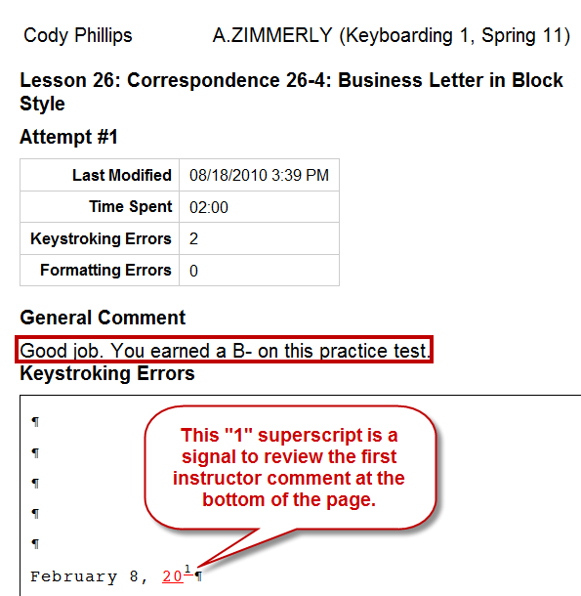

- Click the exercise name or Collapse All to collapse any expanded item.

Understanding Time Spent and Total Time in the Portfolio (*BP)
Best Practice! On jobs in which time is a grading factor, use Browse followed directly by Submit Work—do not navigate away from the screen for that job for any reason or your Time Spent will continue to accumulate. Try to perform all file management actions (downloading, opening, saving, and browsing) quickly and efficiently to minimize Time Spent. See Time Spent and Total Time in the Portfolio for details on time tracking for document formatting and Practice exercises.

When you complete a document processing job in which time is a factor in grading, review the Student Portfolio for time tracking:

- Under My GDP, click Portfolio; click the desired job to expand it.
- Note the Time Spent column and the Total Time for each attempt.

To understand how GDP tracks time so you can complete jobs in a timely manner, read this:

- Time Spent begins at zero when you click Start Work and ends when the file name appears in the Browse box after clicking Browse, assuming you click Submit Work next without leaving this screen. When you click Submit Work to score work and send it to the Portfolio, Time Spent is recorded and ends with the time elapsed when you clicked Browse. However, if you leave the document processing job screen for any reason (including exiting and reopening GDP) or if you use Edit Work without clicking Submit Work, GDP will continue adding minutes to your Time Spent for that job until you finally click Submit Work. Also, any action taken prior to using Submit Work (such as using Edit Work one or more times in a given session) is still considered to be a single attempt on that job in the Portfolio.
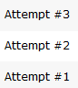
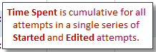
- Time Spent is cumulative for all attempts in a single series of Started and Edited attempts. However, when Start Work is used again, Time Spent restarts from zero. Also, Total Time is cumulative for all attempts. 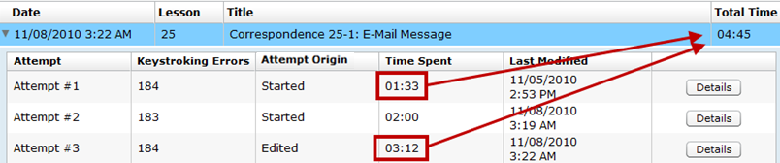

Here are some examples:

- If you spend 3' from Start Work through Browse (but don’t click Submit Work); then you spend an additional 2' to move away from the job or to exit and reopen GDP, return to the job, use Browse again, and then click Submit Work, GDP records your Time Spent as 5'.
- If a you spend 3' from Start Work through Browse (but don’t click Submit Work); then you take another 44" to use Edit Work, Browse to the most recently edited file, and then Submit Work, GDP records your Time Spent as 3:44 (3' + 44"). Both the Start Work and Edit Work sessions are reported as Attempt #1 with Attempt Origin as Started because Submit Work, which sends work to the Portfolio and to the instructor, was never used after the initial Start Work session.
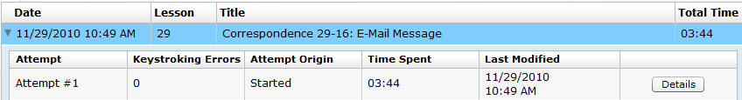

Understanding Attempt Origin in the Portfolio (*BP)
Best Practice! Under Attempt Origin, if you see “Started,” it means you used GDP’s Start Work button to download the starting Word file. If you see “Edited,” it means you used GDP’s Edit button to download the most recent Word file you uploaded to GDP. You edited the file, saved it, used Browse to upload the edited file, and used Submit to score the job. That is the correct and recommended GDP routine to edit a document processing job.

Under Attempt Origin, if you see “Edited attempt x,” it means you used an incorrect routine to edit a document processing job. Rather than using GDP’s Edit button as described previously, you opened Word and then opened the Attempt #2 Word file perhaps using Word's File, Open, or perhaps by using Word's Recent Documents list; you then Used GDP's Browse and Submit buttons. This incorrect routine can skew Time Spent and other factors that might be used in grading and is never recommended.

Understanding Proofreading Checks and Attempt Origin in the Portfolio
Five documents have been designated on the Computer Keyboarding Online 11e Web site as Proofreading Checks. (Check with your instructor regarding your own course requirements.)

- Week 8, Correspondence 27-6, letter
- Week 9, Correspondence 30-17, memo
- Week 10, Report 31-1, business report
- Week 11, Report 34-7, academic report
- Week 13, Table 39-12, ruled table

Here are the guidelines for completing a successful Proofreading Check attempt:

- Each Proofreading Check document must be proofread with 100% accuracy; that means that in the Portfolio, Keystroking Errors must be “0” and the Attempt Origin must be "Started"; for example:
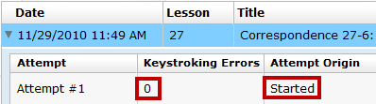
Attempt #1, a Started Attempt with 0 Keystroking Errors, is a successful Proofreading Check.

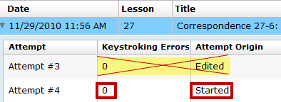
Attempt #4, a Started Attempt with 0 Keystroking Errors, is a successful Proofreading Check.
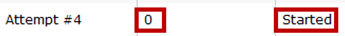
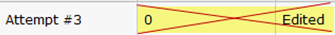
Attempt #3, an Edited attempt with 0 Keystroking Errors, is an unsuccessful Proofreading Check.

- If any Keystroking Errors are noted, 1% point will be deducted from your final grade average.
- If you finish a document and are not yet ready to score it, don't click Submit Work.
- To regain a lost Proofreading Check point, recreate the document using Start Work to begin again from a blank Word screen, and retype the job. You must have zero Keystroking Errors in the Portfolio to regain a lost point.

