TYPING SPEED REQUIREMENTS FOR ADMINISTRATIVE POSITIONS

An Action-Research Project
Scot Ober, July 2011

Method
Online ads for office/administrative/secretarial positions were scanned, using monster.com, Craigs List, and careerbuilder, searching for help-wanted ads that required minimum typing speeds. The search identified 30 such listings, shown in the appendix in the order identified. For the statistics, when an ad required a range of speeds, such as “50-60 wpm,” the average (55 wpm) speed was used. When the ad required, for example, “55+ wpm,” 55 wpm was used.

Results
- Most ads do not require a predetermined typing speed, instead using such phrases as “competent typing skills” or “proficient in typing and Microsoft Office” (most often Word and Excel).
- Required minimum speeds ranged from 35 wpm to 85 wpm. The lower speeds were typically associated with entry-level positions or positions for which typing was not the major requirement (such as for receptionist) and typically did not require any college degree; the higher speeds (often for legal-secretary positions) typically required a minimum number of years of related work experience and typically did require some type of college degree.
- The most common speed requirement (mode) was 60 wpm, accounting for 43 percent of the listings.
- The average speed requirement (mean) was 58 wpm.
- The middle speed requirement (median) was 60 wpm.
- Job applicants who type at least 40 wpm would qualify for 10 percent of the positions that listed minimum typing speeds, those typing 50 wpm would qualify for 18 percent of the positions, and those typing 60 wpm would qualify for 80 percent of the positions.
- Only a few of the listed jobs stated an accuracy requirement; a few listed such phrases as “with accuracy”; one required “with 94% accuracy.”
Note: The goal speed requirement for a grade of C at the end of the McGraw-Hill Gregg College Keyboarding & Document Processing Book 1 (Lessons 1-60) is 40 wpm; for Book 2 (Lessons 61-120), a grade of C requires 50 wpm. The Cengage Keyboarding & Word Processing keyboarding text does not provide speed goals at any point.

Conclusion
Regardless of their competence in word processing, students need high-level typing speeds (typically, at least 60 wpm) in order to even be hired for office positions. Achieving this level of speed requires extensive and systematic skillbuilding practice at every level of keyboarding instruction.

APPENDIX

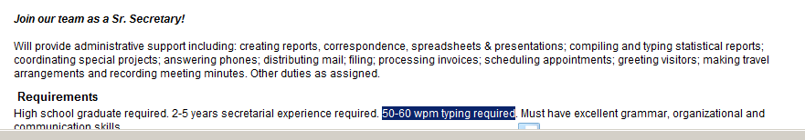
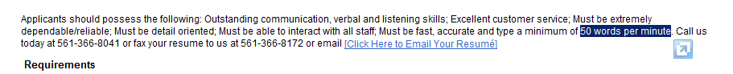
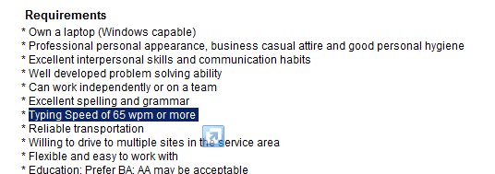

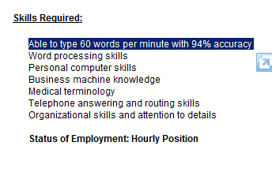


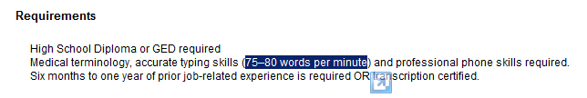
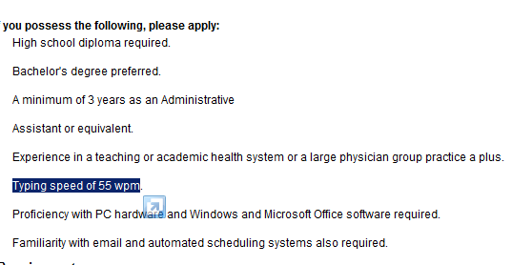
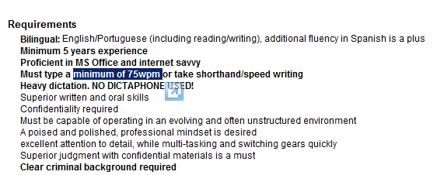
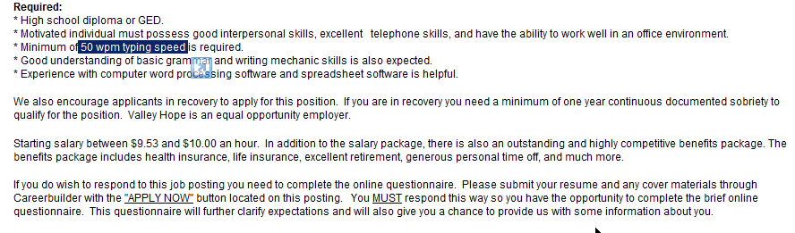
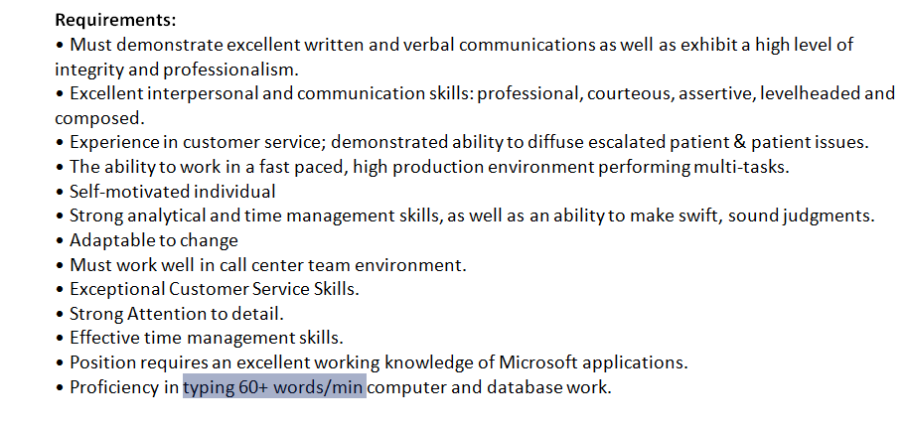
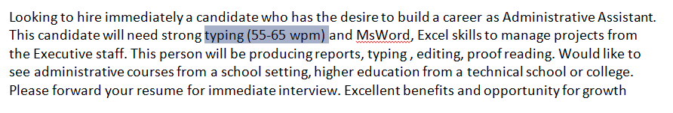
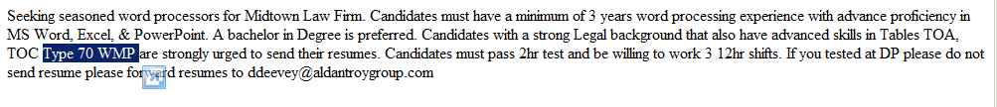
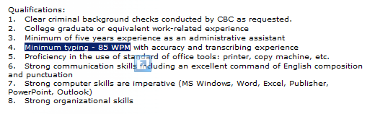
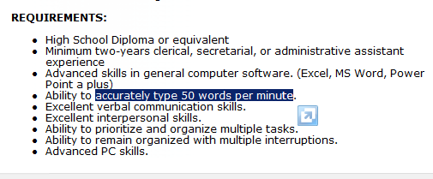
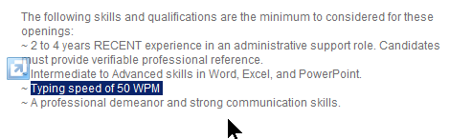
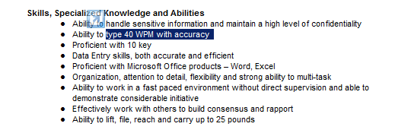
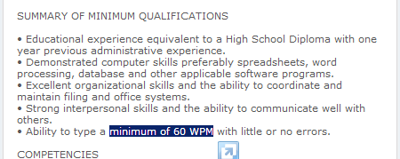
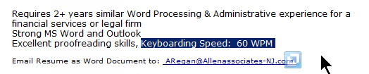
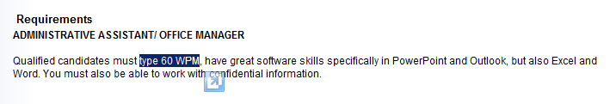
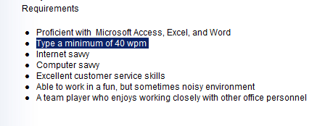
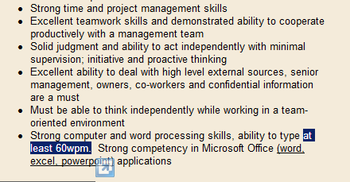
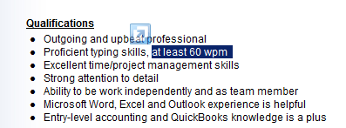

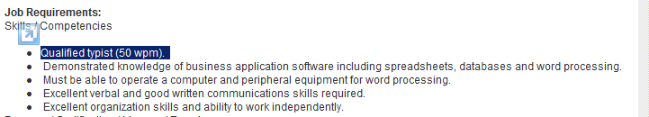
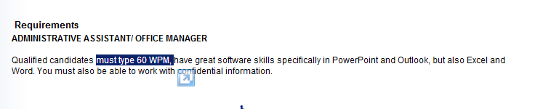
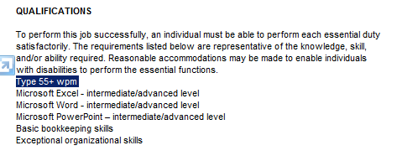
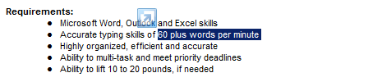


Scot Ober is the senior author of
Gregg College Keyboarding & Document Processing, 11e,
published by McGraw-Hill, 2011.

