
TECHNIQUE CHECK COPY, Lesson 10
- Practice typing the copy in the box, which includes all keys learned in the first ten lessons, keeping your eyes on the copy. Try splitting this Word document screen as follows:
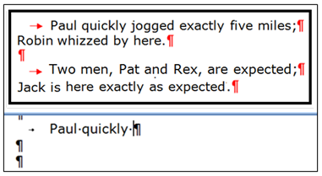
  - Scroll down this page until the technique check copy is positioned at the top of the Word screen.
  - From the View tab, click Split.
  - Drag the blue bar down to split the window into two parts—the technique check copy should display in the top and page 2 in the bottom.
  - Scroll the bottom half of the split screen down until you see the top part of the second page.
  - Click inside any blank line at the top of page 2,
and practice typing the technique check copy.
- You do not have to type fast, just carefully using good technique. Do not correct errors as you type the copy in the box! You will demonstrate proper technique using the Backspace copy.
- Press Tab (→) at the start of the paragraphs. Press Enter (¶) as shown in the copy.
- Skillbuilding to relearn a key. Click Skillbuilding, New Keys tab; click the desired key to move to the lesson of introduction; review the demonstration and type the drills to relearn the key.
- MAP+ for Additional Skillbuilding Drills, Lessons 1-18. If you are on Lessons 1-18, click MAP+, Lesson 1-18; from the drop-down list, click the desired lesson for unlimited additional practice drills on all keys learned up to the selected lesson.
- MAP+ for intensive practice on any key. For Lesson 17 and beyond, click MAP+; click any key on the “live keyboard” to go to intensive practice drills for that key.
- MAP+ for diagnostics: Alphabet (Lesson 17 on), Numbers (Lesson 19 on), and Symbols (Lesson 20 on). After you have completed Lesson 17 (for Alphabet diagnostics), Lesson 19 (for Numbers diagnostics), or Lesson 20 (for Symbols diagnostics), click MAP+, Pretest; from the drop-down list, click the desired drill, take the pretest, and follow the prompts to complete the prescriptive drills.
Note: Many students have a tendency towards incorrect fingering on the keys listed below. Before you come in, take special care to use correct fingering on these keys to avoid repeating the technique check at another time.
C | Lesson 5D: Typed with the D finger.
X | Lesson 7B: Typed with the S finger.
B | Lesson 5B: Typed with the F finger.
Period | Lesson 4D: Typed with the L finger.
Left Shift | Lesson 4C: Hold the left Shift down to capitalize any letters typed with the right hand.
Right Shift | Lesson 6B: Hold the right Shift down to capitalize any letters typed with the left hand.
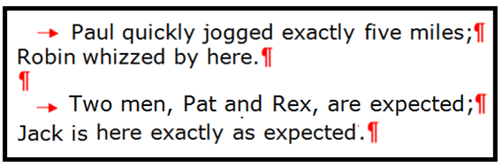

Backspace Key: When you reach the Backspace sign (), backspace 1 time; then type the next letter.

