
TECHNIQUE SELF-ASSESSMENT

Name ____________________________________________ Date ___________________

Workstation | Acceptable | Needs  Improvement
- Position chair so upper/lower legs form a greater-than-90-degree angle, with lower back supported and knees slightly lower than hips. |  | 
- Position text on either side of monitor as close to monitor as possible. |  | 
- Tilt top of monitor slightly away from you and slightly farther than an arm’s length from you. |  | 
- Position the mouse on a pad next to and at the same height as the keyboard.  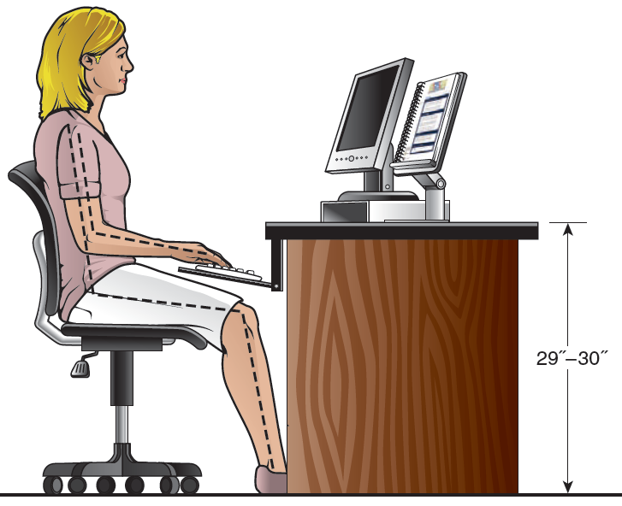 |  | 

Position at Keyboard | Acceptable | Needs  Improvement
- Center your body in front of keyboard. |  | 
- Sit slightly reclined with lower back touching chair; feet flat on floor. |  | 
- Keep elbows relaxed and close to body. |  | 
- Curve fingers naturally over home-row position at same angle as keyboard. |  | 
- Move the mouse with your whole arm, not just your wrist. |  | 

Keystroking | Acceptable | Needs  Improvement
- Operate all keys by touch (eyes on copy most of the time). |  | 
- Use correct finger reaches (strike key with correct finger).  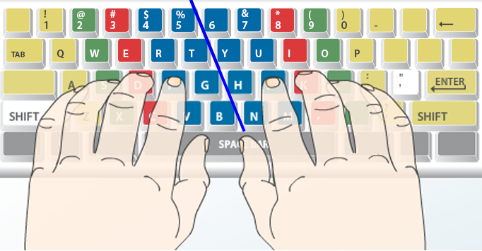 |  | 
- Type with continuity (without hesitation) and with accuracy. |  | 
- Keep forearms at a slight downward slant with hands slightly raised so wrists do not touch keyboard.
- Make quick, light strokes; return fingers to home position or move to next position. |  | 

Keystroking Remediation
 | Relearn a key: Click Skillbuilding, New Keys tab, New Key Drill; click desired key to move to lesson of introduction, review demonstration, and type drills; click New Key Review for extra practice on new keys for that lesson.
 | Enrichment: From the Lessons menu for Lessons 1-20, click Lesson “X” Enrichment, and type the enrichment drills.
 | MAP+ (unlimited skillbuilding drills, Lessons 1-18)  If you are on Lessons 1-18, click MAP+, Lesson 1-18; from drop-down list, click desired lesson for unlimited drills on all keys learned up to and including the selected lesson.
 | MAP+ (unlimited intensive practice on any key)  If you are on Lesson 17 or beyond, click MAP+; click a key on “live keyboard” for intensive, unlimited drills for that key, or click any row or box for intensive practice on that row or that reach.
 | MAP+ Diagnostics—Alphabet (Lesson 17+), Numbers (Lesson 19+), and Symbols (Lesson 20+)  If you are on Lesson 17 or beyond, click MAP+, Pretest, Alphabet. For Lesson 19 or beyond, click Numbers. For  Lesson 20 or beyond, click Symbols. Take pretest and follow prompts to complete unlimited prescriptive drills.
 | 12-Second Speed Sprints (click Skillbuilding, Drills tab; click desired drill)  Achieve higher speeds by typing in short bursts on short, easy copy without error limits; to help break keyboard-watching habit, type each sprint keeping eyes on the copy at all times.
 | Paced Practice (click Skillbuilding, Drills tab; click desired drill)  Use to encourage steady, paced typing; drills alternate between speed and accuracy improvement.
 | Progressive Practice (click Skillbuilding, Drills tab; click desired drill)  Use to help break keyboard-watching; drills build straight-copy speed/accuracy using 30" timed writings.
 | Sustained Practice (click Skillbuilding, Drills tab; click desired drill)  Use to build higher speeds by maintaining speed on increasingly difficult copy.
 | Technique Practice (click Skillbuilding, Drills tab; click desired drill)  Use to build skill on these keys: Shift, Backspace, Tab, Enter, and Space Bar.
 | Pretest/Practice/Posttest (click Skillbuilding, Drills tab; click desired drill)  Use to build straight-copy skill focusing on speed or accuracy while emphasizing specific reaches.

