
TEN-KEY NUMERIC KEYPAD: RESEARCH & ROUTINES
Ten-Key Numeric Keypad Research 1
Ten-Key Numeric Keypad Lessons 2
Supplementary: Ten-Key Numeric Keypad Lesson 2
Supplementary: Ten-Key Numeric Keypad Enrichment 2
Ten-Key Numeric Keypad Timed Practice 3
Numeric Keypad Pretest>>Practice>>Posttest 3
Numeric Keypad Pretest>>Practice>>Posttest Routines 4
Numeric Keypad Timed Practice Reporting 4
Numeric Keypad Pretest>>Practice>>Posttest Reporting 5
Portfolio & Excel Filters for Ten-Key Results 5
Gradebook—Configure Exercises Filters for Ten-Key Results 7
Ten-Key Numeric Keypad Checklist 7

Ten-Key Numeric Keypad Research
The best source for determining final recommendation for a minimum level numeric data entry speed in a ten-key course would be to query some temp agencies and local businesses in your school’s area and determine what standards are reasonable and acceptable. GDP measures speed in DPM (digits per minute) rather than KPH (keystrokes per hour)—two columns below are included for reference. A bottom-line minimum exit DPM speed (C- grade) of 130 DPM is reasonable and in line with general research. Consider averaging selected Ten-Key Numeric Keypad Timed Practice drills to assess student exit skills.

NUMERIC DATA ENTRY SPEEDS
Entry Level
DPM* | KPH** | Source
150 to 200 | 9,000 to 12,000 | E-How.com  “Numeric data entry speeds that qualify clerical workers for employment typically must be between 9,000 and 12,000 KPH. Acceptable alphanumeric data entry speed requirements are a little bit lower than purely numerical speeds, because the addition of the alpha characters slows down most operators. These can be as low as 7,000 KPH to qualify for employment.”  Read more: What Is Data Entry Speed? | eHow.com http://www.ehow.com/about_5081610_data-entry-speed.html#ixzz23oMp4SiI
*(Digits per Minute); **(Keystrokes per Hour)

The average student can expect to spend approximately 100 minutes (2 minutes per exercise) completing the 50 ten-key numeric routines one time each and can expect to achieve about 110 DPM. Of course, if those students repeat all the ten-key routines and therefore complete an additional two hours of practice, their DPM speed should continue to rise significantly. Approximate completion times for an average student are noted next to each ten-key routine and in the section “Ten-Key Numeric Keypad Checklist.”

Ten-Key Numeric Keypad Lessons
Supplementary lessons for the ten-key numeric keypad follow Lesson 20. These lessons introduce touch typing of both the number keys (Supplementary Lesson, pages 70-71) and arithmetic operators +, -, /, and * (Enrichment, page 72). Content for these two lessons can be found in both the textbook and on GDP screens:
- Ten-Key Numeric Keypad Lesson (GDP); Supplementary Lesson, Ten-key Numeric Keypad, pages 70-71 (textbook).
- Ten-Key Numeric Keypad Enrichment (GDP); Enrichment Supplementary Lesson, page 72.

Additional Timed Practice and Pretest>>Practice>>Posttest reinforcement drills are found in GDP immediately after the Supplementary and Enrichment Lesson. These drills can also be accessed via the Skillbuilding button, Drills tab, Ten-Key Numeric Keypad Timed Practice and Numeric Keypad Pretest>>Practice>>Posttest.
- Ten-Key Numeric Keypad Timed Practice
- Ten-Key Numeric Keypad Pretest>>Practice>>Posttest: 3-Digit Numbers
- Ten-Key Numeric Keypad Pretest>>Practice>>Posttest: 4-Digit Numbers
- Ten-Key Numeric Keypad Pretest>>Practice>>Posttest: Short Decimal Numbers
- Ten-Key Numeric Keypad Pretest>>Practice>>Posttest: 1-4 Digit Numbers
- Ten-Key Numeric Keypad Pretest>>Practice>>Posttest: Long Decimal Numbers

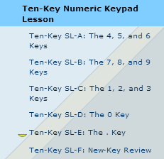
Supplementary: Ten-Key Numeric Keypad Lesson
To access these supplementary lessons in GDP, click the Lessons button; from the Part 1 tab, expand Unit 4; under Lesson 20, click Ten-Key Numeric Keypad Lesson; complete Ten-Key SL-A through Ten-Key SL-F. Content appears both on the GDP screens and in the textbook on pages 70-71.

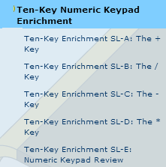
Supplementary: Ten-Key Numeric Keypad Enrichment
To access these supplementary lessons in GDP, click the Lessons button; from the Part 1 tab, expand Unit 4; click Ten-Key Numeric Keypad Enrichment; complete Ten-Key SL-A through Ten-Key SL-F. Content appears both on the GDP screens and in the textbook on page 72.

Ten-Key Numeric Keypad Timed Practice
After students finish typing both lessons, they should complete the Timed Practice. The purpose of the Timed Practice is to measure progress in each of the practice key categories. Ideally, students will increase DPM (digits per minute) and decrease errors.  To access the timed practice drills in GDP, click the Lessons button; from the Part 1 tab, expand Unit 4; click Ten-Key Numeric Keypad Timed Practice; complete Ten-Key Timed Practice 1 through Ten-Key Timed Practice 14. Content appears only in GDP screens.  Assessment:  The degree of difficulty rises as the number of digits increases. Consider averaging selected Ten-Key Numeric Keypad Timed Practice drills to assess student exit skills; for example, perhaps select Timed Practice 4, which covers keys 0-9 and the decimal. Perhaps select Timed Practice 9, which includes 2- to 4-digit numbers. Finally, perhaps select Timed Practice 13 or 14 for a combination of short and long decimal numbers representing the highest degree of difficulty. | 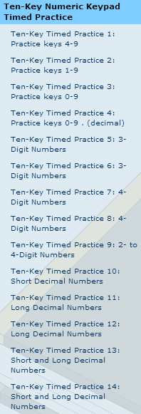

Numeric Keypad Pretest>>Practice>>Posttest
After students finish typing Timed Practice drills, they should complete Pretest>>Practice>>Posttest drills for additional practice. These routines measure progress in each practice key category. Ideally, students will increase DPM and lower errors as they work through each routine.

To establish a beginning speed, students should type the Pretest, pushing moderately for speed. Practice drills are designed to reinforce reaches for a specific number pattern. In the Posttest, their goal is to improve the Pretest score by increasing the DPM and decreasing errors when compared to the Pretest.
- 3-Digit Numbers
- 4-Digit Numbers
- Short Decimal Numbers
- 1-4 Digit Numbers
- Long Decimal Numbers

Numeric Keypad Pretest>>Practice>>Posttest Routines
To access these drills in GDP, click the Lessons button; from the Part 1 tab, expand Unit 4; click Ten-Key Numeric Keypad Pretest>>Practice>>Posttest: 3-Digit Numbers; complete the Pretest; Practice 1, 2, 3; and Posttest. Content appears only in GDP screens.  Repeat the same process for all the P/P/P routines. Approximate completion times are as follows:  - 3-Digit Numbers [10']  - 4-Digit Numbers [11']  - Short Decimal Numbers [10']  - 1-4 Digit Numbers [10']  - Long Decimal Numbers [12'] | 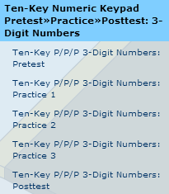

Numeric Keypad Timed Practice Reporting
Results of Timed Practice reported in DPM (digits per minute), time spent, and errors may be viewed in the left pane immediately after completing a Timed Practice as well as in the Portfolio:

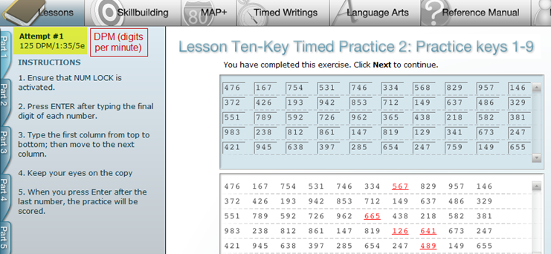
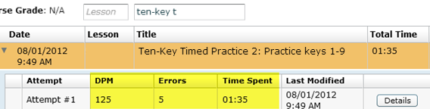

Numeric Keypad Pretest>>Practice>>Posttest Reporting
Results of Pretest>>Practice>>Posttest are reported in DPM (digits per minute), errors are scored, and time spent is calculated. Results may be viewed in the left pane of the practice screen immediately after completing a Pretest or Posttest as well as in the Portfolio:

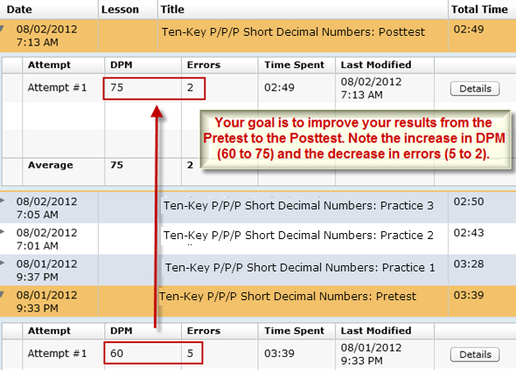

Portfolio & Excel Filters for Ten-Key Results
Follow these steps to filter the Portfolio to display only Ten-Key Numeric Keypad routines:

- From the GPS Reports tab, select the desired Class, Section, and Student to display the Portfolio results.
- Click the Show All button. (If no filter is in use, this step can be skipped.)
- In the Title filter box, type ten; note that in the Title column, only titles that include “ten” display.

To further filter the Portfolio to include a particular group of Ten-Key Numeric Keypad routines:

In the Title box, type ten-key followed by characters from any of these routines:
- sl (for Ten-Key Numeric Keypad Lessons SL-A through SL-F); for example:
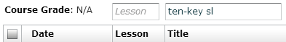
- e (for Ten-Key Enrichment SL-A through SL-E)

- t (for Ten-Key Timed Practice 1 through 14)
Note: These Ten-Key Timed Practice 1 through 14 routines are recommended for use when assessing exit DPM skills.
In the Title box, delete ten-key and type these exact characters to display any of these routines:
- 3-digit numbers: (for Ten-Key Numeric Keypad Pretest>>Practice>>Posttest: 3-Digit Numbers)
- 4-digit numbers: (for Ten-Key Numeric Keypad Pretest>>Practice>>Posttest: 4-Digit Numbers)
- short d: (for Ten-Key Numeric Keypad Pretest>>Practice>>Posttest: Short Decimal Numbers)
- 1-4 (for Ten-Key Numeric Keypad Pretest>>Practice>>Posttest: 1- to 4-Digit Numbers Numbers)
- p l (for Ten-Key Numeric Keypad Pretest>>Practice>>Posttest: Long Decimal Numbers)

To filter the exported Excel spreadsheet to include only Ten-Key Numeric Keypad Drills:

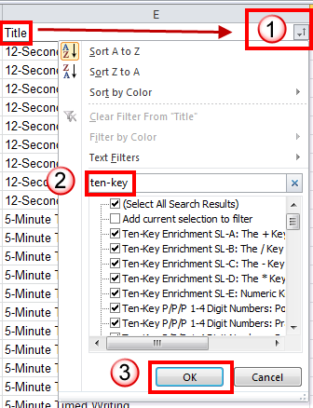
- In the Portfolio, click Export, Excel, and open the Excel file for editing.
- Under the Title column, click the list arrow;
- In the Search box, type ten-key; click OK; the spreadsheet should now display only ten-key routines.

To SUM the Time Spent column in Excel for Ten-Key Numeric Keypad Drills:

- With the exported Student Portfolio Excel file open, select the Time Spent column (click the column letter at the top of the column to select the column in one click).
- From the Data tab, Data Tools group, click Text To Columns.
- From the Convert Text to Columns Wizard – Step 1 of 3 dialog box, select Delimited; click Next.
- In the Step 2 of 3 dialog box, under Delimiters, check Tab; click Finish.
- With the column still selected, right-click; click Format Cells; from the Number tab under Category, click Custom; under Type, scroll down almost to the end and click [h]:mm:ss; click OK.
- Click in the cell at the bottom of the last entry in the Time Spent column.
- From the Home tab, Editing group, click the AutoSum button.
- Note that the column to be summed is surrounded by wavy lines and a formula displays; for example, =SUBTOTAL(9,N2:N341); if necessary, drag the borders to include the entire range of cells to be summed.
- Press Enter to accept the formula, and note the display of the SUM of that column; for example, 1:37:10, meaning 1 hour, 37 minutes, and 10 seconds.

Gradebook—Configure Exercises Filters for Ten-Key Results
If you are using a Gradebook in your course and are in GPS, Gradebook tab, Exercises, Configure Exercises, you need to filter to ten-key numeric keypad drills only. Set the Exercise Filter to Category; the first subfilter to Skillbuilding; and the last four subfilters shown below one by one to achieve that result. See Setting Up an Interim Gradebook [PDF] for details.
Note: You must enlarge the Configure Exercises window by dragging on the right border of the window to display the scroll bars so you can drag them down to view some of these items.

- Alpha/Number/Symbol Practice (displays Ten-Key Numeric Keypad Lesson, New-Key Review only)
- New Key Drill (displays Ten-Key Numeric Keypad Lesson, except for New-Key Review)
- Pretest/Practice/Posttest (displays Numeric Keypad Pretest>>Practice>>Posttest)
- Ten-Key Numeric Keypad (displays Ten-Key Numeric Keypad Timed Practice)

Ten-Key Numeric Keypad Checklist
Consider using this at-a-glance checklist of ten-key routines and corresponding drills. Menu group names, lesson names and exercise titles match those found on GDP menus. Completion times are approximations only. A beginning student should spend approximately 100 minutes completing all 50 ten-key numeric routines one time each.

Ten-Key Numeric Keypad Lesson (12') Title Box Filter
 | Ten-Key SL-A: The 4, 5, and 6 Keys | ten-key sl
 | Ten-Key SL-B: The 7, 8, and 9 Keys | ten-key sl
 | Ten-Key SL-C: The 1, 2, and 3 Keys | ten-key sl
 | Ten-Key SL-D: The 0 Key | ten-key sl
 | Ten-Key SL-E: The . Key | ten-key sl
 | Ten-Key SL-F: New-Key Review | ten-key sl

Ten-Key Numeric Keypad Enrichment (10') Title Box Filter
 | Ten-Key Enrichment SL-A: The + Key | ten-key e
 | Ten-Key Enrichment SL-B: The / Key | ten-key e
 | Ten-Key Enrichment SL-C: The - Key | ten-key e
 | Ten-Key Enrichment SL-D: The * Key | ten-key e
 | Ten-Key Enrichment SL-E: Numeric Keypad Review | ten-key e

Ten-Key Numeric Keypad Timed Practice* (25') Title Box Filter
 | Ten-Key Timed Practice 1: Practice keys 4-9 | ten-key t
 | Ten-Key Timed Practice 2: Practice keys 1-9 | ten-key t
 | Ten-Key Timed Practice 3: Practice keys 0-9 | ten-key t
 | Ten-Key Timed Practice 4: Practice keys 0-9 . (decimal) | ten-key t
 | Ten-Key Timed Practice 5: 3-Digit Numbers | ten-key t
 | Ten-Key Timed Practice 6: 3-Digit Numbers | ten-key t
 | Ten-Key Timed Practice 7: 4-Digit Numbers | ten-key t
 | Ten-Key Timed Practice 8: 4-Digit Numbers | ten-key t
 | Ten-Key Timed Practice 9: 2- to 4-Digit Numbers | ten-key t
 | Ten-Key Timed Practice 10: Short Decimal Numbers | ten-key t
 | Ten-Key Timed Practice 11: Long Decimal Numbers | ten-key t
 | Ten-Key Timed Practice 12: Long Decimal Numbers | ten-key t
 | Ten-Key Timed Practice 13: Short and Long Decimal Numbers | ten-key t
 | Ten-Key Timed Practice 14: Short and Long Decimal Numbers | ten-key t
*Note: Gradebook allows you to set DPM (shown in Gradebook as WPM), Error, and WPM penalty when you select Custom Grading Method; WPM defaults to 0—you must enter values.

Ten-Key Numeric Keypad Pretest>>Practice>>Posttest: 3-Digit Numbers (10') Title Box Filter
 | Ten-Key P/P/P 3-Digit Numbers: Pretest | 3-digit numbers:
 | Ten-Key P/P/P 3-Digit Numbers: Practice 1 | 3-digit numbers:
 | Ten-Key P/P/P 3-Digit Numbers: Practice 2 | 3-digit numbers:
 | Ten-Key P/P/P 3-Digit Numbers: Practice 3 | 3-digit numbers:
 | Ten-Key P/P/P 3-Digit Numbers: Posttest | 3-digit numbers:

Ten-Key Numeric Keypad Pretest>>Practice>>Posttest: 4-Digit Numbers (11') Title Box Filter
 | Ten-Key P/P/P 4-Digit Numbers: Pretest | 4-digit numbers:
 | Ten-Key P/P/P 4-Digit Numbers: Practice 1 | 4-digit numbers:
 | Ten-Key P/P/P 4-Digit Numbers: Practice 2 | 4-digit numbers:
 | Ten-Key P/P/P 4-Digit Numbers: Practice 3 | 4-digit numbers:
 | Ten-Key P/P/P 4-Digit Numbers: Posttest | 4-digit numbers:

Ten-Key Numeric Keypad Pretest>>Practice>>Posttest: Short Decimal Numbers (10') Title Box Filter
 | Ten-Key P/P/P Short Decimal Numbers: Pretest | short d:
 | Ten-Key P/P/P Short Decimal Numbers: Practice 1 | short d:
 | Ten-Key P/P/P Short Decimal Numbers: Practice 2 | short d:
 | Ten-Key P/P/P Short Decimal Numbers: Practice 3 | short d:
 | Ten-Key P/P/P Short Decimal Numbers: Posttest | short d:

Ten-Key Numeric Keypad Pretest>>Practice>>Posttest: 1- to 4-Digit Numbers (10') Title Box Filter
 | Ten-Key P/P/P 1- to 4-Digit Numbers: Pretest | 1-4
 | Ten-Key P/P/P 1- to 4-Digit Numbers: Practice 1 | 1-4
 | Ten-Key P/P/P 1- to 4-Digit Numbers: Practice 2 | 1-4
 | Ten-Key P/P/P 1- to 4-Digit Numbers: Practice 3 | 1-4
 | Ten-Key P/P/P 1- to 4-Digit Numbers: Posttest | 1-4

Ten-Key Numeric Keypad Pretest>>Practice>>Posttest: Long Decimal Numbers (12') Title Box Filter
 | Ten-Key P/P/P Long Decimal Numbers: Pretest | p l
 | Ten-Key P/P/P Long Decimal Numbers: Practice 1 | p l
 | Ten-Key P/P/P Long Decimal Numbers: Practice 2 | p l
 | Ten-Key P/P/P Long Decimal Numbers: Practice 3 | p l
 | Ten-Key P/P/P Long Decimal Numbers: Posttest | p l

