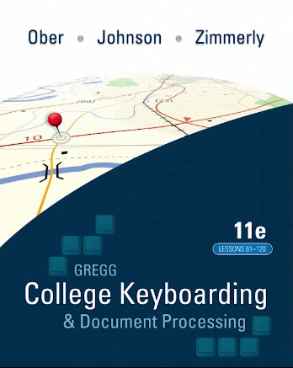

This We Believe

About Technique:

- Demonstrate and emphasize technique frequently during the early lessons, and assess it frequently throughout the course.
- Demonstrate good technique with the students.
- Ensure that essential techniques—such as eyes on copy, correct fingering techniques, and good posture—are being practiced daily.
- Develop locational security (the confidence in knowing where the alphabetic keys are located) to minimize keyboard watching.
- Observe and assess only one or two techniques at a time.
- Always use positive reinforcement when encouraging students to keep their eyes on the copy (or screen).
- Evaluate each technique as acceptable, needs improvement, or not acceptable rather than assign a specific grade.

About Skillbuilding:

- After presenting the home row, introduce three to four new keys each lesson until the entire alphabet has been introduced.
- Teach the keyboard rapidly and logically, but push for speed gradually.
- Speed and accuracy are developed independently. Focus on either speed or accuracy but not on both simultaneously.
- Locational security is developed over time as skillbuilding drills are completed systematically. The error tolerance in timed writings should be decreased over time to correspond to this natural progression in accuracy.
- Assign skillbuilding as a daily activity in every lesson throughout the course.
- Use 15 to 20 minutes of a 50-minute class period for skillbuilding activities.
- Use a variety of skillbuilding routines to maintain student interest in the class.
- Have students set goals to improve their own previous best performance rather than to meet an arbitrary class goal.
- Use MAP+ (Misstroke Analysis and Prescription) to Improve students’ keyboarding skills. MAP+ identifies and analyzes keystroking errors and then prescribes individualized drills to remediate those errors.
- Consider both speed and accuracy when assigning grades for timed writings.
- Maintain a consistent format, length, and difficulty level for timed writings used to assess skill to ensure that any difference in speed is based on keyboarding skill, not on any difference in copy difficulty.
- To ensure continuous speed and accuracy improvement, have your students (1) demonstrate good technique, (2) practice appropriate drills for speed and accuracy, (3) keep eyes on the copy (or screen), and (4) practice in short sessions over a long period of time rather than in long sessions over a short period of time.
- Encourage students to build speed by typing a little faster and to improve accuracy by typing a little slower.
- To build speed, use copy that contains words that are easy to type and that have a low syllabic intensity.
- To improve accuracy, use copy that contains at least one occurrence of every letter of the alphabet.
About Document Processing:

- Consider both the accuracy of the work (mailability) as well as the time it takes to produce the work (speed).
- Assess both what is typed (the alphabetic and numeric characters in the document) as well as how it is typed (the format of the document).
- Assess a student’s document processing skills (1) after the student has been introduced to a sufficient number of formatting concepts, and (2) when the instructor needs to determine if the student can demonstrate an understanding of those concepts by typing documents within a prescribed time period.
- Limit the time for a document processing test to the time available in any given class period, and administer the test in one setting.
- Assess proofreading skills as well as production skills.

