
TIME SPENT AND TOTAL TIME IN THE PORTFOLIO

Time Management Guidelines 1
Time Tracking for Skillbuilding (*BP) 1
Time Tracking for Document Processing Jobs (*BP) 3
Time Tracking for Document Formatting (*BP) 5
Time Tracking for Practice Exercises (*BP) 6
GDP Total Time 6
Review inordinately long times 6
Exporting Student Portfolio Report to Excel 7
To export the Student Portfolio Report to Excel: 7
To sort Time Spent in Excel: 7
To SUM Time Spent in Excel: 8
To convert cells with “days” in order to include them in the SUM: 8


Note! Students should consult with instructors for the best classroom practices. Bottom line, instructors must be aware that Time Spent will be accurate only when students follow these best practice routines. If instructors want accurate and valid Time Spent reporting, they must be diligent in directing students to follow the best practice routines for document processing jobs, document formatting and Practice exercises, particularly if they want to include reading time.

Time Management Guidelines
Here are some general guidelines regarding how much time you can expect the average student expect to spend on lessons, including skillbuilding, document processing, and ten-key drills:

- SKILLBUILDING: The average student can expect to spend approximately 50-60 minutes on each lesson in Lessons 1-20 and 15-20 minutes on each lesson in Lessons 21-60 to complete skillbuilding. Unlimited skillbuilding drills are provided via MAP+ and keystroking remediation drills are available in GDP for additional skillbuilding if WPM requirements are not being met. Visit the MAP+ & Skillbuilding page at the Computer Keyboarding 1 course Web site for details on all skillbuilding drills.
- DOCUMENT PROCESSING: For each of Lessons 21-120, the average student can expect to spend a minimum of 45 minutes on document processing. Optional Practice exercises in the Word Manual would increase this time spent.
- TEN-KEY: The average student can expect to spend a minimum of 6 hours completing 50 ten-key drills three times each. Such drills should be repeated if DPM requirements are not being met.

When you assess time management for grading or other purposes, you can use Time Spent and Total Time in the Student Portfolio for time tracking. However, you must first understand how GDP tracks time.

Time Tracking for Skillbuilding (*BP)

Best Practice! Advise students to visit the MAP+ & Skillbuilding page at the Computer Keyboarding 1 course Web site for details on using any GDP skillbuilding drill to address keyboarding weaknesses. Students should also review the Keystroking Remediation section of this form for appropriate use of any GDP skillbuilding drill for remediation: Technique Self-Assessment [PDF].

Skillbuilding Drills: Time Spent begins when the student clicks the skillbuilding exercise from the GDP menu, continues when the student types the drill, and ends when the student clicks Done. Time pausing on the screen either before, during, or after typing is accumulated in Time Spent. Total Time is cumulative for all attempts for that drill. For example, in this Warmup drill, the student spent 30" pausing on the Warmup screen, 30" typing, and 15" pausing before clicking Done for a Time Spent of 1:15 and a Total Time on both attempts of 2:30.
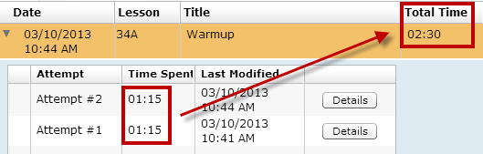

Timed Writing: Total Time counts time based solely on the length of the timed writing being taken. For example, if two 5-minute timings were taken, Total Time is 1 minutes.
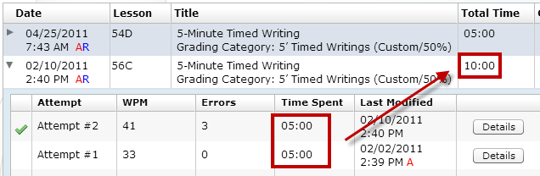

MAP+: Total Time counts only keystroking time spent on any MAP+ drills. Time Spent begins when the student begins typing the selected MAP+ drill and ends when the student types the last keystroke in the drill.
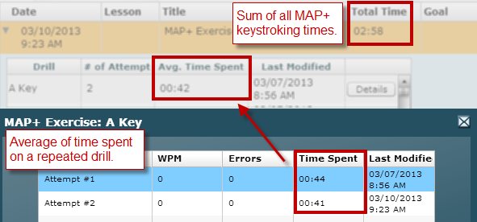

MAP+ drills are grouped in the Portfolio—for example, MAP+ Alphabet (groups Alphabet pretest and prescriptive drills), MAP+ Enrichment (groups enrichment lesson practice), and MAP+ Exercise (groups randomly practiced keys).
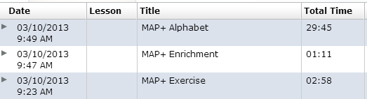

Time Tracking for Document Processing Jobs (*BP)
Best Practice! On jobs in which time is a grading factor, students should use Browse followed directly by Submit Work and should not navigate away from the screen for that job for any reason or the Time Spent will continue to accumulate. Advise students to perform all file management actions (downloading, opening, saving, and browsing) quickly and efficiently to minimize Time Spent. For an explanation of how to track time spent reading formatting directions, click here.

When you assess a document processing job in which time is a factor in grading, you can use Time Spent and Total Time in the Student Portfolio for time tracking. However, you must first understand how GDP tracks time.

Time Spent begins when the student clicks Start Work and ends when the file name appears in the Browse box after clicking Browse—at this point, work is uploaded to the Web site but work does not yet appear in the Portfolio. The closing time stamp, which was recorded at the point of the file name appearance in the Browse box, takes effect only when the student clicks Submit Work to score work and send it to the Portfolio.

If the student moves out of the lesson before or after using Browse and before clicking Submit Work; or if the student exits and starts GDP, returns to the job, and then clicks Browse and Submit Work, the closing time stamp will include all the time spent from Start Work through the final Browse session. Clicking Submit Work is the action that adds the time stamp that represents time spent from Start Work through the most recent Browse session. Here are some examples:

- If a student takes 3 minutes from Start Work through Browse (but doesn’t click Submit Work); then takes 2 more minutes to move away from the job or to exit and reopen GDP, return to the job, use Browse again, and then to Submit Work, GDP records Time Spent as 5 minutes.
- If a student takes 3 minutes from Start Work through Browse (but doesn’t click Submit Work); then takes another 44 seconds to use Edit Work, then to Browse (to upload the most recently edited file), and then to Submit Work, GDP records Time Spent as 3:44 (3' + 44"). Both the Start Work and Edit Work sessions are reported as Attempt #1 because Submit Work, which sends work to the Portfolio and to the instructor, was never used after the initial Start Work session.
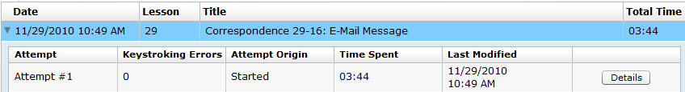

The conclusion for instructors who wish to assess jobs based on Time Spent in Word (disregarding time spent to open and close Word and to use Browse or to navigate away from the job or exit and re-enter GDP) is as follows:

- Make sure students understand that Time Spent begins when they click Start Work or Edit Work and ends when the file name displays in the Browse box after clicking Browse unless they do the following: (a) if they leave that GDP job screen for any reason (including exiting and entering GDP again) or (b) if they use Edit Work without using Submit Work, GDP will continue adding minutes to Time Spent for that job. Also any action taken prior to using Submit Work, such as using Edit one or more times, is still reported as one Started attempt in the Portfolio.
- If time is an important grading factor, students should use Browse followed directly by Submit Work—they should not navigate away from that job for any reason.
- When assigning grades to jobs in which Time Spent is a grading factor, you must consider the estimated amount of extra time students take outside of Word to open, save, and browse to files, and adjust assessment accordingly.
- Time Spent is cumulative for all attempts in a single series of Started and Edited attempts. However, when Start Work is used again, which results in a Started again attempt, Time Spent restarts from zero.

In the following example, Attempt #1 and Attempt #2 were both Started attempts, so the time was restarted at zero for each attempt—Attempt #1 lasted 1:33 and Attempt #2 lasted 2:00. Attempt #3 is an Edited attempt of Attempt #2.
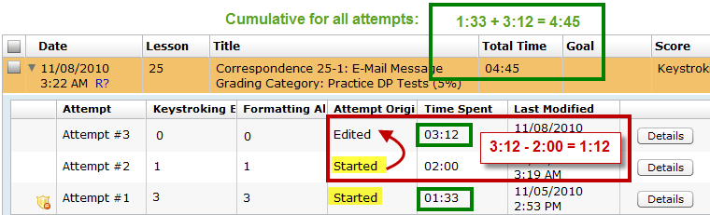

- To calculate how much time was spent on any individual edited attempt, subtract Time Spent on the previous attempt from Time Spent on the attempt in question. To calculate the individual time for Attempt #3 (1:12), subtract 2:00 (the individual time for Attempt #2) from 3:12 (the cumulative time for Attempt #2 and Attempt #3).
- To calculate Total Time, add Attempt #1 to the cumulative time for Attempt #2 and #3 (1:33 + 3:12 = 4:45).

Note: Remember that if you add any attempts, and the total seconds exceed 60, you must convert those seconds to minutes and seconds; for example, if you add 1:45 to 1:20, you get 2:65, which converts to 3:05.

Note: Files of unknown origin (a file tagged with another student’s encryption information or not created using the file that GDP opens when Start Work is used) will have Time Spent and Total Time of 00:00. See Using Scheduling As a Testing Strategy.


Tip: See Practice Exercises & Document Processing, Understanding Proofreading Checks and Attempt Origin in the Portfolio, for information on Proofreading Checks and Attempt Origin.

Time Tracking for Document Formatting (*BP)
Best Practice! Instructors who are concerned about time reporting for time spent reading formatting directions related to a job both on GDP screens and in the textbook should direct students to click the desired menu item in GDP and read the related directions on the screen and in the textbook. Only then should they click Next. In this way, time reporting will accurately include reading time related to document formatting.

Time Spent on formatting screens that precede a document processing job, such as 27E with information on enclosure notations, begins to accumulate when students click the desired menu item and ends when students click Next. If students return later and revisit the menu item, the attempt number will not increase. However, Time Spent and Total Time will include Time Spent on all visits. If students exit GDP without clicking Next, any time spent will not be recorded.

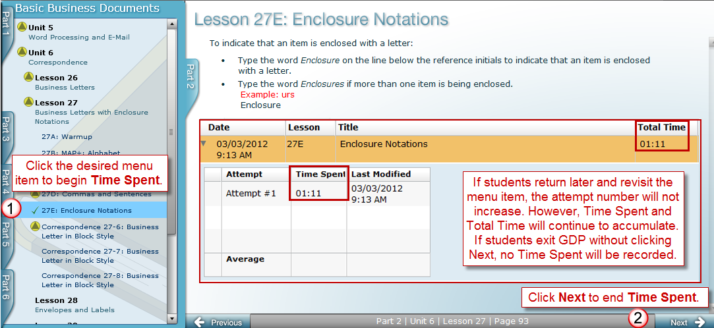

Time Tracking for Practice Exercises (*BP)
Best Practice! Instructors who are concerned about time reporting for time spent reading directions related to a Practice exercise in the Word Manual and GDP screens and on typing the Practice exercise should tell students to click Start Work for the desired Practice exercise, read the related directions on the screen and in the textbook, and type the Practice exercise. Only then should they click Next. In this way, time reporting will accurately include reading time and production time spent typing the Practice exercise.

Time Spent begins to accumulate when students click Start Work from the Practice exercise screen and ends when they click Next. If students return later and click Start Work and Next on a subsequent attempt, the attempt number will not increase. However, Time Spent and Total Time will include Time Spent on all visits. If students exit GDP without clicking Next, any time spent will not be recorded.

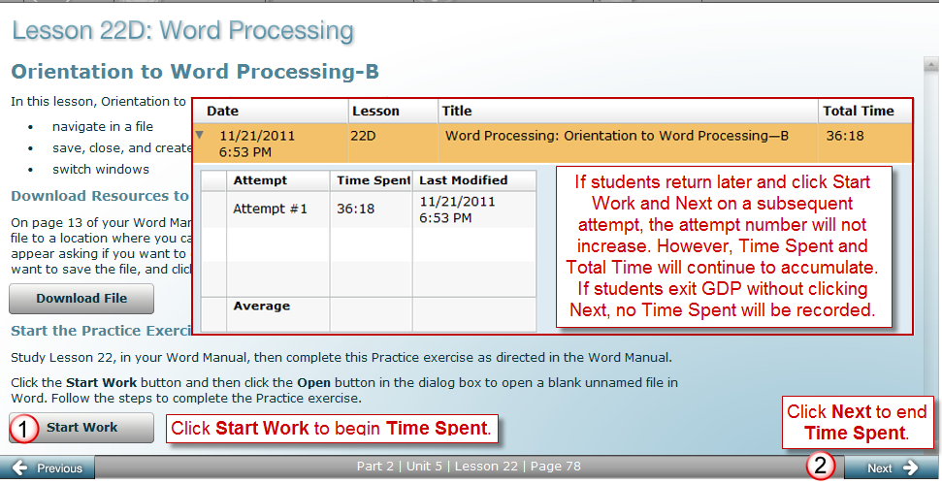

GDP Total Time
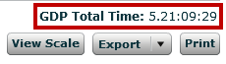
GDP Total Time is reported on the Reports tab at the bottom of the Student Portfolio for each student. In this example, 5.21:09:29 translates to 5 days, 21 hours, 9 minutes, and 29 seconds of time spent cumulatively in GDP.

Review inordinately long times
Scroll down through the Time Spent column, and look for any inordinately long times. Such entries are technically correct, but are likely misrepresenting the time actually spent on a job inside of GDP. Adjust GDP Total Time accordingly for your own records. Typically in such cases, a student has worked on a document but not used Submit until hours or days later. Also, if Practice exercises are not being recorded, the student forgot to click Next after reading the screen and completing the exercise.

Exporting Student Portfolio Report to Excel
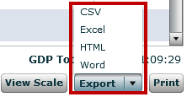
Use the Export button to export the Student Portfolio Report to CSV, Excel, HTML, or Word format. Use Excel for the most powerful sort and SUM features to calculate Time Spent segments and Total Time. See Course Manager Tips [PDF] to learn about Excel’s sort features for columns such as Exercise Category, Exercise Type, and Title.

To export the Student Portfolio Report to Excel:
- Under USERS, click GPS, Reports tab.
- Click the Report Type list arrow, Student Portfolio.
- Click Include Results from, click the desired student, and click View Report.
- From the Student Portfolio Report, click the list arrow next to the Export button at the bottom of the screen, and click Excel.
- Steps will vary depending upon your browser. Follow the prompts to Open or Save the file answering Yes where needed to open the file; click Enable Editing to edit the file in Excel.

To sort Time Spent in Excel:
In this example, unrelated columns were deleted in Excel to illustrate the columns you will likely be most interested in reviewing if time tracking and reporting is important on your campus.
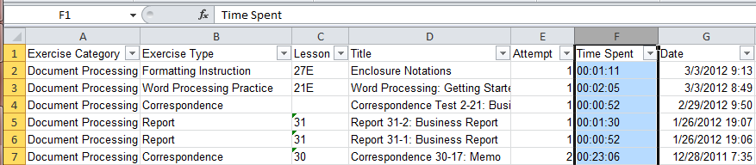

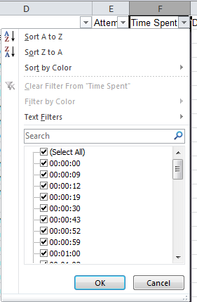
Because you are working in Excel, you can use Excel’s powerful sort features and mathematical capabilities to adjust or eliminate inordinately long times you know are skewing results.

To SUM Time Spent in Excel:
- With the exported Student Portfolio Excel file open, select the Time Spent column (click the column letter at the top of the column to select the column in one click).
- From the Data tab, Data Tools group, click Text To Columns.
- From the Convert Text to Columns Wizard – Step 1 of 3 dialog box, select Delimited; click Next.
- In the Step 2 of 3 dialog box, under Delimiters, check Tab; click Finish.
- With the column still selected, right-click; click Format Cells; from the Number tab under Category, click Custom; under Type, scroll down almost to the end and click [h]:mm:ss; click OK.
- Click in the cell at the bottom of the last entry in the Time Spent column.
- From the Home tab, Editing group, click the AutoSum button.
- Note that the column to be summed is surrounded by wavy lines and a formula displays; for example, =SUM(N259:N566); if necessary, drag the borders to include the entire range of cells to be summed.
- Press Enter to accept the formula, and note the display of the SUM of that column; for example, 17:35:34, meaning 17 hours, 35 minutes, and 34 seconds.
- Review the column; if you see any cells in which the time is left aligned, those times are probably skewing GDP’s Total Time results as they are indicating that a student took at least one day to complete a job. These excessively long times have been excluded by Excel in the SUM process.
Remember: If the student moves out of the lesson before or after using Browse and before clicking Submit Work; or if the student exits and starts GDP, returns to the job, and then clicks Browse and Submit Work, the closing time stamp will include all the time spent from Start Work through the final Browse session. You should manually add adjusted time for these jobs into the total as you deem appropriate.

To convert cells with “days” in order to include them in the SUM:
- Review the column; if you see any cells in which entries that include “days” are left aligned, such as 2.06:48:16, which represents 2 days, 6 hours, 48 minutes, and 16 seconds. Those cells must be converted to be included in the SUM. Follow the next few steps to convert those cells.
- In the formula below this step, change eight instances of “F” to the letter of the Time Spent column that contains the data to be converted, and then select and copy the edited formula:

=IF(ISNUMBER(F2), F2, IF(ISNUMBER(FIND(".",F2)),LEFT(F2,FIND(".",F2)-1)+MID(F2,FIND(".",F2)+1,99), --F2))

- Click in any blank column on the worksheet in the first cell of Row 2 (for example, Cell H2 assuming Column H is blank), click in the Formula box (the box next to fx at the top of the spreadsheeet), and press Ctrl+V to paste.
- After you paste the formula in the blank column, copy down for as many rows as appear in the column with the entries to be changed. (To copy down, point to the black square in the lower right-hand corner of the cell in which you pasted the formula until your pointer looks like a black plus sign, and drag down from that corner.)
- With the copied-down cells still selected, right-click, and click Copy.
- Click in the first cell of Row 2 of the Time Spent column.
- Right-click and from the sortcut menu under Paste Options, click the icon representing Values (V)--the clipboard icon with 123 on it.
- In the Time Spent column, click in the cell holding the SUM formula.l
- From the Home tab, Editing group, click the AutoSum button; that cell should now SUM all entries in the Time Spent column.

